 Università degli Studi di Ferrara

DOTTORATO DI RICERCA IN

“SCIENZE DELL’INGEGNERIA”

CICLO XXVII

COORDINATORE Prof. Trillo Stefano

AXIAL LOAD IDENTIFICATIONS
IN SPACE FRAME SYSTEMS

Settore Scientifico Disciplinare ICAR/09

Dottorando Tutori

Dott. Bonopera Marco Prof. Tullini Nerio

Prof. Chang Kuo-Chun

Anni 2012/2015

AXIAL LOAD IDENTIFICATIONS IN SPACE FRAME SYSTEMS

PhD Thesis by Bonopera Marco

Supervisors:
Prof. Tullini Nerio
Prof. Chang Kuo-Chun

University of Ferrara
PhD in Engineering Sciences
Civil Engineering - Structural Engineering
XXVII cycle

Examiners:
Prof. Olivito Renato Sante, University of Calabria
Prof. Secchi Simone, University of Florence
Prof. Mancini Giuseppe, University of Catania
Dr. Moramarco Tommaso, Istituto di Ricerca per la Protezione Idrogeologica, CNR, Perugia
Prof. Bitelli Gabriele, University of Bologna

March 2016

Contents
Contents i
Introduction 1
1 Non-destructive methods 9
1.1 Introduction 9
1.2 Static method proposed by Tullini (2013) 10
1.2.1 Axial load identification making use of five displacements 12
1.2.2 Axial load identification making use of more than five displacements 14
1.3 Southwell’s method as non-destructive technique 15
1.4 Simplified formula of the second-order displacements of Timoshenko & Gere (1961) and Bazant & Cedolin (1991) 18
1.4.1 Axial load identification making use of one displacement 19
1.5 Proposed static method 20
1.5.1 Axial load identification making use of one displacement 21
1.5.2 Axial load identification making use of more than one displacement 22
1.6 Simplified formula of the first natural frequency of Galef (1968) 23
1.7 Discussion and conclusions 25
2 Identification of the pre-stress force in prismatic beams 27
2.1 Introduction 27
2.2 Compressive axial load identifications by means of the method proposed by Tullini (2013) 27
2.2.1 Preliminary numerical tests on slender prismatic beams 28
2.2.1.1 Simply supported beams with known boundary conditions 28
2.2.1.1.1 Exact identifications 28
2.2.1.1.2 Sensitivity analyses compared to the slenderness 31
2.2.1.2 Simply supported beams with unknown boundary conditions 35
2.2.1.2.1 Exact identifications 35
2.2.1.2.2 Sensitivity analyses compared to the slenderness 39
2.3 Post-tensioned concrete specimen A 43
2.3.1 Measurement of the flexural displacements using Fiber-Bragg-grating differential settlement measurement sensors (FBG-DSM) 50
2.3.1.1 Fiber optic sensing “Bragg gratings” 50
2.3.1.2 Configuration of the Fiber-Bragg-grating differential settlement measurement sensors (FBG-DSM) on the post-tensioned concrete specimen A 52
2.3.1.3 Flexural displacements measured and discussion 54
2.3.2 Experimental evaluation of the elastic modulus of concrete 55
2.3.3 Experimental evaluation of the flexural rigidity 58
2.3.3.1 Test 1: bending test respect to the strong axis 59
2.3.3.2 Test 2: bending test respect to the weak axis 60
2.3.4 Identifications by means of the method proposed by Tullini (2013) 62
2.3.4.1 Laboratory test results 62
2.3.4.1.1 Test 3: bending tests respect to the strong axis 62
2.3.4.1.2 Test 4: bending tests respect to the weak axis 64
2.3.5 Identifications by means of the proposed static method 66
2.3.5.1 Laboratory test results 66
2.3.5.1.1 Test 5: bending tests respect to the strong axis 66
2.3.5.1.2 Test 6: bending tests respect to the weak axis 68
2.3.6 Identifications by means of the Simplified formula of Timoshenko & Gere (1961) and Bazant & Cedolin (1991) 70
2.3.6.1 Laboratory test results 70
2.3.6.1.1 Test 7: bending tests respect to the weak axis 71
2.3.7 Identifications by means of the Simplified formula of Galef (1968) 73
2.3.7.1 Numerical test results 73
2.3.7.1.1 Test 8: natural frequency analyses respect to the strong axis 73
2.3.7.1.2 Test 9: natural frequency analyses respect to the weak axis 75
2.4 Post-tensioned steel specimen B 76
2.4.1 Measurement of the flexural displacements using Fiber-Bragg-grating differential settlement measurement sensors (FBG-DSM) 83
2.4.1.1 Configuration of the Fiber-Bragg-grating differential settlement measurement sensors (FBG-DSM) on the post-tensioned steel specimen B 83
2.4.1.2 Flexural displacements measured and discussion 85
2.4.2 Experimental evaluation of the elastic modulus of steel 87
2.4.3 Experimental evaluation of the flexural rigidity 88
2.4.3.1 Test 10: bending test respect to the strong axis 89
2.4.3.2 Test 11: bending test respect to the weak axis 89
2.4.4 Identifications by means of the method proposed by Tullini (2013) 90
2.4.4.1 Laboratory test results 90
2.4.4.1.1 Test 12: bending tests respect to the strong axis 90
2.4.4.1.2 Test 13: bending tests respect to the weak axis 93
2.4.5 Identifications by means of the proposed static method 95
2.4.5.1 Laboratory test results 95
2.4.5.1.1 Test 14: bending tests respect to the strong axis 95
2.4.5.1.2 Test 15: bending tests respect to the weak axis 98
2.4.6 Identifications by means of the Simplified formula of Timoshenko & Gere (1961) and Bazant & Cedolin (1991) 100
2.4.6.1 Laboratory test results 100
2.4.6.1.1 Test 16: bending tests respect to the weak axis 100
2.4.7 Identifications by means of the Simplified formula of Galef (1968) 102
2.4.7.1 Numerical test results 102
2.4.7.1.1 Test 17: natural frequency analyses respect to the strong axis 102
2.4.7.1.2 Test 18: natural frequency analyses respect to the weak axis 104
2.5 Discussion and conclusions 106
3 Axial load identifications in beam-columns of regular space frames 109
3.1 Introduction 109
3.2 “Exact” finite elements (EFEs) approach 110
3.2.1 Stiffness matrix of the 3D Euler-Bernoulli beam 110
3.3 Identifications by means of the method proposed by Tullini (2013) 112
3.3.1 3D Frame prototype A 113
3.3.1.1 Experimental evaluation of the elastic modulus of aluminium 114
3.3.1.2 Test 1: lateral loads with inward direction 115
3.3.1.3 Test 2: lateral loads with outward direction 117
3.3.1.4 Results 119
3.3.1.4.1 Exact identifications 119
3.3.1.4.2 Laboratory tests 121
3.3.2 3D Frame prototype C 131
3.3.2.1 Laboratory test results 131
3.4 Global buckling load identification by means of the Southwell’s method 136
3.4.1 3D Frame prototype B 137
3.4.1.1 Laboratory test results 137
3.4.1.1.1 X-direction 137
3.4.1.1.2 Z-direction 141
3.4.2 3D Frame prototype C 144
3.4.2.1 Laboratory test results 144
3.4.2.1.1 X-direction 144
3.4.2.1.2 Z-direction 147
3.5 Identifications by means of the Simplified formula of Timoshenko & Gere (1961) and Bazant & Cedolin (1991) 150
3.5.1 3D Frame prototype B 151
3.5.1.1 Test 3: lateral load at the mid-span 151
3.5.1.2 Test 4: lateral load at the top 152
3.5.1.3 Laboratory test results 153
3.5.1.3.1 X-direction 154
3.5.2 3D Frame prototype C 158
3.5.2.1 Laboratory test results 159
3.5.2.1.1 X-direction 159
3.5.2.1.2 Z-direction 163
3.6 Discussion and conclusions 164
4 Axial load identifications in beam-columns of generic space structures 167
4.1 Introduction 167
4.2 Identifications by means of the method proposed by Tullini (2013) 168
4.2.1 Preliminary numerical tests on generic space prototypes 168
4.2.1.1 Regular 3D box truss 169
4.2.1.1.1 Test 1: lateral load at the mid-span 170
4.2.1.1.2 Exact identification results 171
4.2.1.2 Irregular pyramids truss 173
4.2.1.2.1 Test 2: lateral load at the mid-span 175
4.2.1.2.2 Exact identification results 176
4.2.2 3D Bridge prototype 178
4.2.2.1 Laboratory test results 179
4.2.2.1.1 Test 3: generic beam under tensile axial loads 179
4.2.2.1.2 Test 4: generic beam under compressive axial loads 185
4.3 Global buckling load identification by means of the Southwell’s method 192
4.3.1 3D Bridge prototype 192
4.3.1.1 Laboratory test results 192
4.4 Identifications by means of the Simplified formula of Timoshenko & Gere (1961) and Bazant & Cedolin (1991) 195
4.4.1 3D Bridge prototype 195
4.4.1.1 Laboratory test results 195
4.5 Discussion and conclusions 198
5 Future developments 201
Acknowledgments 203
References 205

Introduction

Axial load identifications in structural members may be required to support restoration project of a space frame system or to ascertain how far the global structure is to buckling. In spite of the uncertainties regarding dead loads, an accurate evaluation of the in-situ axial forces in space structures is relevant to support the safety assessments of the entire construction. In fact, a significant re-distribution of the internal forces may indicate a structural damage. In the last decades, various methods have been proposed for the experimental evaluation of the axial load acting in frame elements, such as tie beams of arches and vaults, cables of cable stayed-bridges, members of truss structures, tension chords or diagonal braces of truss girders. Static and dynamic approaches have also been formulated to evaluate axial buckling forces and flexural stiffness of end constraints.
Moreover, axial load identifications are very important for pre-stressed beams. They may be required to determine the losses of the applied pre-stress forces during the time of construction of concrete bridge beams. In fact, during their serviceability life, many factors such as relaxation of the tendons, shrinkage and creep of concrete, friction between tendons and tendon ducts, anchorage slip and ambient temperature can lead to the change of the applied pre-stress forces. Therefore, in order to effectively control the operating state of the bridge beams, it is very important to identify the pre-stress losses. In the last decades, dynamic methods have been principally proposed, unlike static methods, for the experimental evaluation of the losses.
Tie-rod beams were often used in ancient constructions to eliminate the lateral load exercised by vaults and arches. As a consequence of foundation settlements, the tensile force in tie-rods can surpass the relatively low yield strength offered by the old-time metallurgy. For this reason, it is fundamental to identify the tensile forces in tie-rods, especially in the case of evident deformations of arcs and vaults (Bruschi et al. 2004, Candela et al. 2004 and Amabili et al. 2010). For the evaluation of tensile forces, static and dynamic methods have been proposed.
Static methods make use of displacements and deformations of tie-beams subjected to one or more concentrated loads. For instance, several researchers (Beconcini 1996, Briccoli Bati and Tonietti 2001, and Briccoli Bati at al. 1992) have obtained a unique solution for the tensile force and bending moments at both end sections of tie-beams subjected to a force at the mid-span by evaluating displacements, as well as axial deformations at the two opposite sides of the cross section, at three selected locations giving rise to nine distinct measurements. Instead, Rebecchi (2011) and Tullini et al. (2012) proposed a method that makes use of the displacements measured at three given cross sections in a three-point bending test, where the reference model is assumed to be a simply supported beam with rotational end constraints. According to this approach, the axial force, as well as the ﬂexural stiffness coefﬁcients of the end constraints, can be identiﬁed if the beam ends have inﬁnite translational stiffness.
Vice versa, in dynamic methods, resort is made to vibration tests making use of beam model parameters. Blasi and Sorace proposed an approximate method to identify axial force in tie-rods by utilizing both static deflections and vibration frequencies (Blasi and Sorace 1994, and Sorace 1996). Making use of the first three modal frequencies, a method was suggested in Lagomarsino and Calderini (2005), which is based on a minimization procedure of a proper error function; hence, the tensile force and the beam bending stiffness are obtained. Making use of a finite element model, a weighted least-squares estimation method was presented in Livingston et al. (1995), which uses alternatively the two or three lowest frequencies, or the two lowest frequencies with their corresponding (normalized) mode shapes. Moreover, to determine both plane- and space-frame forces, sensitivity-based methods are used in Park et al. (2006), Greening and Lieven (2003), and Bahra and Greening (2006, 2009 and 2011). In detail, Bahra and Greening make use of finite element formulations coupled with model updating techniques, for which non-uniqueness of estimated parameters may arise.
Tullini and Laudiero proposed a method based on the Euler-Bernoulli beam model, in which geometric and elastic properties are known parameters. Making use of any natural frequency and of three displacement components of the corresponding mode shape, it is shown that both axial loads and stiffness of end flexural springs of a beam, subjected to tensile or compression forces, can easily be obtained. As for compression resultants, knowledge of the flexural constraint stiffness implies that critical loads can analytically be evaluated and compared with actual compression forces so as to give an experimental evaluation of the safety factor (Tullini and Laudiero 2008).
An identification technique which takes into account a more general model is given in Amabili et al. (2010). The technique is based on a frequency-based identification method that allows to minimize the measurement error. The method makes use of the Timoshenko beam theory. The part of the tie-rod inserted into the masonry wall is also modelled and a simple support is assumed at the extremities in the wall interiors. The constraints given by the masonry are assumed to be elastic foundations. The unknowns are given by the tensile force and the foundation stiffness. Nonetheless, even in this method, non-uniqueness of estimated parameters may arise.
With reference to the tie-rod of an arch subjected to vertical loads only, the tensile force is obviously not less than the masonry arch thrust reduced by the buttress action developed by the abutments. On the other hand, collapse mechanism due to excessive pretension of the tie-rod with reverse buttress action should be avoided. As for the seismic vulnerability of arches, the simpliﬁed model proposed by Giuriani et al. (2009) provides estimates of both the tie over-tension and the collapse multiplier in transverse arch rocking condition. In particular, the seismic assessment of the transverse arch vulnerability has to be referred to both the tie yielding and the tie anchorage failure. Aimed at preserving the tie-rod in the elastic range and limiting the overall displacements of the transverse arch rocking mechanism, an accurate evaluation of the axial forces in the tie-rod has to be joined with advanced computational tools, as those proposed by Fraternali et al. (2002), Fraternali (2010, 2011) and Milani and Tralli (2012). Moreover, these tools are essential when more complex problems like masonry vaults with tie-rods have to be analyzed.
The experimental evaluation of critical compressive forces of beams with unknown boundary conditions was widely investigated as well. In Lurie (1952), reduction of natural frequencies as the value of the compression force increases is adopted as the ruling parameter and the critical axial load is estimated by assuming a linear relation between the axial load and the square of the natural frequencies. As a matter of fact, approximate formulas of this type need an a-priori estimate of the end constraint stiffness and are quite accurate for known boundary conditions only (Shaker 1975, Plaut and Virgin 1990, and Virgin and Plaut 1993). In Baruch (1973) and Segall and Baruch (1980), the vibration mode shapes are used to give a kernel approximation for the integral formulation of the (column) elastic stability problem. In Go et al. (1997), the vibration mode shapes are used to formulate a finite element model for the buckling load estimation. In these last three papers, knowledge of end constraint stiffness is not required; vice versa, in Klein (1957), Jacobson and Wenner (1968), and Sweet et al. (1976), stiffness of end constraints of a column subjected to null axial load are firstly determined and then, the buckling load is analytically derived.
Cable structures are used for plenty of applications such as: radio towers, power lines, ski lifts and cable stayed-bridges. When used as tension members, cables may take the form of catenary or a simple vertical alignment. As long as dynamic loads do not create large cable displacements, the tension level does not change its magnitude along the cable length. Since vertical cables do not have the problem of the geometric nonlinearity, the tension correlation for these systems is straightforward. Assuming hinged boundary conditions, the taut string model is employed (Chen and Petro 2005) and the axial force is derived from the knowledge of the first vibration frequency. As for axial tension identification, microwave interferometry has emerged as a new technology, suitable for the non-contact vibration monitoring of large structures. Indeed, in Gentile (2010), the radar technique is employed to identify the natural frequencies (and the cable tension) and a comparison with the corresponding quantities obtained by using more conventional techniques is proposed. The advantage of this technique is the accuracy and the simplicity of use provided by the microwave remote sensing, as well as its effectiveness in the simultaneous measurement of the dynamic response of all the stay cables under examination. However, alternatively conducted vibration measurements have shown that, due to improper identification of natural frequencies or to the use of over-simple force-frequency relationships, sometimes the accuracies achieved are not very accurate. For instance, in the presence of short cables subjected to high tensile forces, errors up to ±10% can be obtained. The effects of bending stiffness, cable sag and boundary conditions on natural frequencies are considered in Geier et al. (2006), Kim and Park (2007), Ceballos and Prato (2008), and Ren et al. (2008).
Pre-stressed beams are broadly applied in the highway, urban and railway bridges. In the last decades, researchers did a lot of dynamic methods for the identification of the residue pre-stress force in concrete beams. Lu and Law (2006) presented a method for the pre-stress force identification of a concrete bridge deck using the measured structural dynamic responses, and the pre-stress force is identified using a sensitivity-based finite element model updating procedure in the inverse analysis. Law and Lu (2005) also studied the time domain response of a pre-stressed Euler-Bernoulli beam under external excitation based on modal superposition, and the pre-stress force is identified in the time domain by a system identification procedure. Li et al. (2013) carried out numerical simulations to identify the magnitude of the pre-stress force in a highway bridge making use of the dynamic responses from moving vehicular loads based on dynamic response sensitivity-based finite element model updating. Law et al. (2008) developed a new method of pre-stress load identification using the wavelet-based procedure in which the approximation of the measured response is used to form the identification equation. Bu and Wang (2011) presented a BP neural network method to identify the effective pre-stress load for a simply supported PRC bridge beam based on modal frequencies and dynamic responses of the bridge. Abraham et al. (1995) investigated the feasibility of using damage location algorithm technique for detecting the pre-stress loss in a concrete bridge beam. Kim et al. (2003) studied a vibration based method to detect the pre-stress loss in PSC beams by monitoring changes in a few natural frequencies. Xuan et al. (2009) evaluated the pre-stress loss quantitatively in the steel-strand reinforced structures by an optical fiber sensor based monitoring technique. Xu and Sun (2011) presented a method based on velocity-response-sensitivity for the pre-stress load identifications of eccentrically pre-stressed concrete beams. However, in the non-destructive methods cited therein, pre-stress forces (and losses) cannot be estimated directly, simply and accurately unless the beam has been instrumented during the time of construction.
Other researchers also studied the dynamic behavior of pre-stressed beam with external tendons and predicted the relation between the modal frequency and the given pre-stress force. For example, Miyamoto et al. (2000) studied the effect of the pre-stressing force introduced by the external tendons on the vibration characteristics of a composite girder with the dynamic test results and derived the formula for calculating the natural frequency of a composite girder based on a vibration equation. Hamed and Frostig (2006) presented the effect of the magnitude of the pre-stress force on the natural frequencies of beams with bonded and unbonded tendons. Saiidi et al. (1994 and 1996) reported a study on modal frequency due to the pre-stress force with experimental test results.
The above researchers only considered the pre-stressing effect on dynamic characteristics of the simply supported beam. Very few works have been presented on the pre-stressing effect on the dynamic responses of a beam and identification of pre-stress force directly or indirectly. Recently, Shi et al. (2014) have developed a method for externally pre-stressed concrete beams based on the frequency equation and measured frequencies. The frequency functions, obtained by the frequency equation, are used to estimate the pre-stress force, as the latter is an unknown parameter of the identification process.
Axial load identiﬁcations of beams with any given boundary conditions has been studied recently by Rebecchi (2011), Li et al. (2013), Rebecchi et al. (2013) and Maes et al. (2013). In fact, for space structures, the effective lengths of the beams are unknown and also the assumption of end rigid supports does not hold anymore. The researchers have proposed vibration-based estimations of the axial force for a beam member with unknown boundary conditions. In specific, use is made of any vibration frequency and of ﬁve amplitudes of the corresponding mode shape, but, as for the other dynamic methods cited therein, the ﬂexural mode shape to be used in the identiﬁcation process has to be properly selected. This problem may not be straightforward for a beam belongs to a space structure or to a bridge, where global modes may interfere with local modes.
Four axial load identification methods are proposed in this work: the first three ones make use of static tests, while the last one is based on vibration measurements.
The first non-destructive method is the extension of the identification algorithm proposed by Tullini (2013) for pre-stressed prismatic beams, regular space frames and generic space structures. The procedure can be applied to any slender structural element, regardless of knowledge of length and boundary conditions. The algorithm adopts the Euler-Bernoulli beam model and assumes cross section geometry and elastic properties as known parameters, whereas rotary inertia is neglected. Making use principally of five displacements measured along the beam-column, subjected to a concentrated lateral load, it is shown that the axial load of the beam either in tension or in compression can be obtained with accuracy. The validation of this technique for pre-stressed beams and space frame-structures was obtained by laboratory tests.
The second procedure is a new static method for the compressive axial load identifications of simply supported beams. It can be applied to any structural member. Also in this case, the algorithm adopts the Euler-Bernoulli model and assumes cross section geometry and elastic properties as known constant parameters. In detail, making use of one displacement measured along a beam, subjected to a lateral load, it is shown that the compression force of a beam can be obtained with high accuracy. The validation of the new technique was obtained by experimental tests on two post-tensioned beam specimens.
The use of the simplified formula of the second-order displacements of Timoshenko and Gere (1961) and Bazant and Cedolin (1991) is the third non-destructive method. The formula can be applied to any beam-column of any space frame system. One displacement measured along a beam-column, subjected to a lateral load, is requested for estimating the existing compression force. Buckling load of the single member under investigation is required too. Laboratory tests were performed to validate the analytical results.
The three procedures make use of static parameters only and do not require any selection of the experimental data to be used in the identiﬁcation algorithms. In fact, dynamic methods present in the literature, and cited therein, are particularly sensitive to experimental and model errors in which it is also difficult to select a-priori the best frequency that will estimate the axial loads. Different natural frequency values lead different accuracies in the axial load estimations. Moreover, the phases of the three static tests do not involve the instrumentation of the beam-columns during the construction process, since the measurement devices must to be placed externally and at given cross sections of the element spans respectively.
The last method of this work was proposed recently by Bonopera et al. (2015) and is based on vibration measurements. In detail, the technique is the extension of the simplified formula of the first natural frequency of Galef (1968) for the pre-stress loss identifications of prismatic beams. The formula adopts the Euler-Bernoulli model and, making use of the first natural frequency of the axially unloaded and loaded beam, is able to identify the pre-stress force. Cross section geometry and elastic properties are known parameters. No selection of the mode shape is required, but it is necessary the knowledge of the boundary conditions. Numerical tests on two post-tensioned simply supported beams were developed to validate the procedure.
Chapter 1 describes the principles and concepts of the four experimental techniques. The new static method for the axial load identifications is presented. Moreover, Southwell’s method (Singer et al. 2000) is proposed as a non-destructive technique for the experimental global buckling load evaluations of space frame systems.
Chapter 2 shows principally analytical and experimental results of the pre-stress force identifications through every non-destructive procedure. In specific, the static methods were simulated experimentally on two post-tensioned beam specimens. The displacements were recorded with the innovative devices of Fiber-Bragg-grating differential settlement measurement sensors (FBG-DSM) in the laboratory.
Chapter 3 presents the extensions of the method proposed by Tullini (2013), and of the simplified formula of Timoshenko and Gere (1961) and Bazant and Cedolin (1991) for beam-columns of regular space frames. The procedures were validated by experiments on small-scale 3D prototypes. Moreover, at the beginning, a review of the “exact” finite element approach by means of the static stiffness matrix of 3D Euler-Bernoulli beam is given.
Finally, in Chapter 4, the static methods were studied for the axial load identifications of beam-columns belonging to generic space structures. Numerical and experimental tests were developed on 3D prototypes for validating the identification processes.

Non-destructive methods

Introduction
Chapter 1 describes principles, concepts and formulations of the four techniques proposed. The aim of the non-destructive methods, developed analytically and experimentally in this work, is to identify, in situ, the axial forces present in pre-stressed prismatic beams, regular space frames and generic space structures.
The first method, presented in Section 1.2, generalizes the identification algorithm proposed by Tullini (2013) to study the more general problem of space frames and structures, and the specific problem of the pre-stressed beams. In particular, making use of a set of displacements measured along a structural member, subjected to a lateral load, the procedure may estimate the axial load of an Euler-Bernoulli beam with known geometric and elastic properties. In fact, the algorithm is an explicit transcendental equation depending on the axial force.
Southwell’s method (Singer et al. 2000) is presented in Section 1.3 as a non-destructive approach for the experimental evaluation of the global buckling loads of space frame systems.
Section 1.4 describes the simplified formula of the second-order displacements of Timoshenko and Gere (1961) and Bazant and Cedolin (1991). This formula may be applied to any beam-column with any end constraints so, for this reason, is proposed as non-destructive technique for the compression force identifications. If geometric and elastic properties of the entire space frame system are known constants, the compressive axial force may be identified by one displacement measured along the beam-column subjected to a lateral load. The knowledge of the buckling load of the element under investigation is required.
Instead, Section 1.5 describes the new static method for the compression force identifications of simply supported beams. A simple function dependent on the boundary conditions and on one displacement measured along the beam has been obtained. If geometric and elastic properties of the beam are known, the compression force can be deduced.
The last technique, described in Section 1.6, is the use of the simplified formula of the first natural frequency of Galef (1968). Practically, this work studies the formula’s extension for the pre-stress force estimations of simply supported beams. Using the first natural frequency of the axially unloaded and loaded beam, the formula is able to determine the existing pre-stress force. The knowledge of the buckling load of the beam under examination is requested. The value may be identified experimentally by Southwell’s method (Singer et al. 2000) or analytically by means of a finite element model of the member under observation.
The experimental procedures could be suitable for any slender pre-stressed prismatic beam or for any beam-column belonging to any space frame system.

Static method proposed by Tullini (2013)
Generally, the extremities of a beam belonging to a generic structure can be subjected to displacements and rotations, and the beam length may be undefined due to the finite dimensions of the end joints. To overcome this problem, the formulation of the method has adopted a substructure of assigned length. In specific, the reference model is constituted by a prismatic beam of length L, constrained by two sets of end elastic springs whose parameters , , (i = 0, 1) are collected by the 2×2 stiffness matrices K₀ and K₁ (Fig. 1.1b). The beam is subjected to a tensile axial force N_{x} (tensile forces are assigned positive sign) and to a concentred lateral load F located at the abscissa x = a (Fig. 1.1a). Elastic modulus E and cross-section second area moment I are assumed to be known constants.
Making use of the non-dimensional coordinate z = x/L and neglecting shear deformations, lateral displacements v(z) are ruled by the following governing equation (Timoshenko and Gere 1961, Bazant and Cedolin 1991):

v''''(z) – n v''(z) = 0 | for 0 < z < 1 (1.1)

where prime means derivation with respect to z and n = N_{x} L²/EI is the non-dimensional axial force. In order to solve Eq. (1.1), the beam span has to be subdivided into two intervals having lengths a and L – a, respectively. Consequently, the two solutions v_{I} and v_{II} of the governing equation (1.1) take the form:
0 1 2 3 4
L
a
F
K₀
K₁
0 1 2 3 4
Nx
FPF
x₄
x₃
x₂
x₁
x₀
x
y
(a)

(b)
Nx
Figure 1.1 - Beam belonging to a truss girder (a) and reference model with location of the instrumented sections (b).
for 0 < z < α (1.2)
for α < z < 1 (1.3)

where α = a/L. In general, the boundary conditions can be written as:

(1.4)
(1.5)
(1.6)
(1.7)

where the following dimensionless coefficients have been introduced:

for i = 0, 1 (1.8)
for i = 0, 1 (1.9)
for i = 0, 1 (1.10)

The internal conditions take the form:

v_{I}(α) – v_{II}(α) = 0 , | (1.11)
– = 0 , | (1.12)
– = 0 , | (1.13)
– = – ψ , | (1.14)

where ψ = FL³/EI is the load parameter that has a length dimension.

Axial load identification making use of five displacements
Subsequent to the application of a lateral load F, five vertical displacements v_{i} = v(x_{i}) for i = 0, 1, 2, 3, 4 (Fig. 1.1) are recorded involving both subintervals of the reference beam span. In order to identify the axial force N_{x}, functions v_{I} and v_{II} in Eqs. (1.2) and (1.3) are used to impose the five vertical displacements v₀, v₁, v₂, v₃, v₄ and the three internal conditions (1.11, 1.12, 1.13). Hence, a system of eight linear functions makes coefficients C₁, ..., C₈ dependent on the five experimental displacements v₀, v₁, v₂, v₃, v₄, the load parameter ψ and the unknown parameter n. It is worth noting that the internal conditions (1.11, 1.12, 1.13) do not depend on the dimensionless coefficients (1.8, 1.9, 1.10) and so do coefficients C₁, ..., C₈. Finally, imposing the boundary condition (1.14) gives the following transcendental equation, to be solved for the unknown constant n:

(1.15)

Irrespective to the boundary conditions, the transcendental equation (1.15) is able to give either the tensile or the compressive non-dimensional axial force n corresponding to the experimental values of ψ and v₀, v₁, v₂, v₃, v₄.
If the lateral load F is applied at the end section z₄ (α = 1), only the solution v_{I} in Eq. (1.2) holds. Accordingly, the constants C₁-C₄ can be determined considering the function v_{I} evaluated at the first four instrumented sections:

(1.16)

and the parameter n can be obtained considering the function v_{I} evaluated at the instrumented section z₄:

(1.17)

The same equation holds for a lateral load F applied at the end section z₀ (α = 0) or acting externally the beam span under observation.
The above formulation can be simplified if the sensors are located at sections with non-dimensional coordinates z₀ = 0, z₁ = 1/4, z₂ = 1/2, z₃ = 3/4 and z₄ = 1 and the lateral load F is applied at one of the three sections z₁, z₂ or z₃. In this case, Eq. (1.15) yields g₅(n) = 0 where:

(1.18)
In particular, for a load F located at the mid-span (α = 1/2), p = – 2 and q(n) = or, for a load placed at a quarter of the beam (α = 1/4), p = 4 and q(n) = 1. Some algebraic manipulations reduce the equation g₅(n) = 0 to the following:

(1.19)

If the lateral load F is not directly applied to the beam span under observation, Eq. (1.17) reduces to Eq. (1.19) with ψ = 0. For simply supported beams, as pre-stressed bridge beams, implying v₀ = v₄ = 0, Eq. (1.19) reduces to Eq. (10) reported in Tullini et al. (2012).
In summary, the axial load estimation must conform to the following steps:
- evaluate the displacements v₀, v₁, v₂, v₃, v₄ due to a bending test;
- solve the transcendental equation (1.19) for the unknown constant n by using the ratios (v₁+v₃)/v₂, (v₀+v₄)/v₂ and the expression for ψ;
- find the analytical value N_{a} = n EI/L² of the axial load.

Axial load identification making use of more than five displacements
Measurement errors as well as inaccurate estimates of the geometric and elastic properties may influence the accuracy of the axial force identification. These effects may be reduced making use of a number of sensors s > 5. In this case, functions v_{I} and v_{II} in Eqs. (1.2, 1.3) are used to impose the measurements given by the s sensors and to impose the four internal conditions (1.11, 1.12, 1.13, 1.14). The resulting system of equations can be written as A_{s}c = v, where A_{s} is a (s+4) × 8 matrix, vector c contains the eight coefficients C₁, ..., C₈, and v is a (s+4) vector containing the measurements given by the s sensors as well as the left hand side of the four Eqs. (1.11, 1.12, 1.13, 1.14). The system of linear equations is over-determined and may be solved in a least squares sense making use of Moore-Penrose pseudoinverse that is an 8 × (s+4) matrix. Substituting the optimal value in system A_{s}c = v yields:
(1.20)
System (1.20) depends on the measurements given by the s sensors, the load parameter ψ and the unknown parameter n. Therefore, only the exact value of n satisfies simultaneously all equations in system (1.20), but an estimate of the exact value can be found by searching the minimum of the normalized error norm (Maes et al. 2013):

(1.21)

where ||·||₂ denotes the Euclidean vector norm.
It is worth noting that system (1.20) may also be employed with a number of sensors s = 5. For example, for a concentred load F located at the abscissa z_{j} equal to z₁ or z₂, knowing five displacement measures, matrix A_{s} takes the form:
(1.22)
whereas vector v = {v₀, v₁, v₂, v₃, v₄, 0, 0, 0, −ψ}^{T}. Direct computation shows that Eq. (1.20) yields:
(1.23)
where g₅(n) is reported in Eq. (1.18). The equations in system (1.23) are satisfied if and only if g₅(n) = 0 . Therefore, the procedure described above yields the same result as the one shown in Section 1.2.1. For an increasing number of sensors, the rows corresponding to the condition v(z_{i}) = v_{i} or −v"(z_{i})/L² = χ_{i} have to be added to matrix (1.22) and vector v.

Southwell’s method as non-destructive technique
Southwell’s method (Singer et al. 2000) is considered currently a non-destructive technique for the experimental evaluation of the buckling load of beam-columns.
In the past, Southwell (Southwell 1932) searched for a method that would enable one to obtain the theoretical buckling load of a perfect column from experiments on real imperfect columns. As a result, several researchers extended and applied successfully his method to beam-columns and plane frames with different boundary conditions and external loads, as well as to plates and shells. Generally, the elastic buckling loads obtained were very close to the theoretical predictions for the corresponding perfect elements and frames.
For a typical single column, the most used “Southwell plot” is the “v versus v/N_{x}” diagram, where v is usually the lateral mid-span deﬂection and N_{x} is the existing compression force in the element. The inverse slope of “v versus v/N_{x}” diagram yields the buckling load N_{crE} of the corresponding column and, in specific, the function of the Southwell’s method takes the following form:

(1.24)

where v₀ is the initial lateral mid-span deﬂection (imperfection) measured in the experiment.
Currently, with modern data acquisition systems, large amount of simultaneous data of loads N_{x} and deflections v may be recorded in buckling experiments, since deflection measurements are taken at equal load increments.
Strains were often employed instead of displacements in the Southwell’s method, since strains can be conveniently measured with strain gages. Some researchers showed that the use of bending strains instead of the lateral deﬂections v is permissible, as their experimental results yielded excellent buckling load identifications.
This work extends the Southwell’s method to space frame systems and points out its usefulness as non-destructive test method. This aspect was verified by carrying experiments on some space prototypes. The method permits the stability limit to be determined without destroying the space structure, since it is able to identify its global buckling load.
For a symmetrically loaded symmetric space frame, showed in Fig. 1.2, “v_{x} versus v_{x}/q” diagram may be considered as “Southwell plot”, where v_{x} is the lateral mid-span deﬂection of one column in x-direction (corresponding to the section n. 2) and q is the external symmetric distributed load.

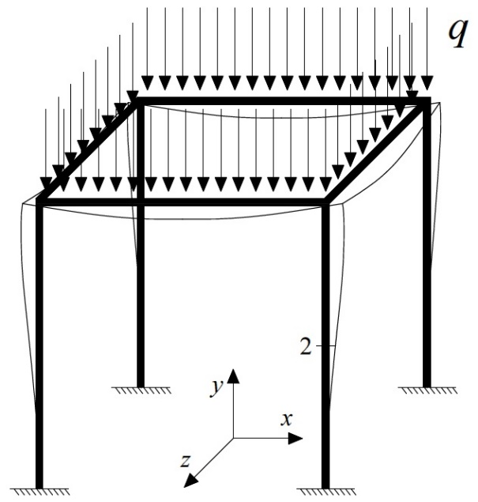
Figure 1.2 - Symmetrically loaded symmetric space frame.
The inverse slope of “v_{2x} versus v_{2x}/q” diagram yields the global buckling load in X-direction q_{crEx} of the structure, as symmetrically loaded symmetric space frames can buckle symmetrically in the horizontal directions X and Z. Therefore, the function of Southwell’s method takes the following form:

(1.25)

where v_{02x} is the initial lateral mid-span deﬂection in X-direction (imperfection) of the column measured in the experiment.
Likewise, for a generically loaded generic space structure, showed in Fig. 1.3, “v_{y} versus v_{y}/P” diagram may be considered the “Southwell plot”, where v_{y} is the vertical mid-span displacement of one beam under compression forces (corresponding to the section n. 2) and P is the external load.

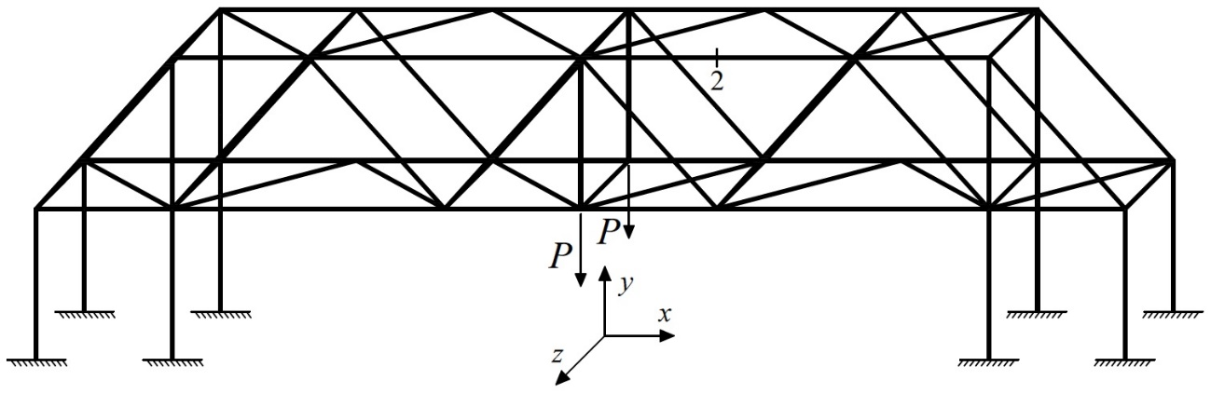
Figure 1.3 - Generically loaded generic space structure.
The inverse slope of “v_{2y} versus v_{2y}/P” graph yields the global buckling load P_{crEy} of the structure in the same Y-direction of the load P, as this loaded space structure buckles in the vertical X-Y plane (I mode of buckling). Consequently, the function of Southwell’s method becomes as follow:

(1.26)

where v_{02y} is the initial vertical mid-span deﬂection (imperfection) measured in the test of the beam considered.
Aim of this work is to present the Southwell’s method as universal non-destructive technique for the global buckling load determinations of space frame systems, useful for preventing damage due to plastic bending. The in-situ application could be necessary to verify a restoration project or to ascertain how far the construction is to buckling because, for example, of the uncertainties regarding the existing dead loads.
Moreover, through the global buckling load value, it is possible to obtain the buckling load of the single structural elements using a finite element model and knowing the elastic and geometric properties of the entire structure. Buckling loads of beam-columns belonging to space frame systems are parameters of the simplified formula of Timoshenko and Gere (1961) and Bazant and Cedolin (1991), and of the simplified formula of Galef (1968).

Simplified formula of the second-order displacements of Timoshenko & Gere (1961) and Bazant & Cedolin (1991)
In making preliminary design computations, it is frequently useful to have an approximate formula for determining the mid-span displacement of a beam-column. Timoshenko and Gere (1961) and Bazant and Cedolin (1991) proposed a simplified formula (1.28) where the second-order deflection v_{tot} is equal to the product of two terms: the first one is the first-order deflection v_{I} (without compressive axial load), while the second one is an amplification factor (1.27) which depends upon the N_{x}/N_{crE} ratio, where N_{x} is the compression force of the beam-column and N_{crE} is the effective axial buckling load. The expression for the amplification factor is

(1.27)

This simplified formula (1.28) can be used with good accuracy in place of the exact (I-order) displacement values v_{I}, if the N_{x}/N_{crE} ratio is not large:

(1.28)

The model of a prismatic beam of length L belonging to a generic structure is considered (Fig. 1.4a). The beam is constrained by two internal fixed ends whose parameters , , (i = 0, 1) are collected by the 2×2 stiffness matrices K₀ and K₁ (Fig. 1.4b). The beam is subjected to a compressive axial force N_{x} and to a concentred lateral load F located at the abscissa x = a (Fig. 1.4a). Elastic modulus E and cross-section second area moment I of each beam element of the entire structure are assumed to be known constants.
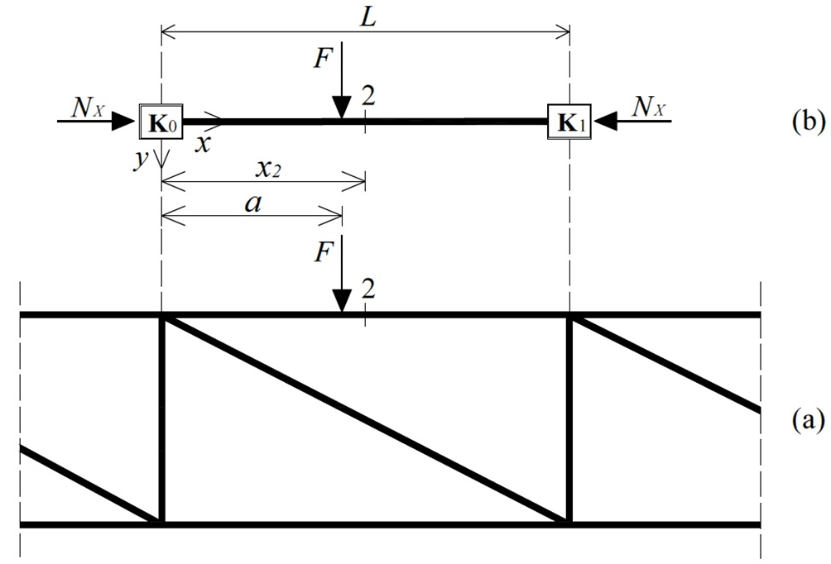
Figure 1.4 - Beam (under compressive axial load) belonging to a truss girder (a) and reference model with location of the instrumented section (b).

Axial load identification making use of one displacement
Subsequent to the application of a lateral load F, one vertical displacement v_{tot} = v(x_{i}) for i = 2 (Fig. 1.4) is recorded. In order to identify the compression force N_{x}, the simplified formula (1.28), after some simple algebraic manipulations, becomes:

(1.29)

where, N_{crE} is the buckling load of the beam under examination and v_{I} = v(x_{i}) is the first-order vertical displacement for i = 2 when the load F is applied at the same section x = a of the experimental test. Buckling load N_{crE} may be determined experimentally making use of Southwell’s method (Singer et al. 2000), described in Section 1.3, or analytically through a finite element model of the entire structure. Conversely, first-order displacement v_{I} must to be calculated analytically only, since it is impossible to measure the deflection of the beam in-situ when the structure is axially unloaded.
In summary, the axial force estimation must conform to the following procedure:
- evaluate the mid-span displacement v₂ due to a bending test, by applying a load F in the element span;
- determine, analytically or experimentally, the buckling load N_{crE};
- calculate analytically the first-order mid-span displacement considering the magnitude and position of the load F of the in-situ test;
- find the compression force N_{a} = N_{x} using Eq. (1.29).

Proposed static method
The end constraints of a beam may be often known as, for example, the case of a pre-stressed beam belonging to a bridge deck. The length of these simply supported beams may be measured in-situ due to the finite dimensions of the end joints, or extrapolated from the design computations of the bridge. The new static method’s formulation is developed based on a prismatic beam of length L pinned at both ends (Fig. 1.5). The beam is subjected to a compressive axial force N_{x} and to a lateral load F at the abscissa x = a (Fig. 1.5). Elastic modulus E and cross-section second area moment I are assumed to be known constants.

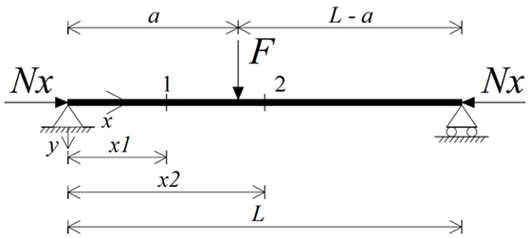
Figure 1.5 - Reference beam model with location of the instrumented sections.
Substituting Eq. (1.29) into the formula of the non-dimensional axial force n= N_{x}L²/EI, parameter n may be expressed depending on the buckling load N_{crE} of the beam:

(1.30)

where v_{I} and v_{tot} are the first- and second-order displacement, respectively, measured at the same cross section along the element span.
Consequently, substituting the Euler’s formula of buckling load for the simply supported beam (1.31):

(1.31)

into the formula (1.30), the non-dimensional axial force n can be obtained depending on the displacements v_{I} and v_{tot} and parameter as follow:

(1.32)

The proposed static approach could be suitable for any beam with any boundary conditions if the bucking length of the beam is considered in the Euler's formula (Eq. 1.31).

Axial load identification making use of one displacement
The first-order displacement v_{I} may be calculated at any given cross section of the beam length using the formulas of the elastic theory.
Subsequently, substituting, for example, the equation of the first-order mid-span deflection v_{I} of the simply supported beam subjected to a lateral load F at the mid-span x = x₂ (1.33):

(1.33)

into Eq. (1.32) yields:

(1.34)

where ψ = FL³/EI is the load parameter that has a length dimension.
From the experimental point of view, in order to identify the compressive non-dimensional axial force n, the load F application at the mid-span x = x₂ and the subsequent measurement of the displacement v_{tot} = v(x_{i}) for i = 2 (Fig. 1.5) are required. In fact, considering the beam as simply supported, equation (1.34) is able to provide the non-dimensional axial force n corresponding to the experimental values of ψ and v₂.
If the load F is kept applied at the mid-span, the equation of the first-order displacement v_{I} at a quarter of the span of the simply supported beam is:

(1.35)

Substituting this equation (1.35) into Eq. (1.32) yields:

(1.36)

where ψ = FL³/EI is the load parameter.
In this case, the load F at the mid-span and the subsequent measurement of the displacement v_{tot} = v(x_{i}) for i = 1 (Fig. 1.5) are required for estimating the non-dimensional axial force n.
The analytical procedure may be also developed when the lateral load F applied at other sections along the span, underlining that the first-order displacement v_{I} inserted analytically and the experimental displacement v_{tot} must be referred at the same cross section.
In summary, the axial load estimation must conform to the following steps:
- evaluate the displacement v₂ or v₁ due to a bending test;
- obtain the unknown constant n from equation (1.34) or (1.36) using the displacement v₂ or v₁ and the expression for ψ ;
- find the analytical value N_{a} = n EI/L² of the compression force.

Axial load identification making use of more than one displacement
The expressions (1.34) and (1.36) may be also used together, performing the experimental measurements v₂ and v₁ in the same time. Considering the unknowns as different parameters, the expressions, cited therein, become:

(1.37)
and
(1.38)

From the average of the parameters n₁ and n₂:

(1.39)

the constant n _{mean} is determined (Eq. 1.39), able to estimate the compression force of the simply supported beam.
The parameter n _{mean} may be certainly calculated from the average of several parameters n_{i} for i = 1, …, n, obtained by measuring the displacements v_{tot} = v(x_{i}) for i = 1, …, n and applying the load F at different sections along the span.
In brief, making use of two deflections, the identification process must conform to the following steps:
- evaluate the displacements v₁ and v₂ due to a bending test;
- obtain the unknown constants n₁ and n₂ from equations (1.38) and (1.37) using the displacements v₁ and v₂ and the expression for ψ ;
- calculate the average parameter n _{mean} ;
- find the analytical value N_{a} = n _{mean} EI/L² of the compression force.

Simplified formula of the first natural frequency of Galef (1968)
Galef (1968) developed an approximate relation between the buckling load and natural frequency which holds true for most single span boundary conditions of Euler-Bernoulli beams, useful to study the dynamic behavior of beam-columns under compressive axial forces.
The approximate formula has the following form:

(1.40)

where, ω_{I} and ω_{0I} are the first natural frequency of the axially loaded and unloaded beam-column, respectively, while N_{x} is the compression force presents in the element and N_{crE} is the corresponding buckling load.
This work extends the formula (1.40) for estimating the pre-stress losses in pre-stressed beams. The procedure based on vibration measurements has been proposed recently as non-destructive method by Bonopera et al. (2015).
For this purpose, the prismatic beam model of length L pinned at both ends (Fig. 1.6b) is considered again, as for the method’s formulation in Section 1.5. The beam is obviously subjected to a compressive axial force N_{x} (Fig. 1.6b), and elastic modulus E and cross-section second area moment I are considered to be known constants.

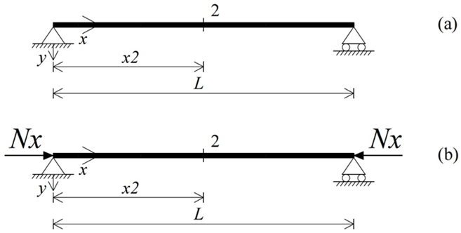
Figure 1.6 - Reference axially unloaded beam (a) and reference axially loaded beam (b) models with location of the instrumented section.
Subsequently, the first natural frequencies of the axially unloaded beam ω_{0Ii} = ω_{0I} (x_{i}) and of the axially loaded beam ω_{Ii} = ω_{I} (x_{i}) are recorded for i = 2 (Figs. 1.6a and 1.6b, respectively). After simple algebraic manipulations, the simplified formula (1.40) is able to identify the compression force N_{x}:

(1.41)

where, the buckling load N_{crE} of the beam can be determined analytically or experimentally making use of Southwell’s method (Singer et al. 2000), described in Section 1.3.
In summary, the axial load estimation of a beam with known boundary conditions is obtained with the following steps:
- evaluate the first natural frequency of the axially unloaded beam ω_{0I} through a vibration test;
- evaluate the first natural frequency of the axially loaded beam ω_{I} through a vibration test;
- determine, analytically or experimentally, the buckling load N_{crE};
- obtain the analytical value N_{a} = N_{x} of the compression (or pre-stress) force by Eq. (1.41).

Discussion and conclusions
The four non-destructive techniques were presented, which allow to evaluate the axial (or pre-stress) forces in structural members of space frame systems.
Southwell’s method (Singer et al. 2000) is extended for the first time as non-destructive technique for the global buckling load evaluations of regular space frames and generic space structures.
The method proposed by Tullini (2013) and the proposed method make use of experimental parameters only. Conversely, the simplified formula of Timoshenko and Gere (1961) and Bazant and Cedolin (1991) requires the analytical calculation of the first-order displacement v_{I} when the procedure is applied to generic space structures. Chapter 3 will show that the experimental displacement measurement v_{I} may be possible for columns of regular space frames during the construction process.
One constant of the simplified formula of Galef (1968) is the first natural frequency of the axially unloaded beam. This parameter can be easily determined experimentally during the construction process when, for example, the pre-stress force of a bridge beam has not been still applied, but this test operation is practically impossible for bridge decks in-situ. For pre-stressed beams of existing bridges, the first natural frequency of the axially unloaded beam must be calculated analytically.
The subsequent chapters will show all techniques developed by analytical simulations and tested on pre-stressed specimens and space prototypes in the laboratory.

Identification of the pre-stress force in prismatic beams

Introduction
Chapter 2 presents principally analytical and experimental identifications of pre-stress forces using every non-destructive method proposed and described in Chapter 1. The procedures provide efficient solutions within the Structural Health Monitoring field, because the comparison between applied and estimated pre-stress forces becomes direct measure of the level of reliability for pre-stressed beams, in terms of pre-stress loss determinations.
Section 2.2 reports some simply supported beams with different slenderness, selected to reproduce ideal boundary conditions of common pre-stressed bridge beams. The effectiveness of the method proposed by Tullini (2013) was tested by several numerical tests.
Section 2.3 illustrates mainly the experimental identifications obtained from a post-tensioned concrete specimen. Test simulations of the proposed methods were also executed on a post-tensioned steel specimen, as reported in Section 2.4. All experiments on the specimens were developed at the National Center for Research on Earthquake Engineering (NCREE) in Taipei, Taiwan, with the displacement measurements at given sections of the deflected spans by Fiber-Bragg-grating differential settlement measurement sensors (FBG-DSM) for the first time in the laboratory.

Compressive axial load identifications by means of the method proposed by Tullini (2013)
Some simply supported beams are reported in this section. They are relevant from the structural point of view and pinned supports were selected to reproduce ideal boundary conditions of common pre-stressed beams. The robustness of the method proposed by Tullini (2013) was tested by several numerical tests showing beams with different slenderness values.
Adopting Euler-Bernoulli beam model, this section shows that, if geometric and elastic properties are known, the compressive axial force (compression forces are assigned negative sign) may be deduced by a set of flexural displacements recorded at given sections along the beam length, after applying the transversal force.

Preliminary numerical tests on slender prismatic beams
Simply supported beams with different slenderness were necessary for preliminary numerical tests. The aim was to verify the robustness of the method applied on prismatic beams either with known or unknown boundary conditions. In fact, the method’s simulations, presented in Rebecchi (2011), Tullini et al. (2012) and Tullini (2013), were only performed on a tie-rod under different tensile forces.
The numerical results of three beams, shown in the following sections, gave excellent agreements between estimated N_{a} and assumed compressive axial forces N_{x}.

Simply supported beams with known boundary conditions

Exact identifications
Three simply supported beams with 100x50x3 mm rectangular hollow section and known boundary conditions are reported, having slenderness of 250, 173 and 134 (Case I, II and III), respectively. The lateral load F applied at the mid-span was 80 N and 160 N, while elastic modulus of steel E was 206 GPa. Two test configurations were considered for each beam (Figs. 2.1, 2.2 and 2.3): three-point bending test with three- and five-displacement measurements.
Three-point bending test with three- measurements made use of Eq. (1.19), reduces to Eq. (10) in Tullini et al. (2012) as v₀ = v₄ = 0, and three-point bending test with five- measurements utilized the process showed in Section 1.2.2, respectively. Then, compressive axial loads N_{a} were achieved from Eq. (1.19) and the process of Section 1.2.2 using the exact parameter values v₀, v₁, v₂, v₃, v₄ and ψ. The constant L was considered to be equal to the beam lengths in the analytical value N_{a} = n EI/L².

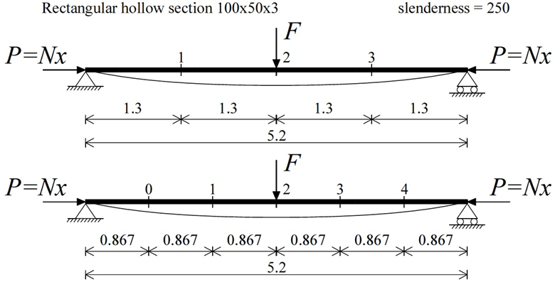
Figure 2.1 - Case I - Slenderness = 250. Three-point bending test with three- (above) and five-measurements (below). Units: m.
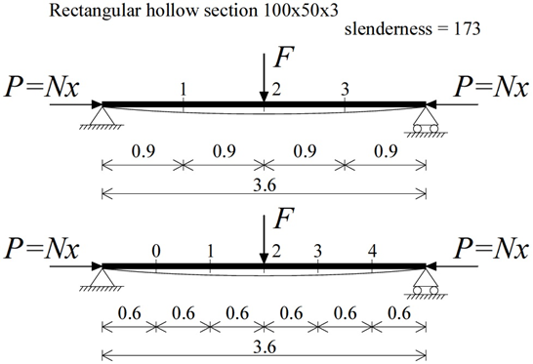
Figure 2.2 - Case II - Slenderness = 173. Three-point bending test with three- (above) and five-measurements (below). Units: m.
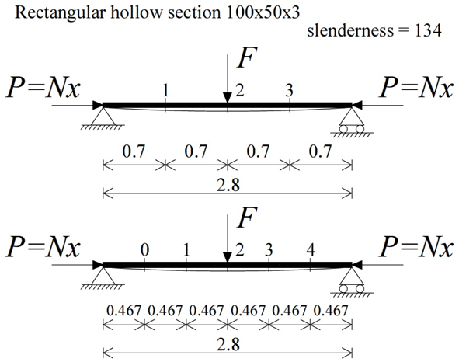
Figure 2.3 - Case III - Slenderness = 134. Three-point bending test with three- (above) and five-measurements (below). Units: m.
The displacement parameters v_{i} = v(x_{i}) for i = 0, 1, 2, 3, 4 (Figs. 2.1, 2.2 and 2.3) subjected to each load F were imposed using the analytical solutions (2.1 and 2.2) of the simply supported beam (Timoshenko and Gere, 1961, Bazant and Cedolin, 1991). The tolerance of the displacements was 0.000001 mm.

for 0 ≤ x ≤ a (2.1)
for a ≤ x ≤ L (2.2)

The value L is the total length of the simply supported beam, a = L/2 as the force F is applied at the mid-span and n = N_{x}/EI. Recalling that , it can be easily verified that a null denominator occurs in Eqs. (2.1) and (2.2) for a compressive axial force n = −π², which is the non-dimensional value of the classical Euler buckling load.
Once the parameters v₀, v₁, v₂, v₃, v₄ obtained, a set of estimated compressive axial loads N_{a} was achieved for each test configuration of the simply supported beams as follow:
- 5 estimated axial loads N_{a} for the beam with slenderness equal to 250 (Fig. 2.4);
- 10 estimated axial loads N_{a} for the beam with slenderness equal to 173 (Fig. 2.5);
- 15 estimated axial loads N_{a} for the beam with slenderness equal to 134 (Fig. 2.6).

Figure 2.4 - Case I - Slenderness = 250. Comparison between estimated (N_{a}) and assumed (N_{x}) values of compressive axial forces.

Figure 2.5 - Case II - Slenderness = 173. Comparison between estimated (N_{a}) and assumed (N_{x}) values of compressive axial forces.

Figure 2.6 - Case III - Slenderness = 134. Comparison between estimated (N_{a}) and assumed (N_{x}) values of compressive axial forces.
The procedure of the test configurations simulated is outlined in Section 1.2.1.
Figs. 2.4, 2.5 and 2.6 show the comparison between the estimated values N_{a} and the assumed values N_{x} of the compression forces. The method proposed by Tullini (2013) is not affected by model errors if the identiﬁcation algorithms make use of the parameters v₀, v₁, v₂, v₃, v₄ and ψ having very high accuracy.

Sensitivity analyses compared to the slenderness
Sensitivity analyses were developed for verifying the robustness of the method compared to the beam slenderness.
The simply supported beams, reported in Section 2.2.1.1.1, are reconsidered. The load F assigned at the mid-span were 40 N, 80 N and 160 N. The same test configurations (Figs. 2.1, 2.2 and 2.3) were taken into account for each beam again: three-point bending test with three- and five-displacement measurements.
In this case, compressive axial loads N_{a} were obtained from Eq. (1.19) and process showed in Section 1.2.2 by the parameters v₀, v₁, v₂, v₃, v₄, and F alternatively modified by adding +0.01 and -0.01 for reproducing possible experimental errors. The load F is a constant of load parameter ψ = FL³/EI.
In specific, the displacements v_{i} = v(x_{i}) for i = 0, 1, 2, 3, 4 (Figs. 2.1, 2.2 and 2.3), subjected to each load F modified, were already imposed alternatively modified by adding +0.01 and -0.01, after using the solutions (2.1 and 2.2) of the simply supported beam (Timoshenko and Gere, 1961, Bazant and Cedolin, 1991). The tolerance was 0.01 mm.
In general, the above operation gave rise to:
- 16 different combinations of simulated experimental values for 10 distinct assumed axial forces N_{x}, regarding to three-point bending test with three- measurements;
- 64 different combinations of simulated experimental values for 10 distinct assumed axial forces N_{x}, regarding to three-point bending test with five- measurements.
As shown in Figs. 2.7, 2.8 and 2.9, both combination sets were achieved for each beam giving rise respectively to:
- 16 estimated axial loads N_{a} for 10 distinct axial forces N_{x}, regarding to three-point bending test with three- measurements;
- 64 estimated axial loads N_{a} for 10 distinct axial forces N_{x}, regarding to three-point bending test with five- measurements.

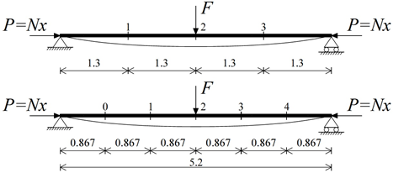
Figure 2.7 - Case I - Slenderness = 250. Comparison between the worst estimated values (N_{a}) and the assumed values (N_{x}) of axial forces for the beam loaded with different load (F) values.

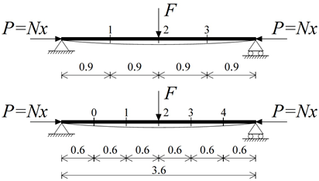
Figure 2.8 - Case II - Slenderness = 173. Comparison between the worst estimated values (N_{a}) and the assumed values (N_{x}) of axial forces for the beam loaded with different load (F) values.

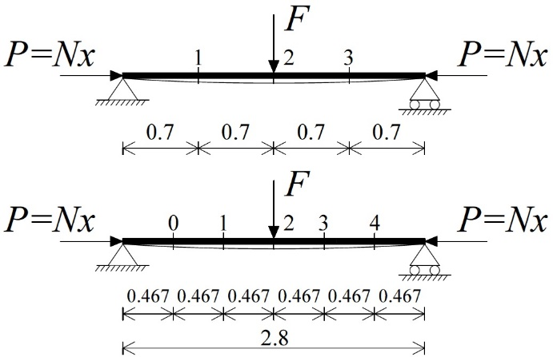
Figure 2.9 - Case III - Slenderness = 134. Comparison between the worst estimated values (N_{a}) and the assumed values (N_{x}) of axial forces for the beam loaded with different load (F) values.
Elastic modulus E of steel was assumed to be constant in all simulations. As already shown in Tullini (2013), estimated values N_{a} of the axial force are quite insensitive to the bending rigidity EI, in fact, the difference in the values of N_{a} is less than the corresponding variation imposed to EI.

Table 2.1 - Simply supported beams with known boundary conditions. Sensitivity analysis results in terms of the determination of estimated values (N_{a}).
Figs. 2.7, 2.8 and 2.9 show the comparison on the compression force between the worst estimated values N_{a} and the assumed values N_{x}. Table 2.1 summarizes the sensitivity analysis results in terms of the determination of values N_{a} corresponding to the maximum assumed axial load N_{x}. Case I configuration furnishes the best approximation of the estimated axial force, in fact, the estimated values N_{a} report a maximum error in terms of absolute value of 3.2%. Case II yields good estimates as well; vice versa, Case III gives unreliable results, except when the greatest load F is applied. Therefore, the best identifications were obtained by increasing the number of sensors to five and applying the greatest load F. Moreover, the beam with the highest slenderness has provided excellent estimations.
The greatest possible distance between each sensor was adopted, in fact, for a simply supported steel rod instrumented with three equally spaced sensors, Tullini et al. (2012) showed that the maximum error is less than 6.0% over the entire investigated range.

Simply supported beams with unknown boundary conditions

Exact identifications
The simply supported beams in Section 2.2.1.1.1 are regarded with unknown boundary conditions (Case I, II and III). The load F applied at the mid-span was 80 N and 160 N, while elastic modulus of steel E was 206 GPa. Three-point bending test with five- and seven-displacement measurements were considered for each beam (Figs. 2.10, 2.11 and 2.12) as able to identify the axial loads in elements with unknown boundary conditions.
Three-point bending test with five- measurements made use of Eq. (1.19) and three-point bending test with seven- measurements utilized the process of Section 1.2.2, respectively. Then, compression forces N_{a} were achieved from Eq. (1.19) and the process of Section 1.2.2 by the exact parameter values v₀, v₁, v₂, v₃, v₄, v₅, v₆ and ψ. In this case, constant L is the distance between the extreme sensors and was always considered less than the beam lengths, as end constraints were assumed unknown. L is parameter of N_{a} = n EI/L² of the identification processes (Sections 1.2.1, 1.2.2).

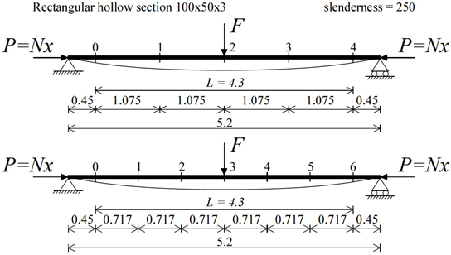
Figure 2.10 - Case I - Slenderness = 250. Three-point bending test with five- (above) and seven-measurements (below). Units: m.

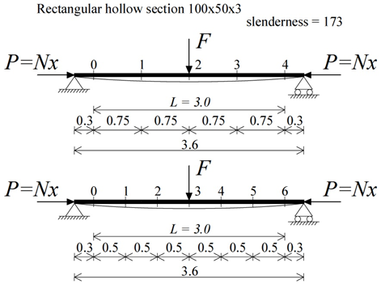
Figure 2.11 - Case II - Slenderness = 173. Three-point bending test with five- (above) and seven-measurements (below). Units: m.

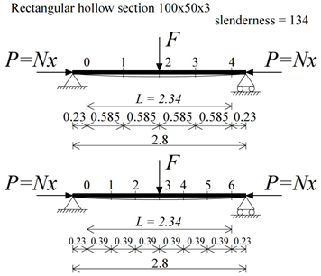
Figure 2.12 - Case III - Slenderness = 134. Three-point bending test with five- (above) and seven-measurements (below). Units: m.
The displacements v_{i} = v(x_{i}) for i = 0, 1, 2, 3, 4, 5, 6 (Figs. 2.10, 2.11 and 2.12), subjected to each load F, were imposed using the analytical solutions (2.1 and 2.2) of the simply supported beam (Timoshenko and Gere, 1961, Bazant and Cedolin, 1991). The tolerance of the displacements was 0.000001 mm.
Once the parameters v₀, v₁, v₂, v₃, v₄, v₅, v₆ achieved, a set of estimated axial loads N_{a} was obtained for each test configuration of the simply supported beams:
- 5 estimated axial loads N_{a} for the beam with slenderness = 250 (Fig. 2.13);
- 10 estimated axial loads N_{a} for the beam with slenderness = 173 (Fig. 2.14);
- 15 estimated axial loads N_{a} for the beam with slenderness = 134 (Fig. 2.15).

Figure 2.13 - Case I - Slenderness = 250. Comparison between estimated (N_{a}) and assumed (N_{x}) values of compressive axial forces.

Figure 2.14 - Case II - Slenderness = 173. Comparison between estimated (N_{a}) and assumed (N_{x}) values of compressive axial forces.

Figure 2.15 - Case III - Slenderness = 134. Comparison between estimated (N_{a}) and assumed (N_{x}) values of compressive axial forces.
Figs. 2.13, 2.14 and 2.15 show the comparison between the estimated values N_{a} and the assumed values N_{x} of compression forces. The method is also not affected by model errors if the identiﬁcation process examines beam members with unknown boundary conditions.

Sensitivity analyses compared to the slenderness
Sensitivity analyses were also carried out for verifying the method applied on beams with unknown end constraints.
The load F applied at the mid-span were 40 N, 80 N and 160 N. Three-point bending test with five- and seven-displacement measurements (Figs. 2.10, 2.11 and 2.12) were taken into account for each beam again.
Compressive axial loads N_{a} were obtained from Eq. (1.19) and process of Section 1.2.2 using the parameters v₀, v₁, v₂, v₃, v₄, v₅, v₆, and F alternatively modified by adding +0.01 and -0.01. The load F is a constant of the load parameter ψ.
In particular, the displacements v_{i} = v(x_{i}) for i = 0, 1, 2, 3, 4, 5, 6 (Figs. 2.10, 2.11 and 2.12), subjected to each load F modified, were already imposed alternatively modified by adding +0.01 and -0.01, after making use of the solutions (2.1 and 2.2) of the simply supported beam. The tolerance was 0.01 mm.
The above operation gave rise in general to:
- 64 different combinations of simulated experimental values for 10 distinct assumed axial loads N_{x}, regarding to three-point bending test with five- measurements;
- 256 different combinations of simulated experimental values for 10 distinct assumed axial loads N_{x}, regarding to three-point bending test with seven- measurements.
Both combination sets were obtained for each beam giving rise respectively to (Figs. 2.16, 2.17 and 2.18):
- 64 estimated axial loads N_{a} for 10 distinct axial forces N_{x}, regarding to three-point bending test with five- measurements;
- 256 estimated axial loads N_{a} for 10 distinct axial forces N_{x}, regarding to three-point bending test with seven- measurements.

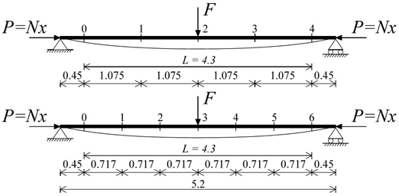
Figure 2.16 - Case I - Slenderness = 250. Comparison between the worst estimated values (N_{a}) and the assumed values (N_{x}) of axial forces for the beam loaded with different force (F) values.

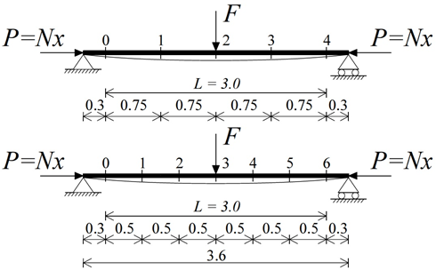
Figure 2.17 - Case II - Slenderness = 173. Comparison between the worst estimated values (N_{a}) and the assumed values (N_{x}) of axial forces for the beam loaded with different force (F) values.

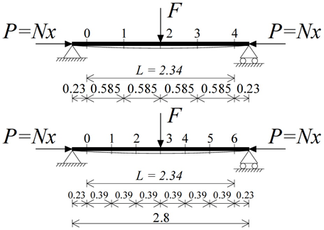
Figure 2.18 - Case III - Slenderness = 134. Comparison between the worst estimated values (N_{a}) and the assumed values (N_{x}) of axial forces for the beam loaded with different force (F) values.
Figs. 2.16, 2.17 and 2.18 show the comparison on the compressive axial force between the worst estimated values N_{a} and the assumed values N_{x}.

Table 2.2 - Simply supported beams with unknown boundary conditions. Sensitivity analysis results in terms of the determination of estimated values (N_{a}).
Table 2.2 summarizes the sensitivity analyses in terms of the determination of values N_{a} corresponding to the maximum assumed axial force N_{x}. The best configuration is still Case I, in fact, the estimated values N_{a} report a maximum error in terms of absolute value equal to 8.0%. Case II gave good estimates when the greatest load F applied; vice versa, Case III yielded unreliable results. When the end constraints are unknown, the increase of the number of sensors to seven and the application of a larger load F are conditions required. Moreover, the greatest possible distance between the extreme sensors is suggested.
The determination of the values N_{a} becomes more unreliable with a smaller member slenderness, either with known or unknown boundary conditions.

Post-tensioned concrete specimen A
Section 2.3 presents principally the experimental results of the pre-stress load identifications by the static procedures, illustrated in Chapter 1, on a post-tensioned concrete specimen with pinned supports to reproduce ideal boundary conditions of a common bridge beam.
After verifying the preliminarily robustness of the method proposed by Tullini (2013), a set of experiments were performed on the concrete specimen in the laboratory of the National Center for Research on Earthquake Engineering (NCREE) in Taipei, Taiwan.

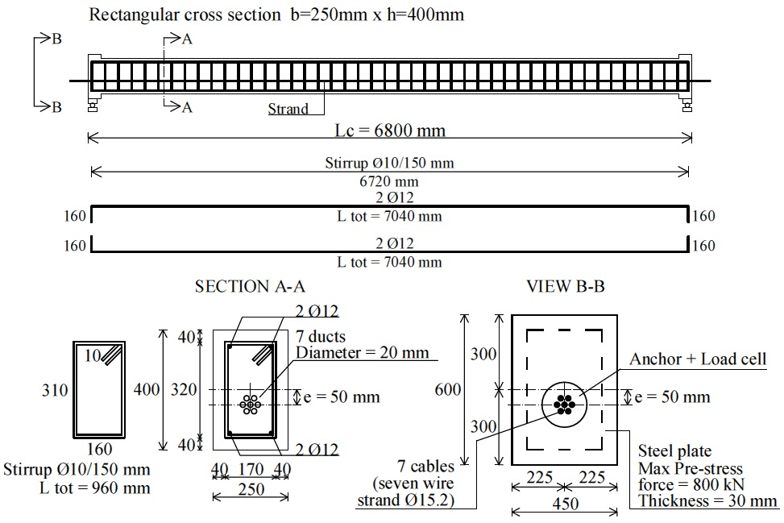
Figure 2.19 - Reinforcement drawing of the post-tensioned concrete specimen A. Units: mm.

The concrete specimen was designed with length of 6.8 m and 250x400 mm (b x h) rectangular cross section (Fig. 2.19). It was cured for 28 days under room temperature after its casting. Compressive strength f_{ck} and elastic modulus E were experimentally evaluated with time during each day of the test executions (and after 28 days of curing), according to Eurocode 2 (Eurocode 2, 2005), as illustrated in Section 2.3.2.

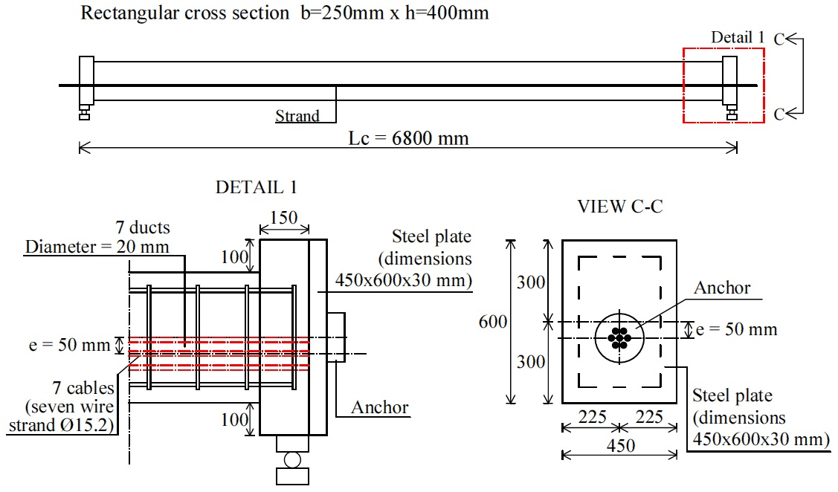
Figure 2.20 - Detail of the beam end of post-tensioned concrete specimen A. Units: mm.
The strand has eccentricity of 50 mm and is composed of seven tendons “seven wire strand” with diameter of 15.2 mm, able to flow inside seven respective plastic ducts remained ungrouted (Fig. 2.22). Ultimate yield strength of the tendons is 1860 MPa. Two 450x600x30 mm steel plates were embedded at the beam ends for eliminating any cracks of the concrete in the serviceability limit state, in order to resist the high pre-stress forces (Fig. 2.20).

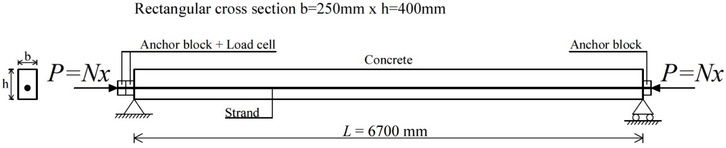
Figure 2.21 - Scheme of the post-tensioned concrete specimen A. Units: mm.
The specimen was inserted in a test frame using a test rig (Fig. 2.23). At one end, a hydraulic oil jack with force capacity of 4000 kN was adopted to assign the pre-stress loads, and one 1000 kN load cell with accuracy of 2 mV/V was placed at the other end (Fig. 2.24). Pre-stress step loads P were assigned to the specimen for a total of three values of 626.0 kN, 696.0 kN and 843.0 kN, when the bending tests applied respect to the strong axis (Fig. 2.27). The lateral load F was applied through a hydraulic actuator, having force capacity of 25.0 kN, at the mid-span with values of around 20.0 kN, 22.5 kN and 25.0 kN (due to the tolerance device), as depicted in Fig. 2.25. Conversely, when the static tests applied respect to the weak axis (Fig. 2.27), pre-stress step forces P were assigned with values of 556.0 kN, 631.0 kN and 684.0 kN, and the load F with magnitude of around 5.0 kN, 7.5 kN and 10.0 kN, always at the mid-span. The concrete beam was always preserved in the elastic range during the static tests. Moreover, in order to create pinned-end constraints, two additional supports were introduced at the beam ends (Fig. 2.26), creating in this way a clear span L equal to 6.7 m (Fig. 2.21).

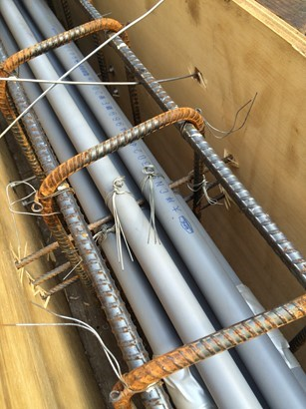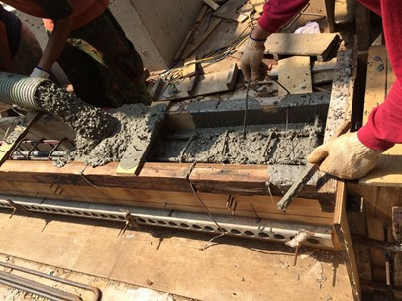
Figure 2.22 - PVC ducts of the tendons (left) and cast of the post-tensioned concrete specimen A (right).
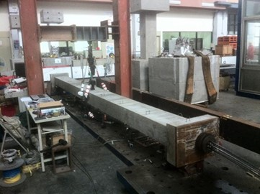
Figure 2.23 - Test rig for the experimental static tests.
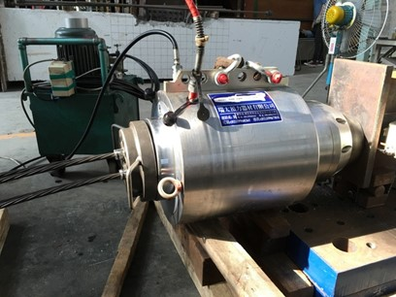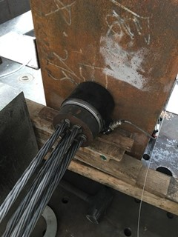
Figure 2.24 - Hydraulic oil jack (left) and load cell at the other end (right) of the concrete specimen A.
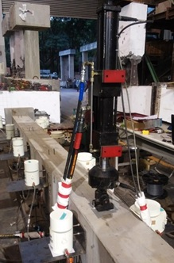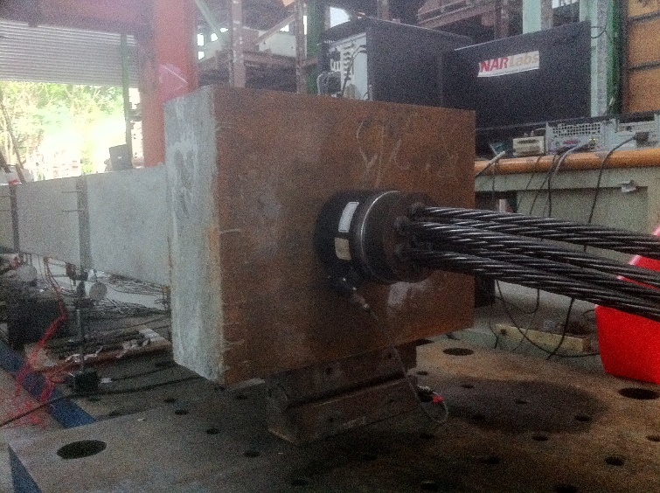
Figure 2.25 - Hydraulic actuator at the mid-span (left), and anchor block and load cell at the beam end after applying the pre-stress force (right).
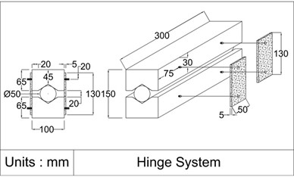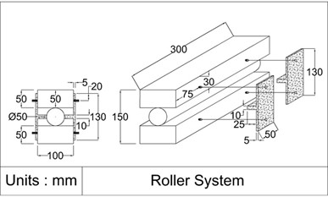
Figure 2.26 - Hinge (left) and roller support (right) for the creation of pinned-end constraints. Units: mm.
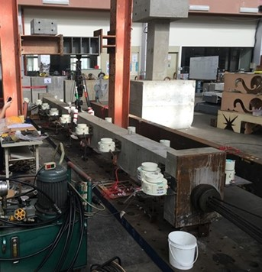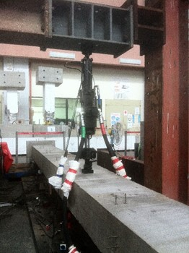
Figure 2.27 - View of the bending tests respect to the strong (left) and the weak axis (right) of concrete specimen A.
Then, the corresponding displacements v_{i} = v(x_{i}) of the deflected shape of the span were short-term measured. In short, four test configurations were carried out as follow:
- Case I: three-point bending test with seven- measurements respect to the strong axis, considering the known boundary conditions (Fig. 2.28);
- Case II: three-point bending test with seven- measurements respect to the strong axis, considering the unknown boundary conditions (Fig. 2.29);
- Case III: three-point bending test with seven- measurements respect to the weak axis, considering the known boundary conditions (Fig. 2.31);
- Case IV: three-point bending test with seven- measurements respect to the weak axis, considering the unknown boundary conditions (Fig. 2.32).

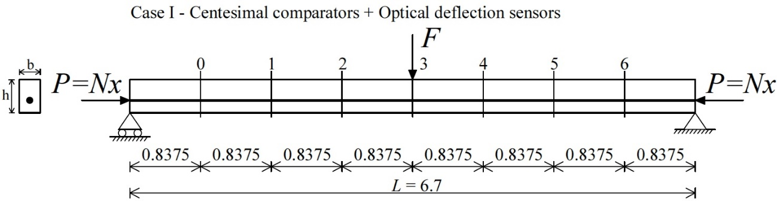
Figure 2.28 - Case I. Experimental test setup with location of the instrumented sections of centesimal comparators and “FBG-DSM”. Units: m.

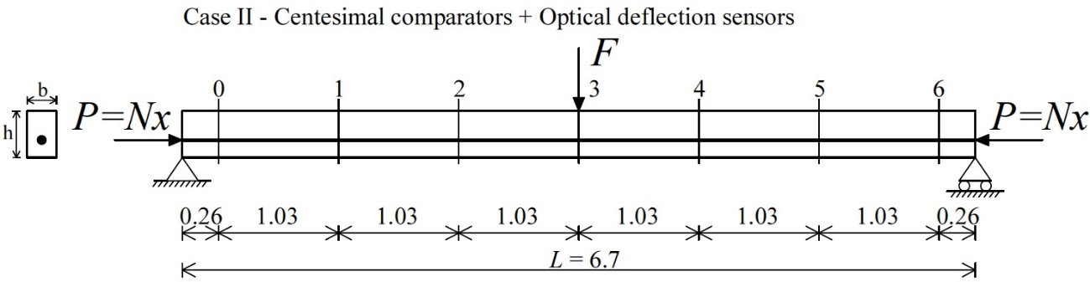
Figure 2.29 - Case II. Experimental test setup with location of the instrumented sections of centesimal comparators and “FBG-DSM”. Units: m.
Cases I and II (Figs. 2.28, 2.29) were concurrently performed, as showed in Fig. 2.30, measuring in total fourteen displacements v_{i} = v(x_{i}) with centesimal comparators, having accuracy of 0.01 mm, and Fiber-Bragg-grating differential settlement measurement sensors (FBG-DSM). Seven centesimal comparators and seven “FBG-DSM” were fixed at the same cross sections i = 0, 1, 2, 3, 4, 5, 6 in one side of the beam (Case I), respectively, while other seven centesimal comparators and seven “FBG-DSM” were always positioned at the same cross sections i = 0, 1, 2, 3, 4, 5, 6, but in the other side of the beam (Case II).
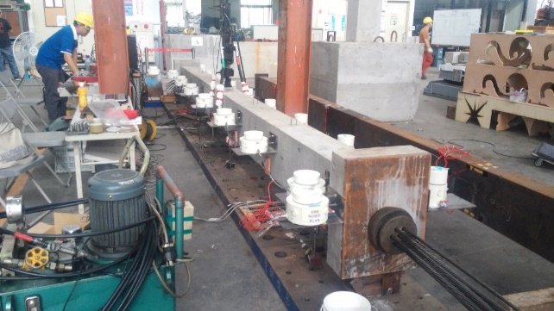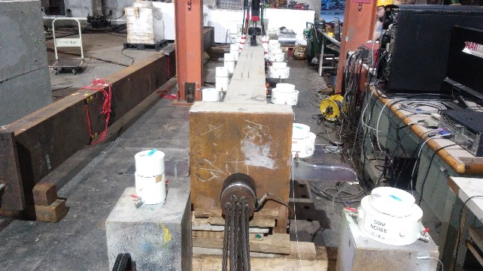
Figure 2.30 - Views of the Case I and II test configurations performed concurrently.
Using this solution, it has been possible to speculate known and unknown boundary conditions of the specimen varying the distance between each sensor, according to the method proposed by Tullini (2013).

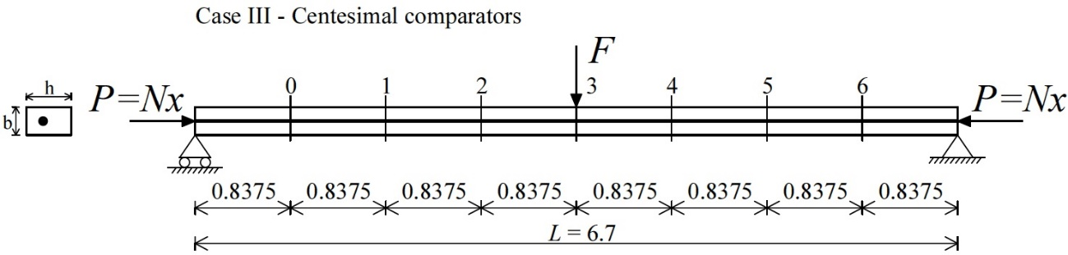
Figure 2.31 - Case III. Experimental test setup with location of the instrumented sections of the centesimal comparators. Units: m.
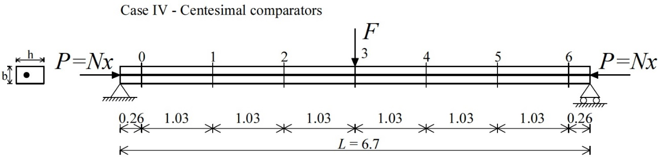
Figure 2.32 - Case IV. Experimental test setup with location of the instrumented sections of the centesimal comparators. Units: m.
Same criteria were used for Cases III and IV (Figs. 2.31, 2.32) performed respect to the weak axis, where the fourteen displacements v_{i} = v(x_{i}) were conversely measured by centesimal comparators only (Fig. 2.33). Seven comparators were positioned in one side of the beam for i = 0, 1, 2, 3, 4, 5, 6 (Case III), respectively, while other seven ones were fixed in the other side for i = 0, 1, 2, 3, 4, 5, 6 (Case IV).

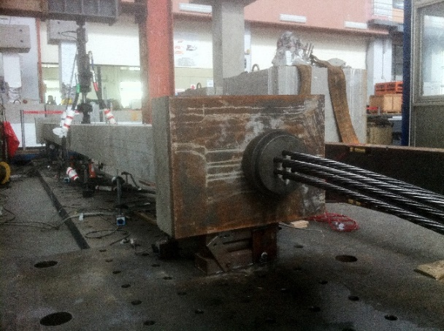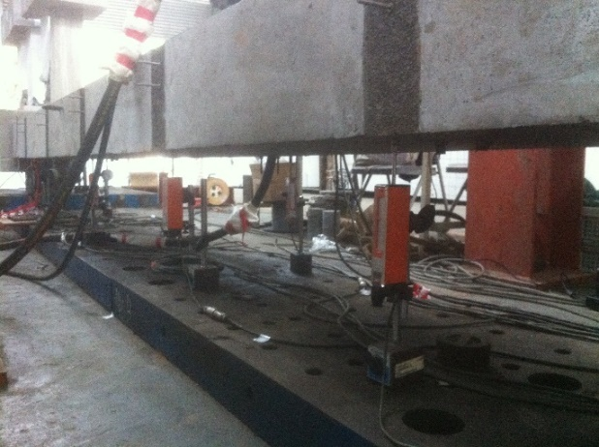
Figure 2.33 - Views of the bending tests respect to the weak axis (left) and arrangement of the centesimal comparators (right).
For each pre-stress force P imposed by hydraulic jack, fourteen vertical displacements v_{i} = v(x_{i}) have been measured for each load F for a time period of around 15 minutes. All instrument data have been recorded with 1 Hz frequency. Load cell, hydraulic actuator, centesimal comparators and “FBG-DSM” were connected to a data logger and to a PC data acquisition system.
The above data records were also obviously used as parameters for the pre-stress force identifications through the proposed method and the simplified formula of Timoshenko and Gere (1961) and Bazant and Cedolin (1991).
It is worth specifying that every single combination of pre-stress force and lateral load P+F did not cause any cracks in the concrete specimen at the serviceability limit state, according to the preliminary calculations in the elastic range.

Measurement of the flexural displacements using Fiber-Bragg-grating differential settlement measurement sensors (FBG-DSM)
As described previously in Section 2.3, Fiber-Bragg-grating differential settlement measurement sensors (FBG-DSM) were utilized for the short-term displacement measurements of the concrete specimen A at given sections (Figs. 2.28, 2.29). The aim has been to provide high-accuracy values since the deflections v_{i} = v(x_{i}) for i = 0, 1, 2, 3, 4, 5, 6 are parameters of the diagnostic techniques.
The innovative “FBG-DSM” device was developed from the National Center for Research on Earthquake Engineering (NCREE) for the real-time monitoring of bridge safety and, currently, NCREE is continually improving the technology for providing new generations of optic-fiber bridge monitoring system.
“FBG-DSM” applications in-situ were carried out for verifying the long-term deflection changes of the multi-span of Dazhi bridge in Zhongshan District of Taipei, Taiwan (Lee 2013), and of Wugu-Yangmei viaduct bridge on the west coast of Taiwan (Lee et al. 2014). Test results showed that girder deflections and design response values were similar and deflections presented an elastic response with no residual reaction.
Therefore, this work involved installing “FBG-DSM” devices in the concrete specimen span to replace conventional operated measurement methods and then obtain reliable displacements. The following sections discuss concepts and applications of the “FBG-DSM” devices in the laboratory of NCREE.

Fiber optic sensing “Bragg gratings”
Optical fibers apply the principle of total reflection to transmit light energy and signals. The optical fibers used for telecommunication are typically single-mode quartz fibers, which yield a light loss rate of approximately 0.2 dB/km and communication band from 1520 to 1580 nm. Optical fibers are a transmission medium and do not have sensing functionality. However, such fibers can be exposed to artificial ultraviolet irradiation to form fiber Bragg gratings (FBG). FBGs are sensing components and thus have sensing functionality (Fig. 2.34).

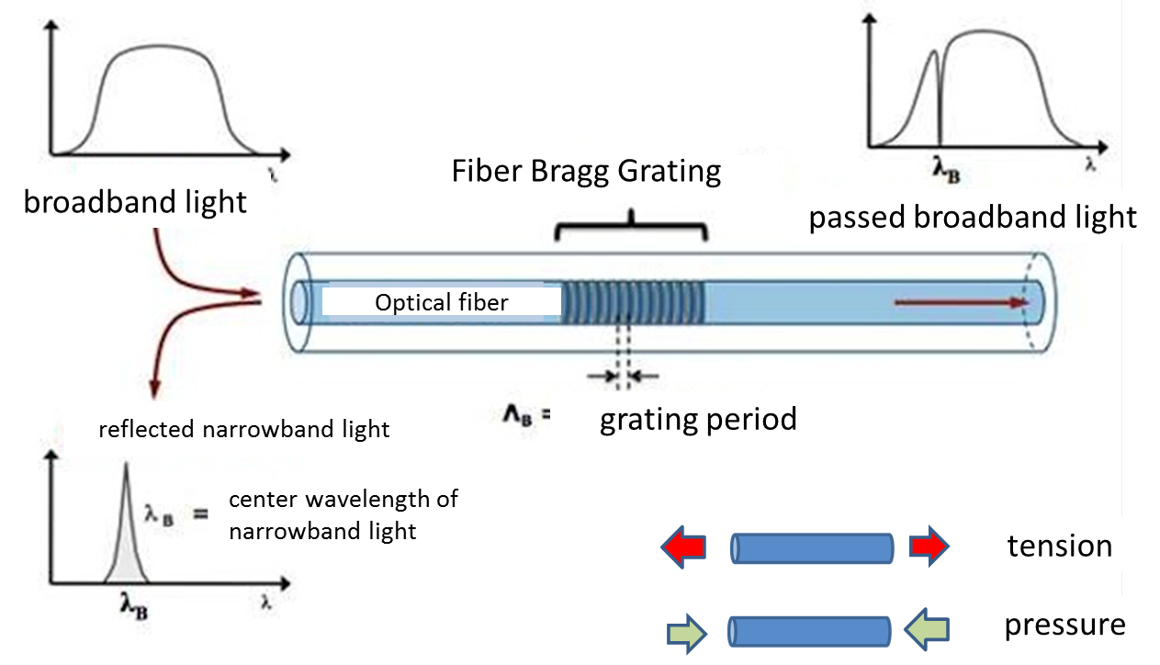
Figure 2.34 - Fiber “Bragg-grating” sensing component.
Broadband light is introduced into one end of the optical fiber, the FBGs reflect specific narrowband light (determined by Grating Period Λ), and the “remaining” broadband light progresses through the fiber. When the FBGs experience tension, the grating periods widen, the center wavelength λB of the reflected narrowband light increases and the spectrum shifts to the right. By contrast, when the FBGs experience pressure, the grating periods shorten, the center wavelength λB of the reflected narrowband light decreases and the spectrum shifts to the left. In addition, the periods between the FBGs change according to the temperature. The material behavior of FBGs when influenced by force or temperature can be mathematically expressed as follows:

(2.3)

where, λ_{B} represents the center wavelength of the reflected narrowband light, Δε represents the response of the gratings under stress, ΔT represents the amount of temperature change of the gratings, and C_{S} and C_{T} represent correlation coefficients. In theory, two FBGs should simultaneously be used for determining how Δε and ΔT influences Δλ. Of which one FBG must be influenced by only temperature (stress free) to eliminate the temperature effects of the other FBG. In practice, the effects of temperature can be rationally overlooked in construction applications if the level of influence of ΔT does not exceed the critical value of 10%; in other words, using one FBG instead of two FBGs to decrease construction burden.
The aforementioned discussion verifies that FBGs can essentially be considered as a type of sensing meter. Subsequently, FBGs can be fabricated into designated sensing instruments, such as deflection or subsidence meters, after mechanical processing. The key process method proposed by NCREE is to clamp the optical fiber with heat shrinkable sleeves, which are used as a connector for introducing external forces into the FBG (Fig. 2.35). Using this connector, instrument components fabricated from local organizations can exert pre-stress, which serves as the sensing origin (Fig. 2.36).

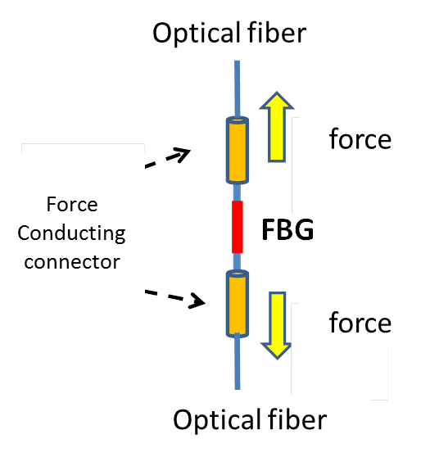
Figure 2.35 - Connector introducing external force into the FBG.

Configuration of the Fiber-Bragg-grating differential settlement measurement sensors (FBG-DSM) on the post-tensioned concrete specimen A
Fiber-Bragg-grating differential settlement measurement sensor (FBG-DSM) obviously constitutes fiber “Bragg gratings” and floats, and its application is based on the communicating pipe principles, floating mechanics and FBG elastic range (Hooke’s law), as illustrated in Figs. 2.37, 2.38. When the concrete specimen span bends downward, after applying the load F, the water within the pipes shift from a higher position to a lower position until the water surface elevation within the pipes are consistent. Therefore, changes in the buoyancy of the floats alter the tension exerted on the FBG, subsequently changing the light wavelength. The data logger was placed on the floor close to the specimen and optical wires ran externally along the beam span, where they connected with a series of “FBG-DSM”. The light wavelength data was analyzed to determine the deflections of the beam. Conventional electronic sensing instruments lack the remote capabilities of optical fibers. Such electronic sensing instruments are limited by wiring distance, signal quality and wiring costs, which indicate the benefits of “FBG-DSM” instruments.

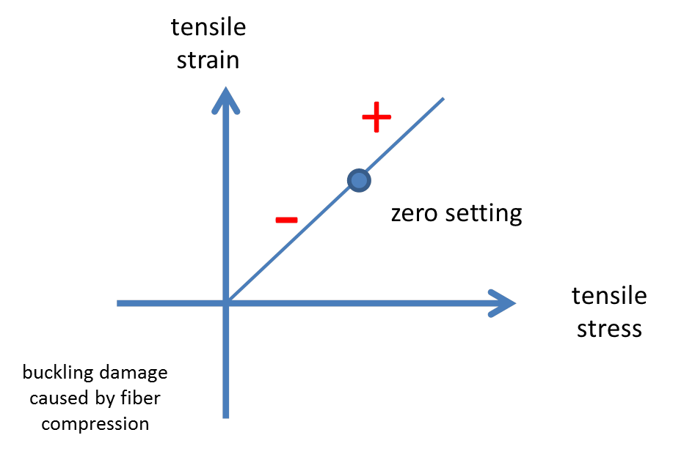
Figure 2.36 - Exerting pre-stress and setting sensing origin.

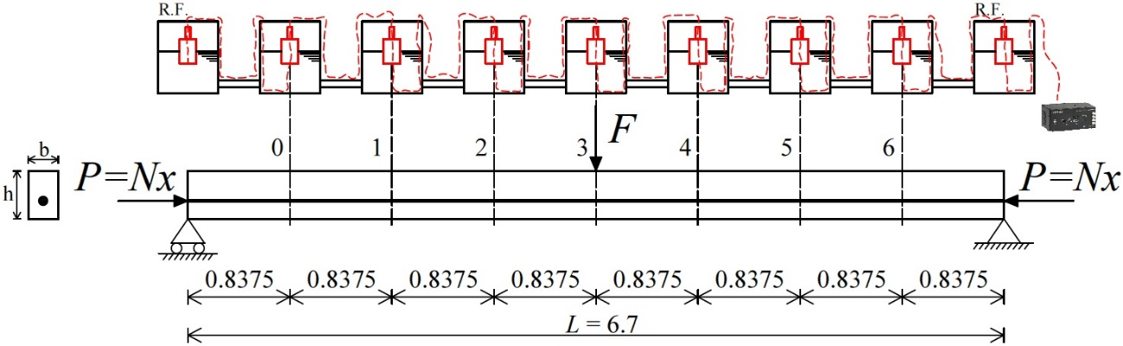
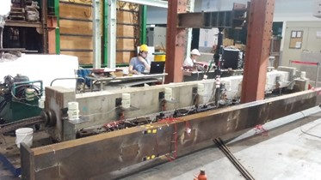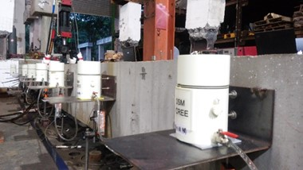
Figure 2.37 - Case I. Configuration of the “FBG-DSM” on the concrete specimen A. Units: m.

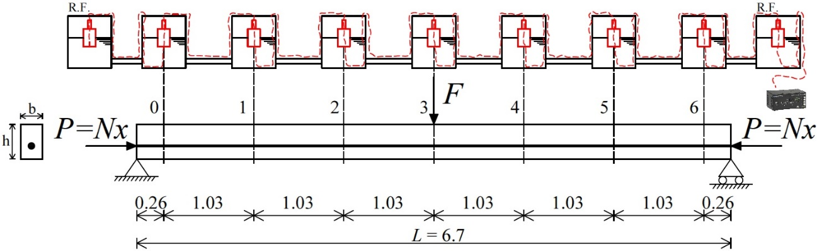
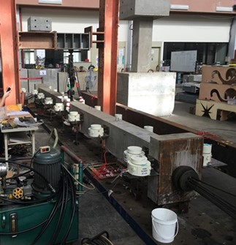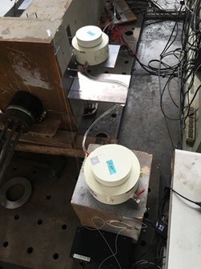
Figure 2.38 - Case II. Configuration of the “FBG-DSM” on the concrete specimen A. Units: m.
Figs. 2.37, 2.38 illustrate the layout of the “FBG-DSM” for Cases I and II, respectively, described in Section 2.3. The two sets of “FBG-DSM” were linked using a connecting pipe. After the load F exertion and deflection of the specimen, the “FBG” readings were estimated for providing the displacement values.

Flexural displacements measured and discussion
The bending tests respect to the strong axis determined that displacements v_{i} = v(x_{i}) for i = 0, 1, 2, 3, 4, 5, 6 measured by “FBG-DSM” (Figs. 2.37, 2.38) were similar to the theoretical ones. The experimental elastic modulus E_{cm}(t), illustrated in Section 2.3.2, was used in the calculations. The comparison on the displacement between experimental and theoretical values reported a maximum error in terms of absolute value of 8.0%.
The deflection data obtained were processed to estimate the pre-stress forces by means of the method proposed by Tullini (2013).

Experimental evaluation of the elastic modulus of concrete
Elastic modulus E of the concrete of post-tensioned specimen A was experimentally evaluated, also obtaining its variation with time E_{cm}(t) during each day of test executions, according to Eurocode 2 (Eurocode 2, 2005).
Together with beam, many cylindrical specimens were cast for investigation of the material properties of concrete used. After 28 days of curing, compressive strength f_{ck} and elastic modulus E were achieved as mean values from compression test on three 100x200 mm cylinders (Fig. 2.39).
In particular, elastic modulus E was obtained applying equation (2.4) to the experimental “Stress σ vs Strain ε” curve of each cylinder:

(2.4)

where σ₂ = 0.4 f_{ck} , σ₁ is the stress value corresponding to the strain ε = 0.00005 and ε₂ is the strain corresponding to the stress σ₂. Cylinder strength f_{ck} is the maximum stress value of “Stress σ vs Strain ε” curve.

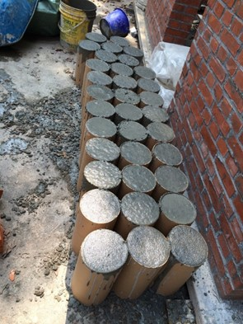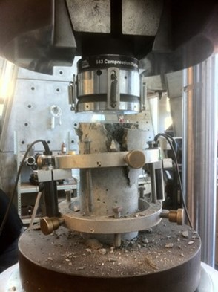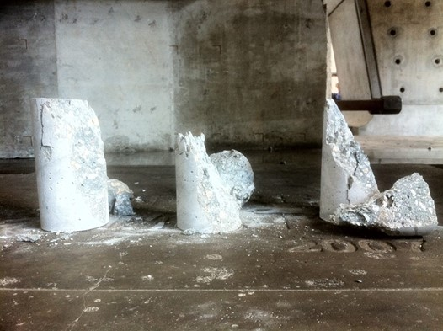
Figure 2.39 - Cylindrical specimens after casting (left), compression test on three cylinders after 28 days of curing (center and right).
Then, during each day of the static test executions, compression test was performed on two 100x200 mm cylinders in order to determine the cylinder strength f_{ck} as mean value. Fig. 2.40 shows the “Stress σ vs Strain ε” curves of one execution day corresponding at the 62 days concrete age.

Figure 2.40 - “Stress σ vs Strain ε” curve of the two specimens at the concrete age of 62 days.
In general, following the procedure proposed by Eurocode 2 (Eurocode 2, 2005), the formula (2.5) makes use of cylinder strength f_{ck}, cited therein, for obtaining the mean cylinder compressive strength f_{cm}:

(2.5)

Subsequently, using the coefficient β_{cc}(t) from equation (2.6):

(2.6)

where s is a coefficient which depends on the type of cement and t is the age of the concrete in days, the mean cylinder strength at an age of t days f_{cm}(t) may be calculated with the expression (2.7):

(2.7)

In the formula (2.6), the coefficient s = 0.2 as the cement is of strength class CEM 42.5 R. exp{ } has the same meaning as e{ }.
Finally, variation of the elastic modulus with time E_{cm}(t) can be estimated by:

(2.8)

where f_{cm}(t) is the mean cylinder strength at an age of t days (Eq. 2.7), meanwhile f_{cm} is the mean compressive strength from Eq. 2.5, that makes use of the strength value f_{ck} from the compression test on two cylinders. E is the elastic modulus determined at the age of 28 days (Eq. 2.4).

Table 2.3 - Material properties obtained for the concrete used.

Figure 2.41 - Variations of the elastic modulus E and Ecm(t) with time.
The material properties tested for the concrete were cylinder strength f_{ck} and elastic modulus E after 28 days of curing and for each execution day of the tests. The 53rd, 55th and 57th day indicate the execution days of the bending tests on the strong axis in reference to the concrete age. While, the 62nd, 64th and 69th day are the execution days of the tests respect to the weak axis. Variation of the elastic modulus with time E_{cm}(t) was estimated by expression (2.8) for each day. The values obtained are summarized in Table 2.3. Fig. 2.41 points out the dispersion of elastic modulus E with time respect to the “Ecm(t) vs Time” curve, that follows the convergent evolution of the theory of concrete.
The material properties (Table 2.3) were also compared with other compression test results present at the Department of Civil Engineering of National Taiwan University. The low values of elastic modulus E, compared to the cylinder strengths f_{ck} achieved, are due to the smaller maximum size of coarse aggregate used in a common concrete produced in Taiwan.
Variations of the elastic modulus with time E_{cm}(t) were mainly used in the non-destructive methods, since E is experimental parameter of the identification processes.

Experimental evaluation of the flexural rigidity
In addition to the elastic modulus E, identification of the flexural rigidities EI_{exp} of specimen A has been also necessary due to the presence of steel tendons.
The EI_{exp} values, since parameters of the methods, were experimentally evaluated respect to the strong and weak axis, and also obtaining their variation with time using the E_{cm}(t) values reported in Table 2.3.

(2.9)

Before to simulate the main experiments, three-point bending tests were executed for obtaining the I-order displacements v₃ and then, the EI_{exp} values by the formula of the simply supported beam (2.9).

Test 1: bending test respect to the strong axis
The load F applied at the mid-span was equal to 2.5 kN, and pre-stress force P equal to 100.0 kN was assigned for preserving the beam in the elastic range without the II-order effects of the compression force. Test 1 configuration is reported in Fig. 2.42, executed in correspondence of the 53rd day of concrete age.

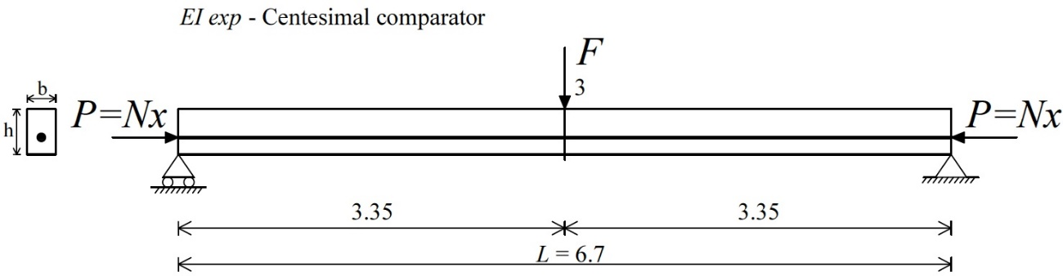
Figure 2.42 - Test 1: Post-tensioned concrete specimen A. Experimental setup for the three-point bending test. Units: m.
Then, considering the mean value of the displacements v₃, measured by one comparator (Case I) for a period of around 15 minutes, expression (2.9) was able to get the EI_{exp} value respect to the strong axis of the specimen:

(2.10)

Subsequently, EI_{exp} value obtained (2.10) was processed with the follow simple operation (2.11) to estimate the moment of inertia I_{exp}:

(2.11)

and then, the variation of the flexural rigidity with time E_{cm}(t)*I_{exp} was calculated, as reported in Table 2.4. The 53rd, 55th and 57th day indicate the execution days of the bending tests in reference to the concrete age.

Table 2.4 - Test 1: Post-tensioned concrete specimen A. Variation of the flexural rigidity with time.
The comparison between the experimental I_{exp} (2.11) and the exact moment of inertia I_{exact} value, obtained by expression (2.12):

(2.12)

has given an error of 6.1%, where E_{S}, A_{S} and ds_{s} are elastic modulus, cross sectional area and distance of the single steel rebar from the center of gravity, respectively. Unlike, E_{P}, A_{P} and dp_{s} are the same characteristics, cited therein, but related to the single steel strand (seven wire strand). Elastic modulus E_{S} and E_{P} are equal to 198.62 GPa, value furnished from the manufactory of the concrete specimen.

Test 2: bending test respect to the weak axis
Transversal force F applied was 300 N, while pre-stress load P equal to 10.0 kN was assigned for preserving the beam without the II-order effects of the compressive axial force. Test 2 configuration is shown in Fig. 2.43, carried out during the 62nd day of concrete age.
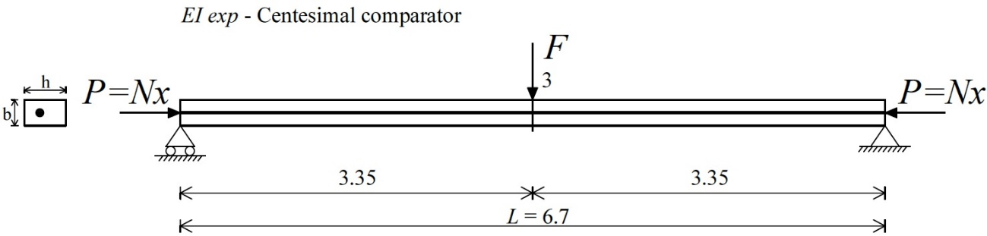
Figure 2.43 - Test 2: Post-tensioned concrete specimen A. Experimental setup for the three-point bending test. Units: m.
The procedure follows Test 1 in which, considering the mean value of the displacements v₃ measured (Case III), expression (2.9) was able to provide the EI_{exp} value compared to the weak axis:

(2.13)

Then, EI_{exp} value obtained (2.13) was processed with the follow operation (2.14) to estimate the moment of inertia I_{exp}:

(2.14)

and consequently, the variation of the flexural rigidity with time E_{cm}(t)*I_{exp} was determined, as reported in Table 2.5. The 62nd, 63rd, 64th and 69th day are the execution days of bending tests in reference to the concrete age.

Table 2.5 - Test 2: Post-tensioned concrete specimen A. Variation of the flexural rigidity with time.
The comparison between the experimental I_{exp} (2.14) and the exact moment of inertia I_{exact} value, obtained by the following expression (2.15):

(2.15)

has provided an error of 16.0%, where E_{S}, A_{S} and ds_{w} are elastic modulus, cross sectional area and distance of the single rebar from the center of gravity, respectively. Conversely, E_{P}, A_{P} and dp_{w} are the same values, cited therein, but related to the single strand. Elastic modulus E_{S} and E_{P} are obviously equal to 198.62 GPa.
Variations of the flexural rigidity E_{cm}(t)*I_{exp} (Tables 2.4, 2.5) were considered in the processes of the proposed method and of the simplified formula of Timoshenko & Gere (1961) and Bazant & Cedolin (1991), as will be shown in the following sections.

Identifications by means of the method proposed by Tullini (2013)
Section 2.3.4 illustrates the experimental results of the pre-stress force identifications of concrete specimen A, described in Section 2.3, by means of the method proposed by Tullini (2013).

Laboratory test results
This section shows that, if exact moment of inertia I and elastic modulus E_{cm}(t) of concrete (Section 2.3.2) are known, pre-stress force N_{a} may be estimated by seven flexural displacements v_{i} = v(x_{i}) for i = 0, 1, 2, 3, 4, 5, 6 short-term recorded at given sections along the beam span, after applying the lateral force F at the mid-span. The method makes use of the process of Section 1.2.2.
The results gave excellent agreements between estimated N_{a} and applied pre-stress forces N_{x} when the measurements performed by Fiber-Bragg-grating differential settlement measurement sensors (FBG-DSM). The tolerance of the displacements of 0.001 mm, used in this section, may be reliable for laboratory tests only. Anyway, measurements with high-accuracy provide better identifications, even when the boundary conditions of the concrete beam under investigation are unknown.

Test 3: bending tests respect to the strong axis
Cases I and II are obviously considered (Figs. 2.28, 2.29). The cases speculate the boundary conditions of the simply supported specimen as known and unknown, respectively.
Pre-stress step loads P equal to 626.0 kN, 696.0 kN and 843.0 kN were assigned, while load F was applied with values of 20.0 kN, 22.5 kN and 25.0 kN (around) for each pre-stress load P. The moment of inertia I is the exact value of the 250x400 mm rectangular cross section. Elastic modulus E_{cm}(t) values were differently considered in the identification procedure depending on the execution days of bending tests.
Sensitivity analyses, depending on the parameters cited therein, were also performed for Cases I and II for verifying the experimental determinations. In detail, pre-stress loads N_{a} were obtained from the process of Section 1.2.2 by the parameters v₀, v₁, v₂, v₃, v₄, v₅, v₆ alternatively modified by adding +0.01 and -0.01 for reproducing possible experimental errors. Conversely, the load F, constant of the parameter ψ, was alternatively multiplied by 0.99 and 1.01. The deflections v_{i} = v(x_{i}) for i = 0, 1, 2, 3, 4, 5, 6 (Figs. 2.28, 2.29), subjected to each load F modified, were already imposed alternatively modified by adding +0.01 and -0.01, after using the solutions (2.1 and 2.2). The tolerance of the analytical displacements was 0.001 mm.
In general, for Cases I and II, the above operation gave rise to:
- 256 different combinations of simulated experimental values for 5 distinct values of the assumed pre-stress force N_{x}.
Then, the combinations obtained gave rise respectively to (Figs. 2.44, 2.45):
- 256 estimated pre-stress loads N_{a} for 5 distinct values of the pre-stress force N_{x} (making use of the process of Section 1.2.2).
Fig. 2.44 shows the comparison on the pre-stress force between the worst estimated values N_{a} and the assumed values N_{x} for Case I, in terms of sensitivity analysis functions. Conversely, the colored data points are related to the last 200 set combinations of displacements recorded v₀, v₁, v₂, v₃, v₄, v₅, v₆, giving rise to a total of 200 experimental identifications N_{a} for each combination of the loads P+F.
Figure 2.44 - Test 3: Case I - Post-tensioned concrete specimen A. Sensitivity analysis results and comparison between estimated (N_{a}) and measured (N_{x}) values of pre-stress forces (colored data points).
Instead, Fig. 2.45 shows the comparison on the pre-stress force between the worst estimated values N_{a} and the assumed values N_{x} for Case II. The colored data points are likewise related to the last 200 set combinations of deflections recorded v₀, v₁, v₂, v₃, v₄, v₅, v₆, giving rise to a total of 200 experimental identifications N_{a} for each single combination P+F.

Figure 2.45 - Test 3: Case II - Post-tensioned concrete specimen A. Sensitivity analysis results and comparison between estimated (N_{a}) and measured (N_{x}) values of pre-stress forces (colored data points).
Cases I and II have showed excellent identifications since the data points of the values N_{a} are mostly between the sensitivity analysis functions (Figs. 2.44, 2.45). It is necessary to increase the load F to reduce the range of the sensitivity analysis functions and obtain acceptable identifications N_{a} (with a maximum error in absolute value of 10.0%) - see the conclusions about the analytical results of the method in Sections 2.2.1.1.2 and 2.2.1.2.2.

Test 4: bending tests respect to the weak axis
Case III speculates the boundary conditions of specimen A as known (Fig. 2.31).
Pre-stress forces P equal to 556.0 kN, 631.0 kN and 684.0 kN were assigned, while load F was applied with values of around 5.0 kN, 7.5 kN and 10.0 kN for each pre-stress force P. The moment of inertia I is the exact value of the 250x400 mm cross section respect to the weak axis. Elastic modulus E_{cm}(t) values were differently considered in the procedure depending on the execution days of the tests.
Sensitivity analyses were also carried out for Case III. Pre-stress loads N_{a} were obtained from the process of Section 1.2.2 using the parameters v₀, v₁, v₂, v₃, v₄, v₅, v₆ alternatively modified by adding +0.01 and -0.01, while the load F, constant of the parameter ψ, was alternatively multiplied by 0.99 and 1.01. The displacements v_{i} = v(x_{i}) for i = 0, 1, 2, 3, 4, 5, 6 (Fig. 2.31), subjected to each load F modified, were already imposed alternatively modified by adding +0.01 and -0.01, after using the solutions (2.1 and 2.2). The tolerance of the displacements was 0.01 mm.
For Case III, the above operation gave rise in general to:
- 256 different combinations of simulated experimental values for 5 distinct values of the assumed pre-stress force N_{x}.
Then, the combinations obtained gave rise respectively to (Fig. 2.46):
- 256 estimated pre-stress loads N_{a} for 5 distinct values of the pre-stress force N_{x} (using the process of Section 1.2.2).
The colored data points in Fig. 2.46 are related to the last 200 set combinations of the displacements recorded v₀, v₁, v₂, v₃, v₄, v₅, v₆, giving rise to a total of 200 experimental identifications N_{a} for each combination P+F. Moreover, the sensitivity analysis functions show the comparison on the pre-stress force between the worst estimated N_{a} and the assumed values N_{x}.

Figure 2.46 - Test 4: Case III - Post-tensioned concrete specimen A. Sensitivity analysis results and comparison between estimated (N_{a}) and measured (N_{x}) values of pre-stress forces (colored data points).
The lack of high-accuracy measurements gave unreliable determinations since the data points of values N_{a} are outside the sensitivity analysis functions (Fig. 2.46), even if the slenderness considered (weak axis) was higher. In fact, centesimal comparators have allowed measurements with 0.01 mm tolerance. Moreover, the load increment F was not possible, due to avoid the cracks of concrete in the serviceability limit state.
The sensitivity analyses (Figs. 2.44, 2.45 and 2.46) confirm that estimated values N_{a} are insensitive to the variation of the flexural rigidity EI, since it was modified by the variation of elastic modulus E_{cm}(t) during the execution days of bending tests.

Identifications by means of the proposed static method
Section 2.3.5 shows the test results of pre-stress force identifications of concrete specimen A by means of the proposed static method, described in Section 1.5.

Laboratory test results
Section 2.3.5.1 shows that, if experimental flexural rigidity EI of the concrete specimen is known, pre-stress force N_{a} may be identified by two displacements v_{i} = v(x_{i}) for i = 1, 3 short-term measured at a quarter and at the mid-span of the beam, after applying the concentrated load F at the mid-span. The method makes use of the procedure shown in Section 1.5.2.
Experimental results gave excellent agreements between estimated N_{a} and applied pre-stress forces N_{x} by the two above measurements from centesimal comparators.

Test 5: bending tests respect to the strong axis
Case I configuration is taken into account (Fig. 2.28) considering the deflection measurements v_{i} = v(x_{i}) for i = 1, 3 only, as shown in Fig. 2.47. The boundary conditions of the simply supported specimen are known, according to the formulation of the method.

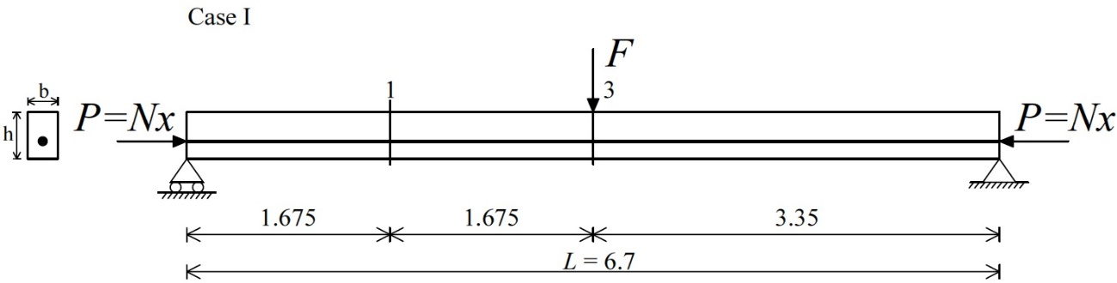
Figure 2.47 - Test 5: Case I - Post-tensioned concrete specimen A. Experimental setup considered for the proposed static method. Units: m.
Pre-stress forces P and lateral loads F were equal to the values described in Section 2.3.4.1.1. Flexural rigidity EI values, depending on the elastic modulus E_{cm}(t) constants, were differently considered in the identification process for each test execution day.
Sensitivity analyses were developed as made for the method proposed by Tullini (2013). In detail, pre-stress loads N_{a} were obtained from the process of Section 1.5.2 by the reference parameters v₁, v₃ and ψ alternatively multiplied by 0.99 and 1.01. The deflections v_{i} = v(x_{i}) for i = 1, 3 (Fig. 2.47), subjected to each load F modified, were already imposed alternatively multiplied by 0.99 and 1.01, after using the solutions (2.1 and 2.2). The tolerance of the displacements was 0.01 mm.
For Test 5, the above operation gave rise in total to:
- 7 different combinations of simulated experimental values for 5 distinct values of the assumed pre-stress force N_{x}.
Then, the combinations obtained gave rise respectively to (Fig. 2.48):
- 7 estimated pre-stress loads N_{a} for 5 distinct values of the pre-stress force N_{x} (utilizing the procedure of Section 1.5.2).
Fig. 2.48 shows the comparison on the pre-stress load between the worst estimated values N_{a} and the assumed values N_{x} for Test 5, in terms of sensitivity analysis functions. Unlike, the colored data points are related to the last 200 set combinations of displacements recorded v₁ and v₃, giving rise totally to 200 experimental identifications N_{a} for each single combination P+F.

Figure 2.48 - Test 5: Case I - Post-tensioned concrete specimen A. Sensitivity analysis results and comparison between estimated (N_{a}) and measured (N_{x}) values of the pre-stress forces 626.0 kN and 696 kN (colored data points).
Pre-stress force identifications N_{a} of Test 5 have been excellent since the data points are completely between the sensitivity analysis functions (Fig. 2.46) - except for the combination P = 696.0 kN and F = 20.0 kN. In fact, the maximum error of the sensitivity analysis functions in correspondence of the pre-stress force N_{x} = 850.0 kN is equal to 11.2% (in terms of absolute value). The estimates of N_{a} do not depend on the magnitude of the transversal loads F and, moreover, are insensitive to the variation of the flexural rigidity EI, dependent on the elastic modulus E_{cm}(t) constants.

Test 6: bending tests respect to the weak axis
Case III test configuration is considered (Fig. 2.31) taking into account the deflection measurements v_{i} = v(x_{i}) for i = 1, 3 only, as depicted in Fig. 2.49. The boundary conditions of the simply supported specimen are known as for Test 5.

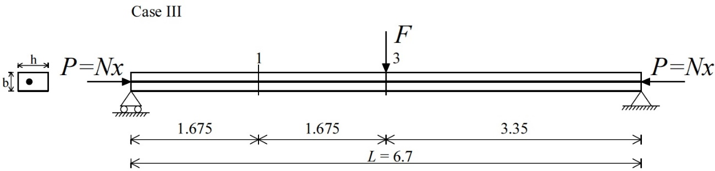
Figure 2.49 - Test 6: Case III - Post-tensioned concrete specimen A. Experimental setup considered for the proposed static method. Units: m.
Pre-stress forces P and loads F were already described in Section 2.3.4.1.2. Flexural rigidity EI values, depending on the elastic modulus E_{cm}(t) constants, were differently considered for each execution day of the tests.
Sensitivity analyses were also developed for Test 6. Pre-stress loads N_{a} were obtained by the reference parameters v₁, v₃ and ψ alternatively multiplied by 0.99 and 1.01. The displacements v_{i} = v(x_{i}) for i = 1, 3 (Fig. 2.49), subjected to each load F modified, were already imposed alternatively multiplied by 0.99 and 1.01, after using the expressions (2.1 and 2.2). The tolerance was 0.01 mm.
In general, for Test 6, the above operation gave rise to:
- 7 different combinations of simulated experimental values for 5 distinct values of the assumed pre-stress force N_{x}.
Consequently, the combinations gave rise respectively to (Fig. 2.50):
- 7 estimated pre-stress loads N_{a} for 5 different values of the pre-stress force N_{x}.
Fig. 2.50 shows the sensitivity analysis functions in terms of comparison on the pre-stress force between the values N_{a} and the values N_{x}. Conversely, the colored data points are corresponding to the last 200 set combinations of displacements v₁, v₃ measured, giving rise totally to 200 experimental estimations N_{a} for each load combinations P+F.

Figure 2.50 - Test 6: Case III - Post-tensioned concrete specimen A. Sensitivity analysis results and comparison between estimated (N_{a}) and measured (N_{x}) values of pre-stress forces (colored data points).
The identifications N_{a} of Test 6 have been likewise excellent (Fig. 2.50) as the previous estimations respect to the strong axis - except for the combination P = 631.0 kN and F = 5.0 kN. The maximum error of the sensitivity analyses in correspondence of pre-stress load N_{x} = 850.0 kN is equal to 4.1% (in absolute value).
The proposed static method results enough insensitive to the errors and, moreover, the reliable determinations N_{a} were obtained through a not accurate-measuring tolerance (equal to 0.01 mm).

Identifications by means of the Simplified formula of Timoshenko & Gere (1961) and Bazant & Cedolin (1991)
Section 2.3.6 shows the test results of the identifications N_{a} of concrete specimen A by means of the simplified formula of Timoshenko & Gere (1961) and Bazant & Cedolin (1991), described in Section 1.4.

Laboratory test results
The section shows that, if experimental flexural rigidity EI of the specimen is known, pre-stress force N_{a} may be identified by one displacement v_{i} = v(x_{i}) recorded at the mid-span of the beam, after applying the transversal load F at the same section. The technique follows the procedure shown in Section 1.4.1.
Conversely to the other methods, bending test simulations were performed respect to the weak axis only. Test results gave excellent estimations of the N_{a} values considering the deflection measurement by centesimal comparator.

Test 7: bending tests respect to the weak axis
Test configuration of the simplified formula is Case III with the displacement measurement v₃ only, as depicted in Fig. 2.51. The end restraints of the simply supported beam are known, according to the concepts of the formula (Eq. 1.28).

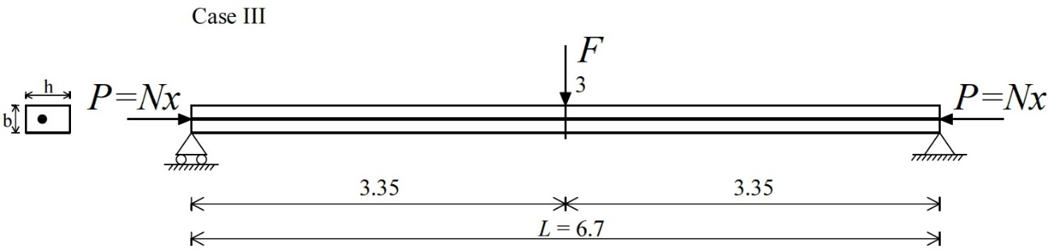
Figure 2.51 - Test 7: Case III - Post-tensioned concrete specimen A. Experimental setup considered for the simplified formula. Units: m.
Pre-stress forces P and lateral loads F are reported in Section 2.3.4.1.2. Flexural rigidity EI values, depending on the constants E_{cm}(t), were differently taken into account for the buckling load evaluation N_{crE}(t) for each day of the tests, since parameter of the simplified formula.
Sensitivity analyses were likewise performed. Pre-stress loads N_{a} were achieved from the procedure of Section 1.4.1 by the parameters F and v₃ alternatively multiplied by 0.99 and 1.01. The v₃ values (Fig. 2.51), calculated by each load F modified, were inserted in the simplified formula alternatively multiplied by 0.99 and 1.01, after making use of the solution (2.1). The tolerance was 0.01 mm. Conversely, the first-order deflections v_{I} were analytically determined for each combination P+F, as described in Section 1.4.1, and not-modified with any algebraic manipulation since they are not experimental parameters of the formula.
The above operation gave rise in total to:
- 4 different combinations of simulated experimental values for 5 distinct values of the assumed pre-stress force N_{x}.
The combinations achieved then gave rise respectively to (Fig. 2.52):
- 4 estimated pre-stress loads N_{a} for 5 distinct values of the pre-stress force N_{x} (following the procedure of Section 1.4.1).
The data points in Fig. 2.52 are the experimental identifications N_{a} related to the last 200 values of the displacement v₃ recorded for each load combinations P+F.

Figure 2.52 - Test 7: Case III - Post-tensioned concrete specimen A. Sensitivity analysis results and comparison between estimated (N_{a}) and measured (N_{x}) values of pre-stress forces (colored data points).
Pre-stress load identifications N_{a} of Test 7 have been excellent since the data points are included into the sensitivity analysis functions (Fig. 2.52), except for the combination P = 631.0 kN and F = 5.0 kN. The maximum error of the sensitivity analysis functions in correspondence of the pre-stress load N_{x} = 850.0 kN is equal to 9.2% (in absolute value). Likewise to the proposed method, the estimates of N_{a} do not depend on the transversal load magnitudes F and, additionally, are insensitive to the variation of the flexural rigidity EI, dependent on the elastic modulus E_{cm}(t) constants.
The simplified formula’s application (Eq. 1.29) on prismatic beams provides excellent identifications when the ratio between displacements v_{tot} and v_{I}, parameters of the formula, is greater than 1.2 (v_{tot} /v_{I} > 1.2).

Identifications by means of the Simplified formula of Galef (1968)
The section illustrates the numerical results of the pre-stress force determinations of specimen A by means of the simplified formula of Galef (1968), recently presented by Bonopera et al. (2015).

Numerical test results
The existing pre-stress force P may be identified making use of the first natural frequencies of the axially unloaded ω_{0I} and loaded ω_{I} beam, if buckling load N_{crE} is a known parameter. The method follows the procedure shown in Section 1.6.
Numerical results have given excellent agreements between estimated N_{a} and assumed pre-stress forces N_{x} when the natural frequency analyses have been performed respect to the weak axis.
The related experimental simulations could be easily developed in the laboratory recording the vibration-based measurements by outer accelerometers and then, extrapolating the natural frequencies ω_{0I} and ω_{I} of the first mode shape.

Test 8: natural frequency analyses respect to the strong axis
Test 8 configuration is reported in Fig. 2.53: section n. 3 at the mid-span indicates where the experimental vibration-based measurements could be executed.
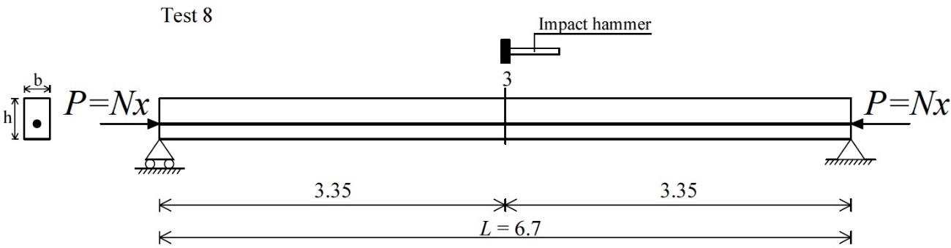
Figure 2.53 - Test 8 - Post-tensioned concrete specimen A. Experimental setup respect to the strong axis. Units: m.
The analyses were done by finite elements model for obtaining the first mode natural frequencies of the axially unloaded ω_{0I} and loaded ω_{I} specimen (Fig. 2.54). The end restraints of the simply supported beam were assumed known L = 6.7 m, according to the concepts of the formula. Elastic modulus E of concrete was assumed equal to 36.35 GPa and subsequently, buckling load N_{crE,fem} was determined analytically (Eq. 1.31).

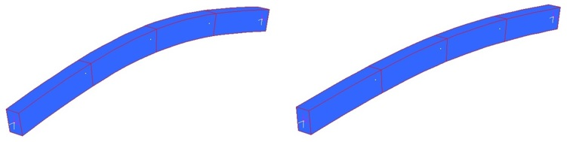
Figure 2.54 - Test 8 - Post-tensioned concrete specimen A. Natural frequency analyses by finite elements model: axially unloaded (left) and loaded specimen (right).

With regards to the sensitivity analyses, pre-stress forces N_{a} were achieved from the procedure illustrated in Section 1.6 by the above parameters ω_{0I} and ω_{I} alternatively multiplied by 0.99 and 1.01 for reproducing possible experimental errors. The maximum applied pre-stress load, considered by finite elements model, was 1350.0 kN for preserving concrete and pre-stressing steel tendons in the elastic range.
The above operation gave rise in particular to:
- 4 combinations of simulated experimental values ω_{0I}/ω_{I} for 5 distinct values of the assumed pre-stress force N_{x}.
Then, the above combinations gave rise respectively to (Fig. 2.55):
- 4 estimated pre-stress forces N_{a} for 5 distinct values of the pre-stress force N_{x} (making use of the procedure of Section 1.6).
Fig. 2.55 shows the comparison on the pre-stress force between the worst estimated N_{a} and the assumed values N_{x} for Test 8, and the table with manipulations and values obtained from the sensitivity analysis corresponding to N_{x} = 1350.0 kN.

Figure 2.55 - Test 8 - Post-tensioned concrete specimen A. Table of sensitivity analysis for N_{x} = 1350.0 kN (left) and comparison between estimated (N_{a}) and assumed (N_{x}) values of pre-stress forces (right).
The analytical identifications N_{a} are not reliable using the first mode frequencies ω_{0I} and ω_{I} obtained respect to the strong axis (Δ > 10.0%). In fact, the maximum error of the sensitivity analysis for N_{x} = 1350.0 kN is equal to 28.1% in terms of absolute value (Fig. 2.55).

Test 9: natural frequency analyses respect to the weak axis
Test 9 setup is reported in Fig. 2.56: vibration-based measurements could be performed at the mid-span, after impacting the beam by an instrumented hammer.

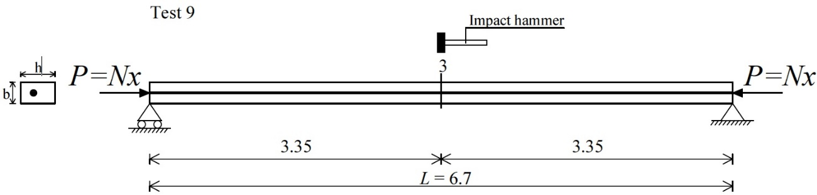
Figure 2.56 - Test 9 - Post-tensioned concrete specimen A. Experimental setup respect to the weak axis. Units: m.
Finite elements model was used for determining the first mode natural frequencies of the axially unloaded ω_{0I} and loaded ω_{I} specimen. The analyses were obviously executed respect to the weak axis, as depicted in Fig. 2.57. The pinned-end constraints are known L = 6.7 m and additionally, with elastic modulus of concrete E = 36.35 GPa, buckling load N_{crE,fem} respect to the weak axis has been calculated analytically (Eq. 1.31).

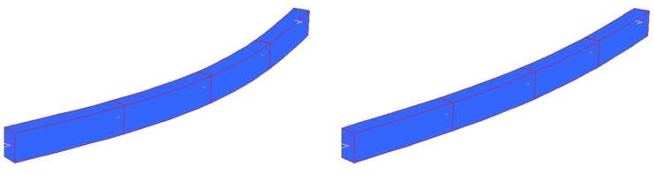
Figure 2.57 - Test 9 - Post-tensioned concrete specimen A. Natural frequency analyses by finite elements model: axially unloaded (left) and loaded specimen (right).

The above parameters ω_{0I} and ω_{I} were alternatively multiplied by 0.99 and 1.01, after determining them by finite elements model.
The simple algebraic operation gave rise to:
- 4 combinations of simulated experimental values ω_{0I}/ω_{I} for 5 distinct values of the assumed pre-stress force N_{x}.
Then, the combinations gave rise respectively to (Fig. 2.58):
- 4 estimated pre-stress forces N_{a} for 5 distinct values of the pre-stress force N_{x} (following the procedure of Section 1.6).
Fig. 2.58 shows the comparison on the pre-stress load between the worst estimated values N_{a} and the assumed values N_{x}, and the table with manipulations and values achieved from the sensitivity analysis when N_{x} = 1350.0 kN (maximum applied pre-stress load).

Figure 2.58 - Test 9 - Post-tensioned concrete specimen A. Table of sensitivity analysis for N_{x} = 1350.0 kN (left) and comparison between estimated (N_{a}) and assumed (N_{x}) values of pre-stress forces (right).
The identifications N_{a} are excellent when the simplified formula makes use of the first mode frequencies ω_{0I}/ω_{I} determined respect to the weak axis. The maximum error in absolute value of the sensitivity analysis for N_{x} = 1350.0 kN is 8.4% (Fig. 2.58). In general, the method requires high magnitude of the existing axial forces P = N_{x} for obtaining reliable estimations N_{a}, due to the formulation of the simplified formula. This condition could be achievable when the vibration-based measurements are executed respect to the weak axis.

Post-tensioned steel specimen B
Pre-stress load identifications were also experimentally determined by means of all static procedures on a post-tensioned simply supported steel beam. The simplified formula of Galef (1968) was likewise applied analytically.
Laboratory tests were likewise performed at the National Center for Research on Earthquake Engineering (NCREE) in Taipei, Taiwan.

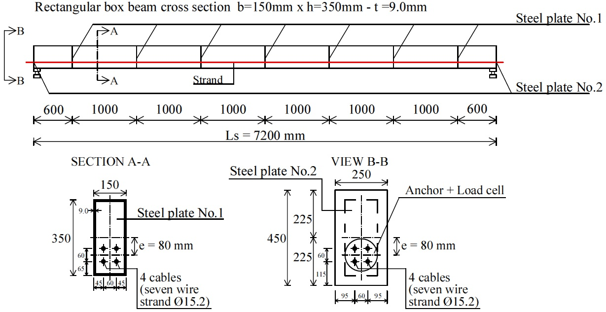
Figure 2.59 - Drawing of the post-tensioned steel specimen B. Units: mm.

The steel beam was designed with length of 7.2 m and 150x350x9 mm rectangular box cross section (Fig. 2.59). Yielding stress f_{yk} and elastic modulus E were experimentally evaluated as illustrated in Section 2.4.2.

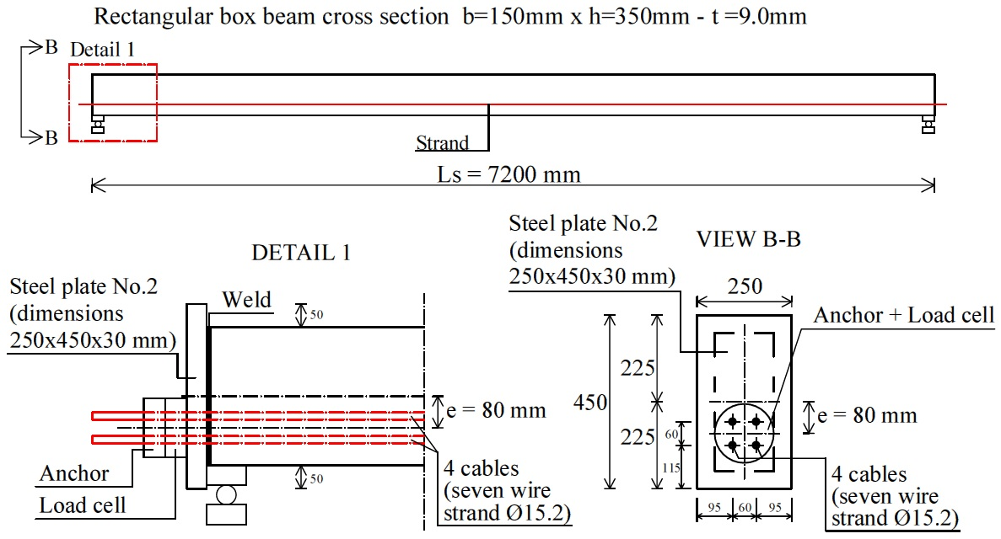
Figure 2.60 - Detail of the beam end of post-tensioned steel specimen B. Units: mm.
The strand has eccentricity equal to 80 mm and is composed of four tendons “seven wire strand” with diameter of 15.2 mm, able to flow inside four distinct plastic ducts (Fig. 2.60). Ultimate yield strength of tendons is 1860 MPa. Several 150x350x9 mm steel plates were inserted by welding into the box cross section and along the span of the specimen, for avoiding any buckling phenomena during the serviceability limit state. Moreover, two 250x450x30 mm steel plates were welded at the beam ends in order to resist the high pre-stress forces (Fig. 2.60).

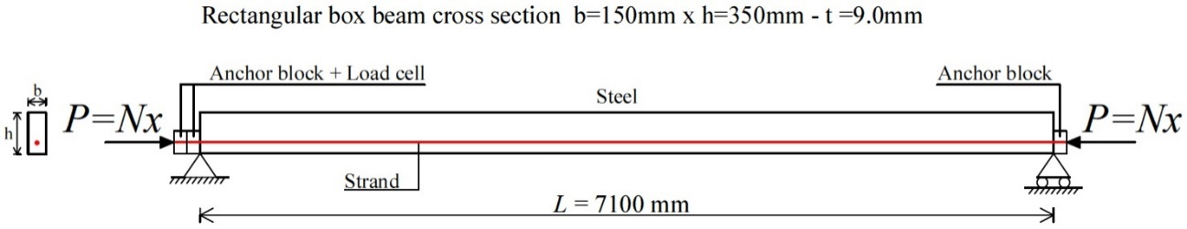
Figure 2.61 - Scheme of the post-tensioned steel specimen B. Units: mm.
The specimen was inserted in a test frame using a test rig (Fig. 2.63). A hydraulic oil jack with force capacity of 4000 kN was used to assign the pre-stress loads at one end, and one 1000 kN load cell with accuracy of 2 mV/V was placed at the other end (Fig. 2.64). Four pre-stress loads P were totally assigned to the specimen with values of 299.0 kN, 370.0 kN, 448.0 kN and 482.0 kN, when the bending tests applied respect to the strong axis. The transversal load F was applied by a hydraulic actuator, with force capacity of 25.0 kN, at the mid-span with values of around 20.0 kN, 22.5 kN and 25.0 kN, as shown in Fig. 2.65. Conversely, when the static tests performed respect to the weak axis (Fig. 2.67), pre-stress forces P were assigned with values of 311.0 kN, 360 kN, 401.0 kN and 452.0 kN, and the load F with values of around 7.5 kN, 10.0 kN and 12.5 kN, always at the mid-span. The steel specimen was always obviously preserved in the elastic range during experiments. Additionally, in order to create pinned-end restraints, two additional supports were placed at the beam ends (Fig. 2.66), giving rise to a clear span L equal to 7.1 m, as showed in Fig. 2.59.

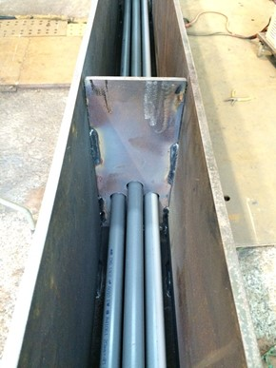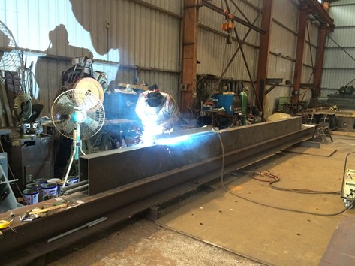
Figure 2.62 - PVC ducts of the tendons (left) and post-tensioned steel specimen B under construction (right).
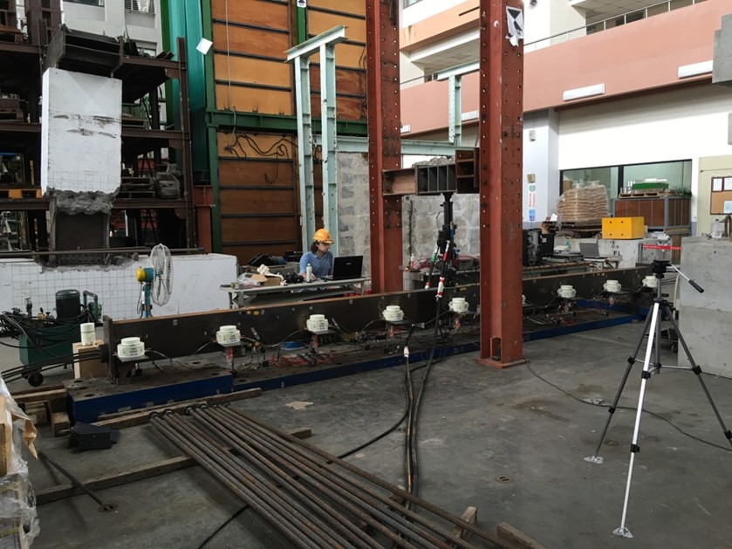
Figure 2.63 - Test rig for the experimental tests.
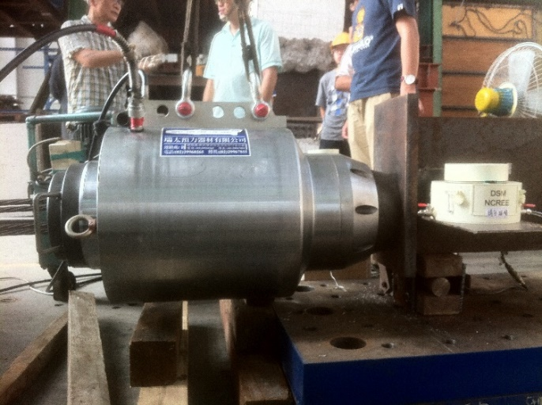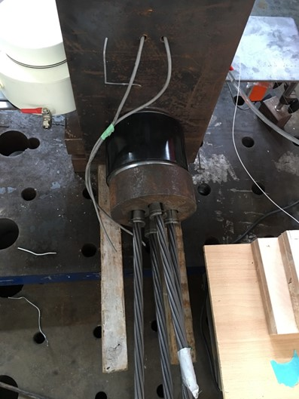
Figure 2.64 - Hydraulic oil jack (left) and load cell at the other end (right) of the steel specimen B.
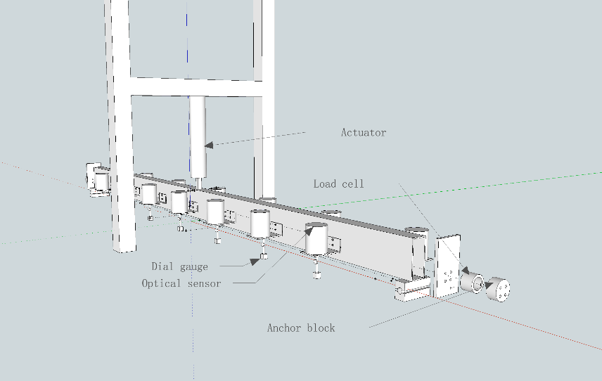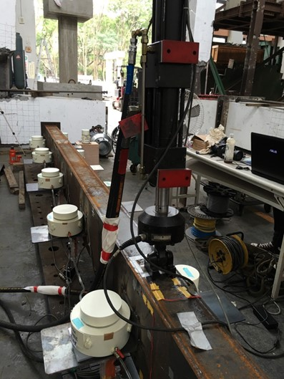
Figure 2.65 - 3D experimental setup of the steel specimen B (left) and hydraulic actuator at the mid-span (right).
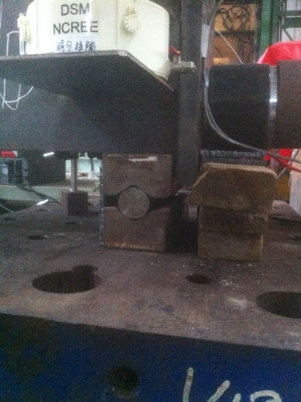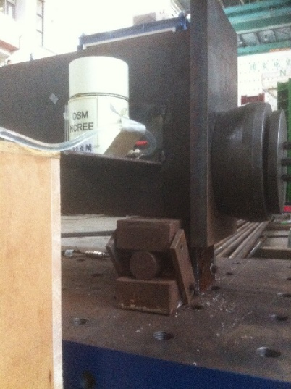
Figure 2.66 - Pinned-end constraints: hinge (left) and roller support (right).
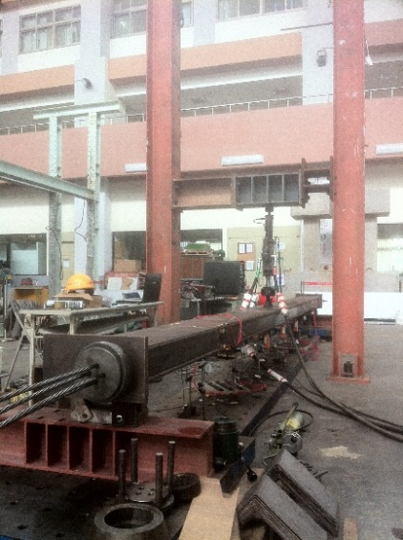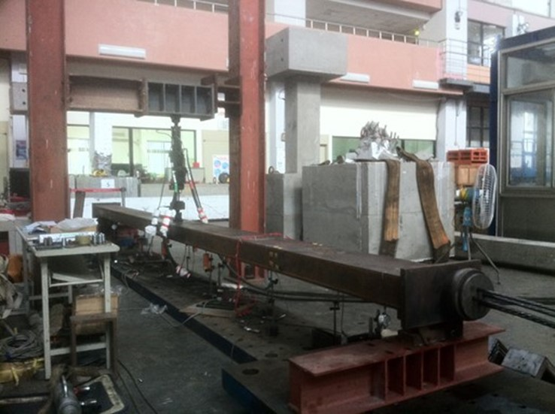
Figure 2.67 - Views of the bending tests respect to the weak axis of steel specimen B.
Subsequently, as made for the concrete specimen, the corresponding displacements v_{i} = v(x_{i}) of the deflected shape of the span were short-term measured. In short, four configurations were developed as follow:
- Case V: three-point bending test with seven- measurements respect to strong axis, considering equidistant sensor positions (Fig. 2.68);
- Case VI: three-point bending test with seven- measurements respect to strong axis, considering non-equidistant sensor positions (Fig. 2.69);
- Case VII: three-point bending test with seven- measurements respect to weak axis, considering equidistant sensor positions (Fig. 2.71);
- Case VIII: three-point bending test with seven- measurements respect to weak axis, considering non-equidistant sensor positions (Fig. 2.70).

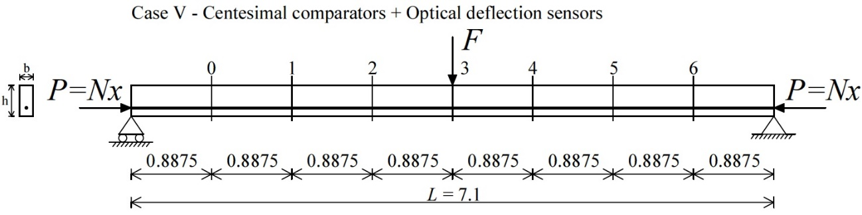
Figure 2.68 - Case V. Experimental test setup with location of the instrumented sections of centesimal comparators and “FBG-DSM”. Units: m.
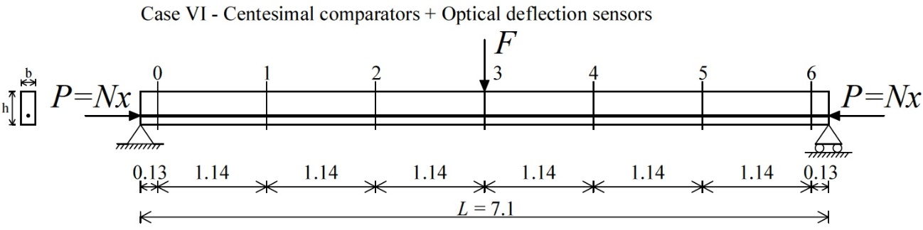
Figure 2.69 - Case VI. Experimental test setup with location of the instrumented sections of centesimal comparators and “FBG-DSM”. Units: m.
Cases V and VI (Figs. 2.68, 2.69) were concurrently performed, as shown in Fig. 2.70, by measuring in total fourteen displacements v_{i} = v(x_{i}) through centesimal comparators, with accuracy of 0.01 mm, and Fiber-Bragg-grating differential settlement measurement sensors (FBG-DSM). Seven comparators and seven “FBG-DSM” were placed at the same cross sections i = 0, 1, 2, 3, 4, 5, 6 in one side of the beam (Case V) respectively, while other seven comparators and seven “FBG-DSM” were always fixed at the same cross sections i = 0, 1, 2, 3, 4, 5, 6, but in the other side of the specimen (Case VI).

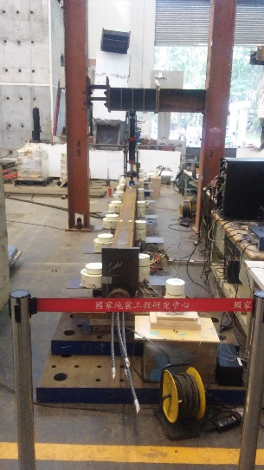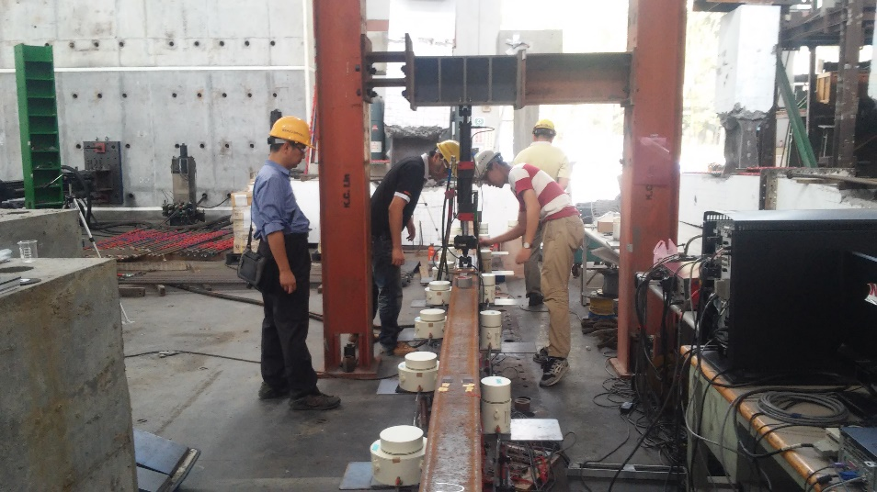
Figure 2.70 - Views of the Case V and VI test configurations developed concurrently.
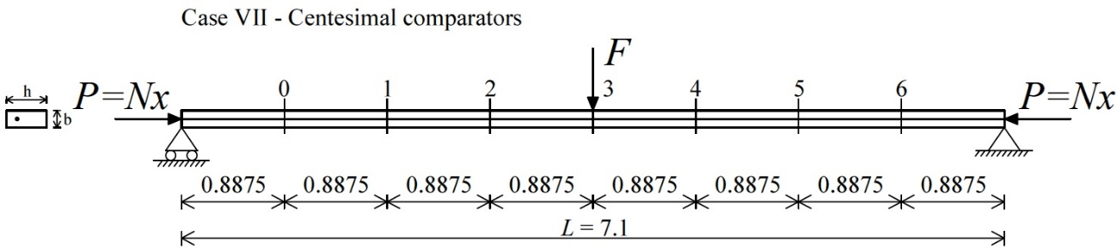
Figure 2.71 - Case VII. Experimental test setup with location of the instrumented sections of the centesimal comparators. Units: m.

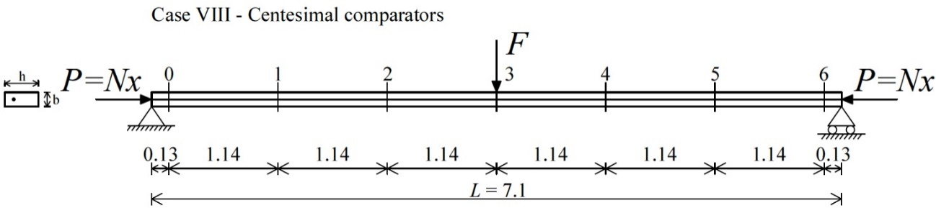
Figure 2.72 - Case VIII. Experimental test setup with location of the instrumented sections of the centesimal comparators. Units: m.
Cases VII and VIII carried out respect to the weak axis using the same criteria (Figs. 2.71, 2.72), but the fourteen displacements v_{i} = v(x_{i}) were recorded by centesimal comparators only, as depicted in Fig. 2.73. Seven comparators were fixed in one side of the specimen for i = 0, 1, 2, 3, 4, 5, 6 (Case VII) respectively, while other seven ones were positioned in the other side for i = 0, 1, 2, 3, 4, 5, 6 (Case VIII).

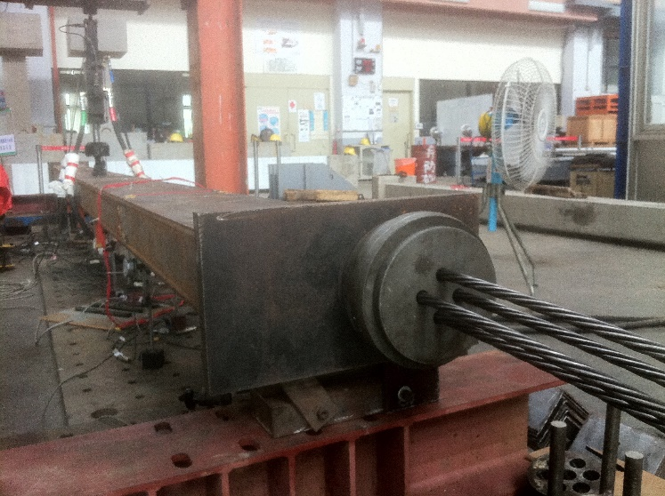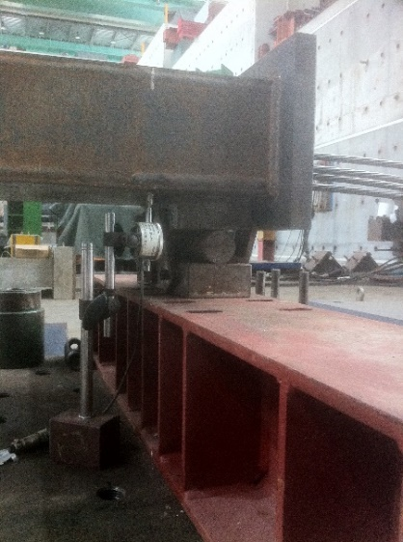
Figure 2.73 - Bending tests respect to the weak axis (left) and detail of one centesimal comparator during the measurement (right).
For each pre-stress load P applied by hydraulic jack, fourteen displacements v_{i} = v(x_{i}) have been measured for each load F for a time period of around 10 minutes. All instrument data have been recorded with 1 Hz frequency. Data logger and PC data acquisition system were the same devices used for the experiments on concrete specimen.
The above data records were also obviously utilized for the identifications by means of the proposed method and the simplified formula of Timoshenko and Gere (1961) and Bazant and Cedolin (1991).
It is worth specifying that every single combination of pre-stress force and lateral load P+F did not reach the yield stress in the specimen, according to the preliminary calculations in the elastic range.

Measurement of the flexural displacements using Fiber-Bragg-grating differential settlement measurement sensors (FBG-DSM)
Fiber-Bragg-grating differential settlement measurement sensors (FBG-DSM) were utilized for the short-term displacement measurements of steel specimen B at given cross sections, as described in Section 2.4 (Figs. 2.68 and 2.69).
This work involved installing “FBG-DSM” devices in the specimen span to replace conventional measurement methods and then obtain reliable displacements, as developed for the concrete specimen. The main concepts of “FBG-DSM” were already illustrated in Section 2.3.1.

Configuration of the Fiber-Bragg-grating differential settlement measurement sensors (FBG-DSM) on the post-tensioned steel specimen B
Figs. 2.74 and 2.75 illustrate the layout of “FBG-DSM” devices for Cases V and VI respectively, described in Section 2.4. The two sets of “FBG-DSM” were connected with optical wires along the beam length and linked using a connecting pipe. After the load application F and the deflection of the span, the FBG readings were estimated for providing the deflection values v_{i} = v(x_{i}) for i = 0, 1, 2, 3, 4, 5, 6.

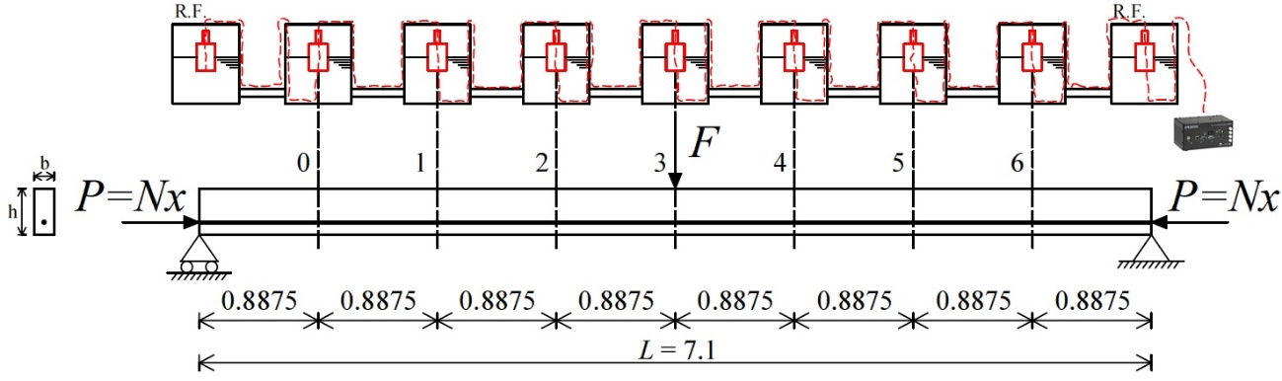
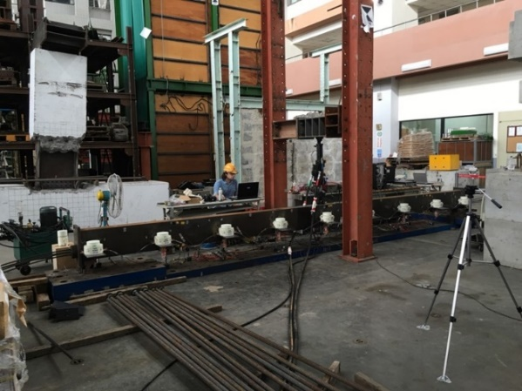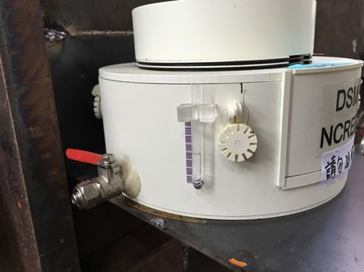
Figure 2.74 - Case V. Configuration of the “FBG-DSM” on the steel specimen B. Units: m.

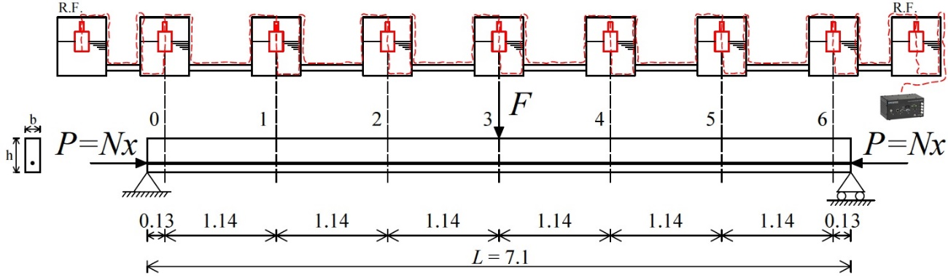
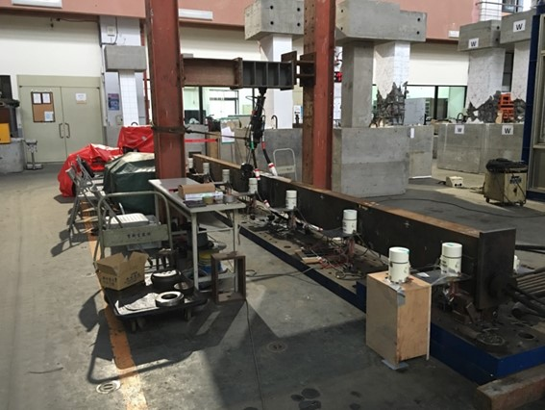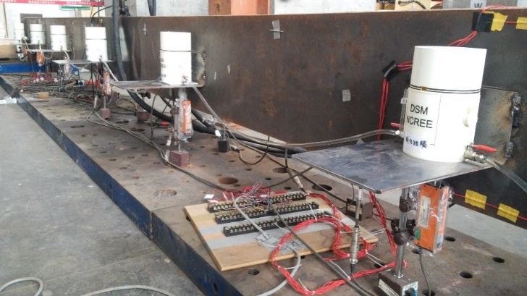
Figure 2.75 - Case VI. Configuration of the “FBG-DSM” on the steel specimen B. Units: m.

Flexural displacements measured and discussion
Static tests respect to the strong axis have provided that displacements v_{i} = v(x_{i}) for i = 0, 1, 2, 3, 4, 5, 6 recorded by “FBG-DSM” (Figs. 2.74 and 2.75) were analogous to the theoretical ones. The experimental elastic modulus E, illustrated in Section 2.4.2, was considered in the elastic calculations. The comparison on the displacement between experimental and theoretical values reported a maximum error of 8.0% in terms of absolute value, except for the measurements close to the end restraints of the specimen (see the following tables).

Table 2.6 - Case VI. Comparison between exact values and recorded values of the displacements.
Table 2.7 - Case VI. Comparison between exact values and recorded values of the displacements.
Table 2.8 - Case VI. Comparison between exact values and recorded values of the displacements.
Table 2.9 - Case VI. Comparison between exact values and recorded values of the displacements.
Table 2.10 - Case VI. Comparison between exact values and recorded values of the displacements.
Table 2.11 - Case VI. Comparison between exact values and recorded values of the displacements.
Table 2.12 - Case VI. Comparison between exact values and recorded values of the displacements.
Table 2.13 - Case VI. Comparison between exact values and recorded values of the displacements.
Table 2.14 - Case VI. Comparison between exact values and recorded values of the displacements.
Table 2.15 - Case VI. Comparison between exact values and recorded values of the displacements.
Table 2.16 - Case VI. Comparison between exact values and recorded values of the displacements.
The displacement data obtained were processed to identify pre-stress loads by the proposed method (Section 1.5).

Experimental evaluation of the elastic modulus of steel
Elastic modulus E and yielding stress f_{yk} of the steel specimen B were experimentally evaluated. In particular, the parameters were achieved as mean values from tensile tests by universal machine on three hourglass specimens, created for investigation of the material properties, according to ASTM standard (Fig. 2.76). The hydraulic universal machine MTS 647 used at NCREE has wedge grip, 1000 kN force capacity and 70 MPa maximum pressure.

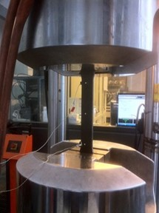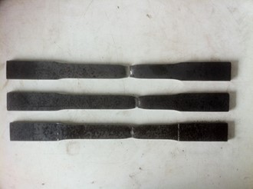
Figure 2.76 - Tensile tests by universal machine with the displacement sensors on the specimen (left) and the three hourglass specimens after rupture (right).
Fig. 2.77 shows the “Force vs Displacement” diagram of each single hourglass specimen test.

Figure 2.77 - “Force vs Displacement” diagrams of the three hourglass specimens after tensile tests.
The approach of the least squares was used for the elastic modulus E determination and obviously applied on each “Stress σ vs Strain ε” graph of the specimens (Fig. 2.78).

Figure 2.78 - “Stress σ vs Strain ε” graphs of the three hourglass specimens after tensile tests.
The mean values from the above diagrams (Figs. 2.77, 2.78) have reported elastic modulus E = 231.3 GPa and yielding stress f_{yk} ≈ 470 MPa. Elastic modulus E was then used within the identification process of the method proposed by Tullini (2013), as will be shown in Section 2.4.4.

Experimental evaluation of the flexural rigidity
Flexural rigidity EI_{exp} estimations of the steel specimen B have been also necessary due to the presence of steel tendons.
Three-point bending tests were performed, respect to the strong and weak axis, for obtaining I-order displacements v₃ and then, EI_{exp} values by the expression of the simply supported beam (2.9).

Test 10: bending test respect to the strong axis
Test 10 configuration is illustrated in Fig. 2.79. The load F applied at the mid-span was equal to 2.5 kN, and pre-stress force P of 21.0 kN was assigned for preserving the specimen without the II-order effects, since expression (2.9) is part of the I-order elastic theory.

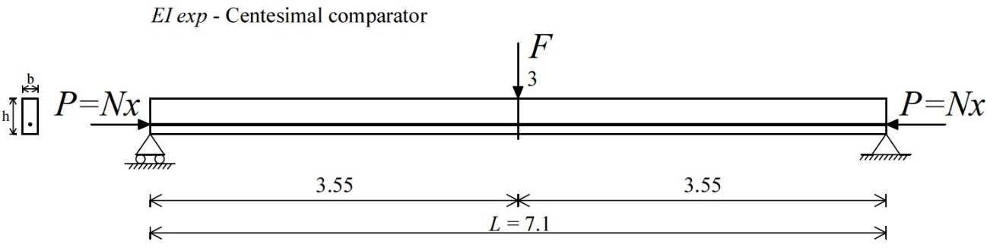
Figure 2.79 - Test 10: Post-tensioned steel specimen B. Experimental setup for the three-point bending test. Units: m.
Then, considering the mean value of the displacements v₃, recorded by one comparator (Case V) for around 10 minutes, equation (2.9) has been able to give the EI_{exp} value of the beam respect to the strong axis:

(2.16)

Test 11: bending test respect to the weak axis
The force F applied was equal to 1.0 kN, while pre-stress load P equal to 2.0 kN was assigned for preserving the beam without the II-order effects. Test 11 configuration is shown in Fig. 2.80.

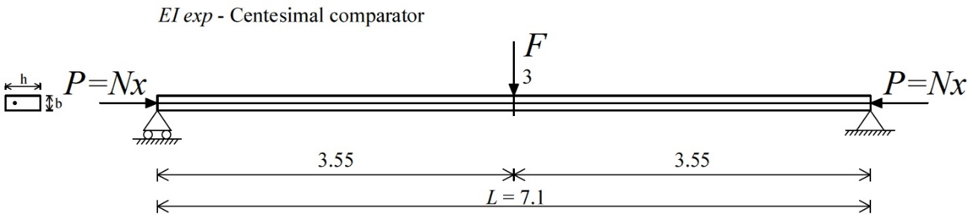
Figure 2.80 - Test 11: Post-tensioned steel specimen B. Experimental setup for the three-point bending test. Units: m.
The procedure has followed Test 10 process in which, by the mean value of the displacements v₃ measured (Case VII), expression (2.9) has been able to provide the EI_{exp} constant respect to the weak axis:

(2.17)

Flexural rigidity EI_{exp} values (Eqs. 2.16, 2.17) were considered in all static methods, since they are parameters of the identification processes, as will be shown in the following sections.

Identifications by means of the method proposed by Tullini (2013)
Section 2.4.4 presents the test results of pre-stress force identifications of steel specimen B by means of the method proposed by Tullini (2013).

Laboratory test results
The laboratory tests have followed the process shown in Section 1.2.2 by seven displacements v_{i} = v(x_{i}) for i = 0, 1, 2, 3, 4, 5, 6 short-term recorded at given sections along the span, after applying the load F.
In general, the experimental results gave excellent agreements between estimated N_{a} and applied pre-stress forces N_{x}, even if the measurements were carried out by centesimal comparators that means sensors with 0.01 mm tolerance.

Test 12: bending tests respect to the strong axis
Case V is considered (Fig. 2.68) and it speculates the boundary conditions as known.
Pre-stress loads P equal to 299.0 kN, 370.0 kN, 448.0 kN and 482.0 kN were assigned, while load F was applied with values of around 20.0 kN, 22.5 kN and 25.0 kN for each pre-stress force P. The moment of inertia I is the exact value of the 150x350x9 mm rectangular box cross section, while elastic modulus E = 231.3 GPa is evaluated experimentally in Section 2.4.2.
Sensitivity analyses, depending on the above parameters, were performed for Case V to analyze the experimental determinations. In detail, pre-stress loads N_{a} were obtained from the process of Section 1.2.2 by the parameters v₀, v₁, v₂, v₃, v₄, v₅, v₆ alternatively modified by adding +0.01 and -0.01 for reproducing possible experimental errors. Conversely, the load F, constant of the parameter ψ, was alternatively multiplied by 0.99 and 1.01. The displacements v_{i} = v(x_{i}) for i = 0, 1, 2, 3, 4, 5, 6 (Fig. 2.68), subjected to each load F modified, were already imposed alternatively modified by adding +0.01 and -0.01, after utilizing the equations (2.1 and 2.2). The tolerance of the analytical displacements was 0.01 mm.
In general, the above operation gave rise to:
- 256 different combinations of simulated experimental values for 5 distinct values of the assumed pre-stress force N_{x}.
Then, the combinations obtained gave rise respectively to (Fig. 2.81):
- 256 estimated pre-stress loads N_{a} for 5 distinct values of the pre-stress force N_{x} (utilizing the process of Section 1.2.2).
Fig. 2.81 shows the correlation on the pre-stress force between the worst estimated values N_{a} and the assumed values N_{x}, in terms of sensitivity analysis functions. Conversely, the blue data points are related to the last 200 set combinations of deflections measured v₀, v₁, v₂, v₃, v₄, v₅, v₆, giving rise totally to 200 identifications N_{a} for each single load combinations P+F.

Figure 2.81 - Test 12: Case V - Post-tensioned steel specimen B. Sensitivity analysis results and comparison between estimated (N_{a}) and measured (N_{x}) values of pre-stress forces (blue data points) considering E(I_{exact}) constant.
Instead, Fig. 2.82 shows the comparison on the pre-stress force between N_{a} and N_{x} when flexural rigidity is equal to EI_{exp} (Eq. 2.16). The sensitivity analysis functions were obtained with the same process cited therein. The blue data points are likewise related to the last 200 set combinations of displacements recorded v₀, v₁, v₂, v₃, v₄, v₅, v₆, giving rise in total to 200 identifications N_{a} for each combination P+F.

Figure 2.82 - Test 12: Case V - Post-tensioned steel specimen B. Sensitivity analysis results and comparison between estimated (N_{a}) and measured (N_{x}) values of pre-stress forces (blue data points) considering EI_{exp} constant.
The estimations N_{a} are excellent since the data points are mostly between the sensitivity analysis functions (Figs. 2.81, 2.82). The load increase F would allow to reduce the range between the maximum and minimum values of the functions and getting reliable identifications N_{a} (with a maximum error in absolute value of 10.0%).

Test 13: bending tests respect to the weak axis
Cases VII and VIII are taken into account (Figs. 2.71, 2.72). The test configurations speculate the end constraints of the simply supported specimen as known and unknown, respectively.
Pre-stress forces P equal to 311.0 kN, 360 kN, 401.0 kN and 452.0 kN were assigned, while load F was applied with values of around 7.5 kN, 10.0 kN and 12.5 kN for each pre-stress force P. The moment of inertia I is the exact value of the 150x350x9 mm rectangular box cross section, while elastic modulus E = 231.3 GPa is evaluated experimentally in Section 2.4.2.
Sensitivity analyses were also carried out for Cases VII and VIII. In particular, pre-stress loads N_{a} were achieved from the process of Section 1.2.2 by the parameters v₀, v₁, v₂, v₃, v₄, v₅, v₆ alternatively modified by adding +0.01 and -0.01, while the load F, constant of the parameter ψ, was alternatively multiplied by 0.99 and 1.01. The displacements v_{i} = v(x_{i}) for i = 0, 1, 2, 3, 4, 5, 6 (Figs. 2.71, 2.72), subjected to each load F modified, were already imposed alternatively modified by adding +0.01 and -0.01, after using the solutions (2.1 and 2.2). The tolerance of the displacements was 0.01 mm.
For both Cases, the above operation gave rise in general to:
- 256 different combinations of simulated experimental values for 5 distinct values of the pre-stress force N_{x}.
The combinations obtained then gave rise respectively to (Fig. 2.83):
- 256 estimated pre-stress loads N_{a} for 5 different values of the pre-stress force N_{x} (procedure of Section 1.2.2).
The colored data points in Fig. 2.83 are related to the last 200 set combinations of the displacements recorded v₀, v₁, v₂, v₃, v₄, v₅, v₆, giving rise totally to 200 experimental identifications N_{a} for each combination P+F. Both Cases VII (K) and VIII (UnK), with known and unknown boundary conditions, are taken into account, respectively. Moreover, the sensitivity analysis functions show the comparison on the pre-stress load between the values N_{a} and N_{x}.

Figure 2.83 - Test 13: Cases VII (K) and VIII (UnK) - Post-tensioned steel specimen B. Sensitivity analysis results and comparison between estimated (N_{a}) and measured (N_{x}) values of pre-stress forces (colored data points).
Table 2.17 summarizes the sensitivity analyses in terms of the determination of N_{a} values, corresponding to the maximum assumed pre-stress force P = 450.0 kN and transversal load F = 12.5 kN. The estimations report a maximum error in absolute value equal to 10.7%.

Table 2.17 - Test 13: Cases VII (K) and VIII (UnK) - Post-tensioned steel specimen B. Sensitivity analysis results in terms of the determination of estimated values (N_{a}).
Test results confirm excellent identifications N_{a} when the beam under investigation has higher slenderness (weak axis) and when, additionally, the greatest load F is assigned (F = 12.5 kN). In fact, for both Cases, the data points are mostly between the functions obtained (Fig. 2.83) with maximum identification error less than 10% (in absolute value). The ductile behavior of steel has allowed to increase the load magnitude F at the mid-span.

Identifications by means of the proposed static method
Section 2.4.5 shows the test results of pre-stress force determinations of steel specimen B by means of the proposed method, described in Section 1.5.

Laboratory test results
Fiber-Bragg-grating differential settlement measurement sensors (FBG-DSM) have provided high-accuracy measurements. The proposed method gave very good agreements between estimated N_{a} and applied pre-stress forces N_{x} using the deflection recorded at the mid-span. In fact, the technique may determine the existing compressive axial load by one reference displacement only, as shown in Section 1.5.1. The tolerance of the experimental deflections was 0.01 mm.

Test 14: bending tests respect to the strong axis
Case V configuration (Fig. 2.68) is taken into account twice. Firstly, considering the displacement measurement v_{i} = v(x_{i}) for i = 3 only (Fig. 2.84) and secondly, considering the measurements v_{i} = v(x_{i}) for i = 1, 3 (Fig. 2.85).

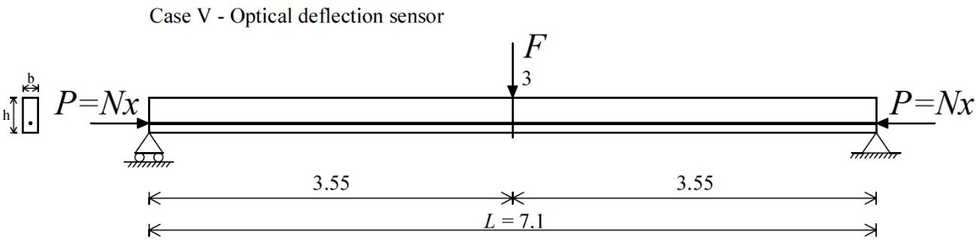
Figure 2.84 - Test 14a: Case V - Post-tensioned steel specimen B. Experimental setup considering one displacement measurement v₃. Units: m.

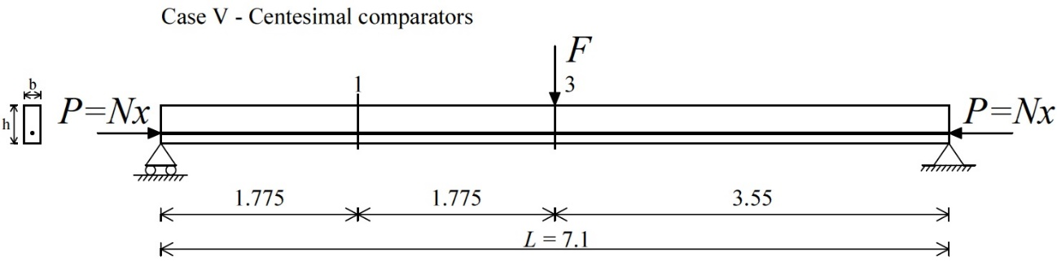
Figure 2.85 - Test 14b: Case V - Post-tensioned steel specimen B. Experimental setup considering two displacement measurements v₁ and v₃. Units: m.
With regards to Test 14a (Fig. 2.84), the recording v₃ is by “FBG-DSM”, while the measurements v₁ and v₃ are from centesimal comparators with regards to Test 14b (Fig. 2.85). Pre-stress forces P and loads F are described in Section 2.4.4.1.1. Flexural rigidity is equal to EI_{exp} (Eq. 2.16).
Sensitivity analyses were obviously performed for both Tests 14a and 14b. Pre-stress loads N_{a} of Test 14a were obtained from the process of Section 1.5.1, while the identifications N_{a} of Test 14b followed the procedure of Section 1.5.2. The parameters v₁, v₃ and ψ were alternatively multiplied by 0.99 and 1.01 for reproducing eventually experimental errors. The deflections v_{i} = v(x_{i}) for i = 1, 3 (Figs. 2.84, 2.85), subjected to each load F modified, were already introduced alternatively multiplied by 0.99 and 1.01, after using the equations (2.1 and 2.2). The tolerance was 0.01 mm.
For Test 14a, the operation cited therein gave rise to:
- 4 different combinations of simulated experimental values for 5 distinct values of the pre-stress force N_{x}.
Unlike, for Test 14b, the operation gave rise totally to:
- 7 different combinations of experimental values likewise for 5 values of the pre-stress force N_{x}.
The combinations then gave rise respectively to:
- 4 estimated pre-stress loads N_{a} for 5 distinct values of the pre-stress force N_{x} - following the procedure of Section 1.5.1 (Fig. 2.86);
- 7 estimated pre-stress loads N_{a} for 5 distinct values of the pre-stress force N_{x} - following the procedure of Section 1.5.2 (Fig. 2.87).
Figs. 2.86 and 2.87 illustrate the comparison on the pre-stress load between the worst estimated N_{a} and the assumed values N_{x} for both tests, in terms of sensitivity analysis functions. Conversely, the blue data points refer to the last 200 set combinations of deflections recorded v₁ and v₃, giving rise in total to 200 identifications N_{a} for each combination P+F.

Figure 2.86 - Test 14a: Case V - Post-tensioned steel specimen B. Sensitivity analysis results and comparison between estimated (N_{a}) and measured (N_{x}) values of pre-stress forces (blue data points and mean values in the table).
Figure 2.87 - Test 14b: Case V - Post-tensioned steel specimen B. Sensitivity analysis results and comparison between estimated (N_{a}) and measured (N_{x}) values of pre-stress forces (blue data points).
Pre-stress load estimations N_{a} have been excellent by “FBG-DSM” at the mid-span (Test 14a) in fact, the displacement v₃ measured with high-accuracy is enough for obtaining very good results (Fig. 2.86). Test 14b has provided more data points outside the maximum and the minimum values of the functions (Fig. 2.87). Anyway, the maximum errors of the sensitivity analysis functions in correspondence of the assumed pre-stress force N_{x} = 450.0 kN are equal to 12.9% and 11.7% for Tests 14a and 14b, respectively.

Test 15: bending tests respect to the weak axis
Case VII configuration is considered (Fig. 2.71), taking into account the deflection measurements v_{i} = v(x_{i}) for i = 1, 3 only, as reported in Fig. 2.88. The boundary conditions of the simply supported specimen are known, according to the formulation of the method.

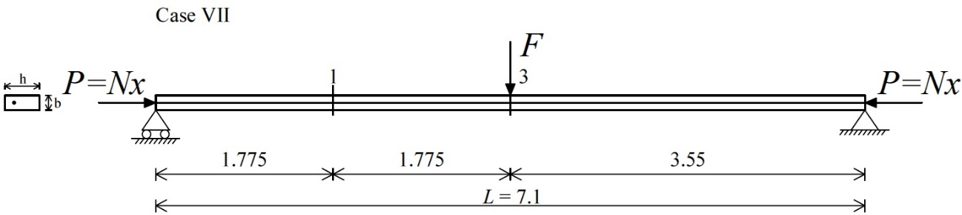
Figure 2.88 - Test 15: Case VII - Post-tensioned steel specimen B. Experimental setup considered for the proposed static method. Units: m.
Pre-stress forces P and loads F were already described in Section 2.4.4.1.2. Flexural rigidity is equal to EI_{exp} (Eq. 2.17).
With regards to the sensitivity analyses, pre-stress loads N_{a} were obtained by the parameters v₁, v₃ and ψ alternatively multiplied by 0.96 and 1.04. The displacements v_{i} = v(x_{i}) for i = 1, 3 (Fig. 2.88), subjected to each load F modified, were already imposed alternatively multiplied by 0.96 and 1.04, after making use of the equations (2.1 and 2.2). The tolerance was 0.01 mm.
The above operation gave rise in general to:
- 7 distinct combinations of simulated experimental values for 5 different values of the assumed pre-stress force N_{x}.
Then, the combinations obtained gave rise respectively to (Fig. 2.89):
- 7 estimated pre-stress loads N_{a} for 5 distinct values of the pre-stress force N_{x}.
Fig. 2.89 shows the sensitivity analysis functions in terms of comparison on the pre-stress force between the values N_{a} and N_{x}. Instead, the blue data points are always corresponding to the last 200 set combinations of displacements v₁ and v₃ recorded, giving rise totally to 200 experimental identifications N_{a} for each combination P+F.

Figure 2.89 - Test 15: Case VII - Post-tensioned steel specimen B. Sensitivity analysis results and comparison between estimated (N_{a}) and measured (N_{x}) values of pre-stress forces (blue data points).
The sensitivity analyses confirm the robustness of the proposed method, in fact, the maximum error in correspondence of the assumed pre-stress force N_{x} = 450.0 kN is equal to 11.2% (in absolute value). Moreover, the identifications N_{a} (blue data points) confirm that the non-destructive method results enough insensitive to the experimental errors, as described about concrete specimen in Section 2.3.5.1.2.

Identifications by means of the Simplified formula of Timoshenko & Gere (1961) and Bazant & Cedolin (1991)
The section presents the experimental identifications N_{a} of steel specimen through the simplified formula of Timoshenko & Gere (1961) and Bazant & Cedolin (1991), illustrated in Section 1.4.

Laboratory test results
Experimental simulations were assumed respect to the weak axis of the specimen only. Test results gave excellent estimations of the N_{a} values taking into account the measurements from centesimal comparators.

Test 16: bending tests respect to the weak axis
Test configuration of the simplified formula is Case VII with the displacement measurement v₃ only, as shown in Fig. 2.90. The end restraints of the simply supported beam are known, according to the concepts of the formula (Eq. 1.28).

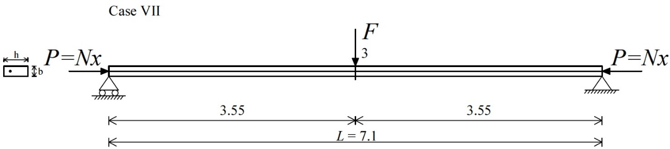
Figure 2.90 - Test 16: Case VII - Post-tensioned steel specimen B. Experimental setup considered for the simplified formula. Units: m.
Pre-stress forces P and loads F are reported in Section 2.4.4.1.2. Flexural rigidity is equal to EI_{exp} (Eq. 2.17) and assumed for buckling load N_{crE} evaluation, since it is parameter of the formula.
Sensitivity analyses were likewise executed. Pre-stress loads N_{a} were achieved from the procedure of Section 1.4.1 by the parameters F and v₃ alternatively multiplied by 0.99 and 1.01, and 0.98 and 1.02, respectively. The v₃ values (Fig. 2.90), calculated by each load F modified, were already imposed in the simplified formula alternatively multiplied by 0.98 and 1.02, after using the solution (2.1). The tolerance was 0.01 mm. As described in Section 1.4.1, first-order displacements v_{I} were determined analytically for each combination P+F and not-modified with any algebraic operation since they are not experimental parameters.
The operation, cited therein, gave rise in total to:
- 4 distinct combinations of simulated experimental values for 5 different values of the pre-stress force N_{x}.
Subsequently, the combinations achieved gave rise respectively to (Fig. 2.91):
- 4 estimated pre-stress loads N_{a} for 5 distinct values of the pre-stress force N_{x} (following the procedure of Section 1.4.1).
The data points in Fig. 2.91 are the experimental identifications N_{a} related to the last 200 values of displacement recorded v₃ for each single combination P+F.

Figure 2.91 - Test 16: Case VII - Post-tensioned steel specimen B. Sensitivity analysis results and comparison between estimated (N_{a}) and measured (N_{x}) values of pre-stress forces (blue data points).
Test 16 gave rise to excellent determinations N_{a} since the blue data points are mainly included into the sensitivity analysis functions (Fig. 2.91). In detail, the maximum error in correspondence of the assumed pre-stress force N_{x} = 450.0 kN is equal to 9.3% (in absolute value).

Identifications by means of the Simplified formula of Galef (1968)
Section 2.4.7 illustrates the analytical pre-stress force identifications on the steel specimen B by the simplified formula of Galef (1968), presented recently by Bonopera et al. (2015).

Numerical test results
The existing pre-stress load P may be identified by the first natural frequencies of the axially unloaded ω_{0I} and loaded ω_{I} beam, if buckling load N_{crE} is a known constant. The extension of the dynamic formula follows the steps of Section 1.6.
Numerical results have confirmed excellent agreements between estimated N_{a} and assumed pre-stress forces N_{x} when the natural frequency analyses have been performed respect to the weak axis.
Experiments could be easily developed in the laboratory recording vibration-based measurements at given cross sections along the element.

Test 17: natural frequency analyses respect to the strong axis
Test 17 configuration is shown in Fig. 2.92: the mid-span section indicates where the vibration-based measurements could be recorded by an accelerometer.

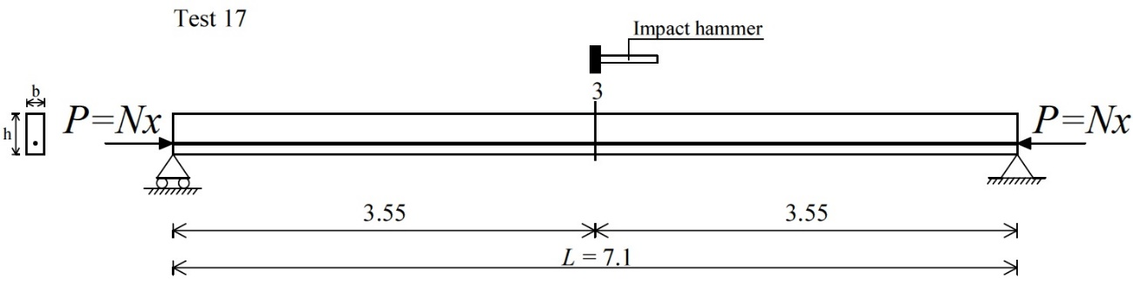
Figure 2.92 - Test 17 - Post-tensioned steel specimen B. Experimental setup respect to the strong axis. Units: m.
The analyses by finite elements model have given the first mode natural frequencies of the axially unloaded ω_{0I} and loaded ω_{I} specimen (Fig. 2.93). The end restraints of the simply supported beam were assumed known L = 7.1 m, according to the concepts of the formula. Buckling load N_{crE,fem} was determined analytically (Eq. 1.31), assuming elastic modulus E of steel equal to 200.0 GPa.

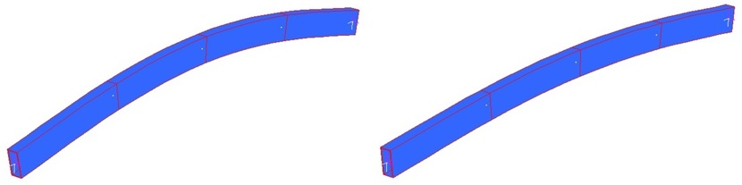
Figure 2.93 - Test 17 - Post-tensioned steel specimen B. Natural frequency analyses by finite elements model: axially unloaded (left) and loaded specimen (right).

With regards to the sensitivity analyses, pre-stress forces N_{a} were obtained from the procedure of Section 1.6 by the parameters ω_{0I} and ω_{I} alternatively multiplied by 0.99 and 1.01 for reproducing eventually experimental errors. The maximum assumed pre-stress load by finite elements model was 750.0 kN for preserving structural steel and pre-stressing tendons in the elastic range.
The above operation gave rise in detail to:
- 4 combinations of simulated experimental values ω_{0I} / ω_{I} for 5 different values of the pre-stress force N_{x}.
The combinations, cited therein, then gave rise respectively to (Fig. 2.94):
- 4 estimated pre-stress forces N_{a} for 5 distinct values of the pre-stress force N_{x} (following the procedure of Section 1.6).
Fig. 2.94 shows the comparison on the pre-stress force between the values N_{a} and the values N_{x} for Test 17, and the table with manipulations and values from the sensitivity analysis corresponding to N_{x} = 750.0 kN.
Figure 2.94 - Test 17 - Post-tensioned steel specimen B. Table of sensitivity analysis for N_{x} = 750.0 kN (left) and comparison between estimated (N_{a}) and assumed (N_{x}) values of pre-stress forces (right).
The numerical identifications N_{a} were unreliable by the first mode frequencies ω_{0I} / ω_{I} obtained respect to the strong axis (Δ > 10.0%) in presence of moderate experimental errors. In specific, the maximum error in absolute value of the sensitivity analysis for N_{x} = 750.0 kN is 24.5% (Fig. 2.94).

Test 18: natural frequency analyses respect to the weak axis
Test 18 setup is reported in Fig. 2.95: vibration-based measurements could be performed at the mid-span, after impacting the specimen by an instrumented hammer.

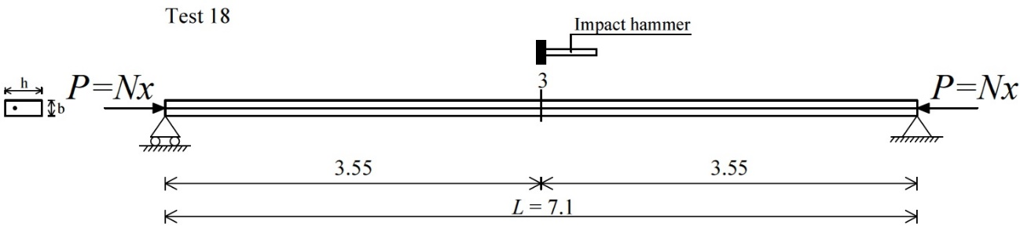
Figure 2.95 - Test 18 - Post-tensioned steel specimen B. Experimental setup respect to the weak axis. Units: m.
Natural frequency analyses by finite elements model, respect to the weak axis, have given the first mode natural frequencies of the axially unloaded ω_{0I} and loaded ω_{I} specimen (Fig. 2.96). Buckling load N_{crE,fem} respect to the weak axis was calculated analytically (Eq. 1.31), assuming elastic modulus of steel E = 200.0 GPa.

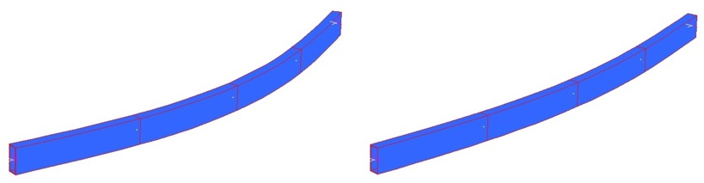
Figure 2.96 - Test 18 - Post-tensioned steel specimen B. Natural frequency analyses by finite elements model: axially unloaded (left) and loaded specimen (right).

The parameters ω_{0I} and ω_{I} were then alternatively multiplied by 0.99 and 1.01, after obtaining them from finite elements model.
The simple algebraic manipulation gave rise to:
- 4 combinations of simulated experimental values ω_{0I} / ω_{I} for 5 distinct values of the assumed pre-stress force N_{x}.
Subsequently, the above combinations gave rise respectively to (Fig. 2.97):
- 4 estimated pre-stress forces N_{a} for 5 distinct values of the pre-stress force N_{x} (following the procedure of Section 1.6).
Fig. 2.97 shows the comparison on the pre-stress load between the values N_{a} and the values N_{x}, and the table with manipulations and values achieved from the sensitivity analysis corresponding to N_{x} = 750.0 kN.
Figure 2.97 - Test 18 - Post-tensioned steel specimen B. Table of sensitivity analysis for N_{x} = 750.0 kN (left) and comparison between estimated (N_{a}) and assumed (N_{x}) values of pre-stress forces (right).
The identifications N_{a} are excellent when the simplified formula makes use of the first mode frequencies ω_{0I}/ω_{I} determined respect to the weak axis (Δ < 10.0%). The maximum error in absolute value of the sensitivity analysis for N_{x} = 750.0 kN is 3.3% (Fig. 2.97).
Sensitivity analyses were moreover performed multiplying alternatively the parameters ω_{0I}/ω_{I} by 0.98 and 1.02, and by 0.97 and 1.03, as shown in Figs. 2.98 and 2.99, respectively. The corresponding results have confirmed that vibration-based measurements, respect to the weak axis, are necessary for obtaining reliable pre-stress force estimations N_{a}.
Figure 2.98 - Test 18b - Post-tensioned steel specimen B. Table of sensitivity analysis for N_{x} = 750.0 kN (left) and comparison between estimated (N_{a}) and assumed (N_{x}) values of pre-stress forces (right).
Figure 2.99 - Test 18c - Post-tensioned steel specimen B. Table of sensitivity analysis for N_{x} = 750.0 kN (left) and comparison between estimated (N_{a}) and assumed (N_{x}) values of pre-stress forces (right).

Discussion and conclusions
The robustness of the static methods has been confirmed by laboratory tests on both post-tensioned specimens. The presented identification results will allow to apply these techniques on a pre-stressed real-scale bridge beam (Chapter 5), since they are able to determine pre-stress loads with low estimation errors (Δ < 10.0%). Pre-stress losses may be then identified considering the initial applied pre-stress load from the design computations of the bridge beam.
The greatest success is referred to the test results from the concrete specimen, since approximate 28,000 bridges exist in Taiwan and most of them are obviously composed of concrete decks. In the near future, safety inspections will become increasingly important for monitoring the pre-stress losses in-situ.
The method proposed by Tullini (2013) yields pre-stress force estimations even if the boundary conditions of the beam under observation are unknown. For concrete members, it is not easy to achieve the high lateral load value, due to the different mechanical behavior of concrete in the serviceability limit state. The displacement measurements with 0.001 mm tolerance, by Fiber-Bragg-grating differential settlement measurement sensors (FBG-DSM), are more reliable in the laboratory due to the different external conditions. In fact, for example, small movements of the end restraints could influence the recorded values in-situ. Moreover, elastic modulus and exact value of the moment of inertia of the cross section are essential for the identification process, without the experimental flexural rigidity identification of the beam.
The proposed static method results efficacious and enough insensitive to the experimental errors with a measuring displacement tolerance of 0.01 mm. The accuracy of the identifications does not depend on the transversal load magnitude; this condition means practically that the method is more achievable in-situ. The experimentally flexural rigidity identification of the member is required.
The simplified formula of Timoshenko & Gere (1961) and Bazant & Cedolin (1991) has provided excellent identifications, but its application on a bridge deck is practically impossible in-situ. In fact, the formula requires the measurement of the displacement contribution given by the pre-stress force when applied respect to the strong axis. The expression may be more suitable when extended on isolated pre-stressed columns. Chapter 3 treats the compression force estimations in columns of space frames, also by means of the simplified formula.
The above static methods do not require any selection of the experimental data to be used in the procedures and, moreover, do not involve any instrumentations during the construction process of the beam. In fact, the sensors must to be fixed externally and at given sections of the span respectively.
Reliable identifications were obtained by means of the simplified formula of Galef (1968), when the first mode natural frequencies were determined respect to the weak axis of the specimens. No selection of the mode shape is required. Vibration-based measurements can be easily executed experimentally on a real bridge in-situ, respect to the weak axis of the pre-stress beams under investigation. Considering the results achieved, the numerical simulations on the post-tensioned prismatic specimens will be developed experimentally at NCREE, as one continuing part of the current research project.

Axial load identifications in beam-columns of regular space frames

Introduction
Chapter 3 presents the extensions of the method proposed by Tullini (2013), and of the simplified formula of Timoshenko and Gere (1961) and Bazant and Cedolin (1991) for beam-columns of regular space frames. The non-destructive procedures were validated by experimental tests on three small-scale 3D prototypes having different column slendernesses. All experiments were conducted at the Department of Civil Engineering of National Taiwan University (NTU) in Taipei, Taiwan.
Compressive axial load identifications in column members may be required to support restoration project of a space frame or to ascertain how far the global structure is to buckling. In spite of the uncertainties regarding dead loads, an accurate evaluation of the in-situ compression forces in columns is relevant to support the safety assessments of the entire construction (Fig. 3.1). At the end of the procedures performed, efficient and suitable practical test solutions have been obtained to be applied on constructions in-situ, within the Structural Health Monitoring field.

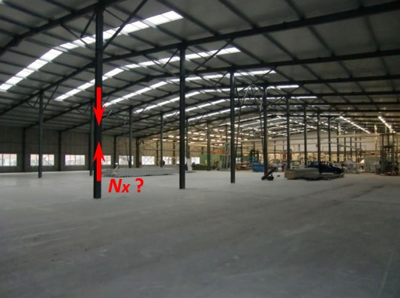
Figure 3.1 - Space frame of an industrial shed.

In particular, Section 3.4 describes the effectiveness of Southwell’s method (Singer et al. 2000) extended experimentally for the first time as non-destructive technique for the global buckling load evaluations of space frames. The regular frame prototypes (3D Frames B and C) are symmetric and, moreover, were considered symmetrically loaded during the experiments.

“Exact” finite elements (EFEs) approach
The “exact” finite elements (EFEs) approach was used as numerical technique for finding the necessarily approximate solutions of the space frame prototypes under examination. Accurate representation of the geometries, inclusion of material properties, easy representation of the solutions and capture of local effects, as the flexural displacement extrapolations, were required. In specific, non-linear (II-order) static and linear buckling analyses were the simulations utilized in this study.
“EFEs” approach makes use of the static stiffness matrix of the 3D Euler-Bernoulli beam for each element of the three space prototypes, as reported in Caironi et al. (1999) and, furthermore, it will be presented in the following Section 3.2.1.

Stiffness matrix of the 3D Euler-Bernoulli beam
“EFEs” approach makes use of the static stiffness matrix K_{E} of the 3D Euler-Bernoulli beam (Fig. 3.2) having coefficients (3.1 and 3.2) taking into account the non-linear effects (II-order).
From the theory of finite elements (FEs), the assembled stiffness matrices K_{E} of each element, oriented in the 3D reference system according to the structure geometry, allow to find the approximate solutions in terms of local effects as stress, strain and deformation.

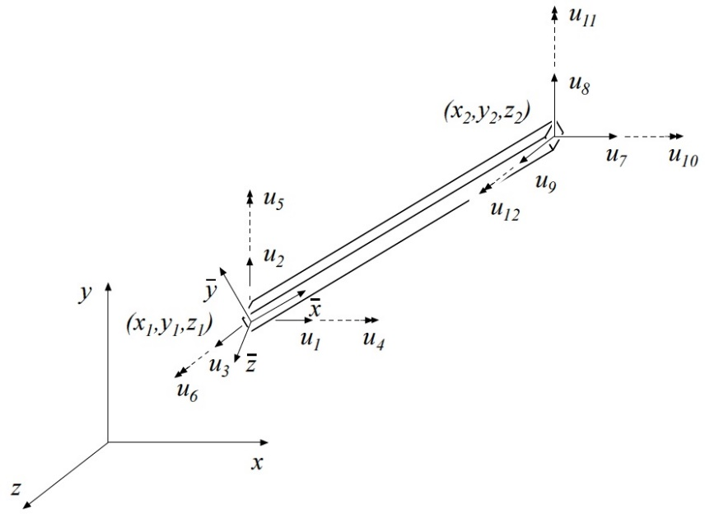
Figure 3.2 - 3D Euler-Bernoulli beam element.

The II-order effects, respect to the y-axis of the 3D Euler-Bernoulli beam (Fig. 3.2), are considered by the following corrective coefficients (3.1):

(3.1)

furthermore, respect to the z-axis (Fig. 3.2), the expressions of the coefficients are the same (3.2):

(3.2)

For the 3D Euler-Bernoulli beam under compression force, the stability functions respect to y- and z- axis are equal to Eqs. 3.3 and 3.4, respectively:

(3.3)

(3.4)

while, with regards to the beam under tensile axial force, the functions have the following terms (3.5 and 3.6), always respect to y- and z- axis:

(3.5)

(3.6)

The constant L is the beam length, while parameters α_{y} and α_{z} are equal to the following formulas (3.7):

(3.7)

where, P is the axial force presents in the element (compression or tensile force), E is the elastic modulus, I_{y} and I_{z} are the moments of inertia respect to y- and z- axis, respectively.
Finally, the global stiffness matrix K_{E} (3.8) is computed by multiplying the corrective coefficients (3.1 and 3.2) for each element of the linear stiffness matrix of 3D Euler-Bernoulli beam (without II-order factors):

(3.8)
The formulation of the stiffness matrix K_{E} (3.8) is suitable for non-linear static analyses of space structures. Conversely, when linear buckling analysis is required, the constants α_{y} and α_{z} take the following form (3.9):

(3.9)

where λ is the load multiplier of the global buckling loads P_{crE} of the space structure, if consists of 3D Euler-Bernoulli beams (as for the prototypes considered in this chapter).

Identifications by means of the method proposed by Tullini (2013)
Section 3.3 reports the compression force identifications using the method proposed by Tullini (2013) on columns of two space frame prototypes in small-scale, having different slenderness, for reproducing in laboratory real frames with homogeneous structural material as steel or aluminium (Fig. 3.3).

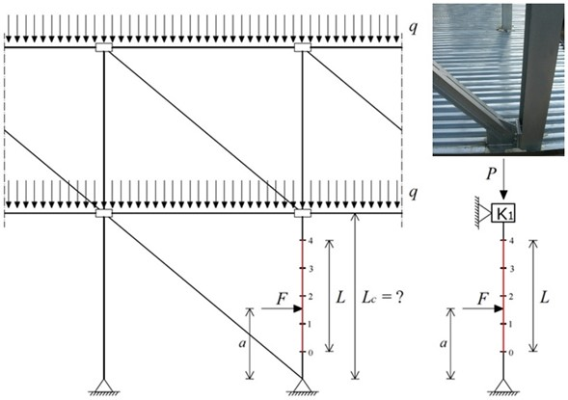
Figure 3.3 - Scheme of a steel frame (left) and beam-column under investigation with unknown top boundary condition (right).

After verifying the method through numerical simulations, experimental tests were carried out on the prototypes (3D Frames A and C) at the Teaching Laboratory of the Department of Civil Engineering of National Taiwan University (NTU) in Taipei, Taiwan.

3D Frame prototype A
3D Frame prototype A was designed with height of 500 mm (L_{C}) and beam spans equal to 400 mm (L_{B}). It is consisted of slender aluminium beams having tube cross section with external diameter of 10.0 mm and tube thickness of 1.0 mm (Fig. 3.4). Yielding stress f_{yk}, ultimate stress f_{uk} and elastic modulus E were experimentally evaluated, as described in Section 3.3.1.1.

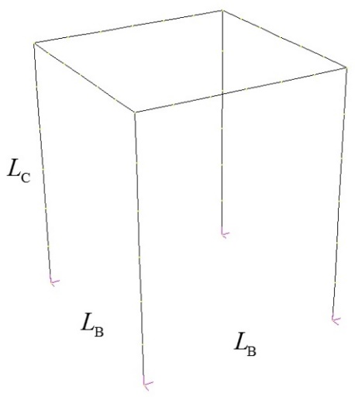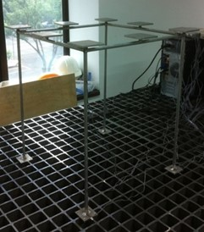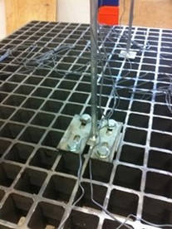
Figure 3.4 - Scheme of 3D Frame prototype A (left). Steel table for the experimental tests (center). External fixed restraints (right).

3D Frame A was externally bounded by fixed restraints on a steel table for laboratory tests, while the internal restraints were created by welding (rigid joints), as depicted in Fig. 3.4. Different external load conditions were applied by adding known cast iron disks on the upper part of the structure, whereas the lateral loads F+F were applied by two 10 kN load cells, with accuracy of 2.0 mV/V, at the mid-height of two columns. The prototype was always preserved in the elastic range during numerical and experimental simulations, considering the buckling load of the columns firstly.
In particular, test configurations were mainly divided as follow:
- Test 1: lateral loads F+F with inward direction (Section 3.3.1.2);
- Test 2: lateral loads F+F with outward direction (Section 3.3.1.3).

Experimental evaluation of the elastic modulus of aluminium
Elastic modulus E, yielding stress f_{yk} and ultimate stress f_{uk} of the aluminium of 3D Frame A were experimentally evaluated. The parameters were obtained as mean values from tensile tests by universal machine on three specimens, created for investigation of the mechanical properties (Fig. 3.5). The hydraulic universal machine MTS 647 used at NCREE has wedge grip, 1000 kN force capacity and 70 MPa maximum pressure.

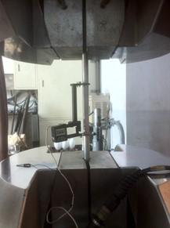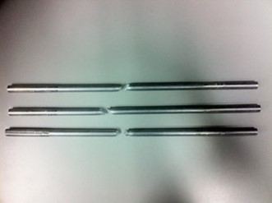
Figure 3.5 - Tensile tests by universal machine with the displacement sensors on the specimen (left) and the three specimens after rupture (right).
The approach of the least squares was used for the elastic modulus E evaluation and applied on each “Stress σ vs Strain ε” graph of the specimens (Fig. 3.6).

Figure 3.6 - “Stress σ vs Strain ε” graphs of the three specimens after tensile tests.
The mean values, from the above diagrams (Fig. 3.6), have reported elastic modulus E = 74.13 GPa, yielding stress f_{yk} ≈ 320 MPa and ultimate stress f_{uk} ≈ 345 MPa. Elastic modulus E was then used as experimental value within the compression force identification process.

Test 1: lateral loads with inward direction
Test 1 configuration takes into account the lateral loads F+F with inward direction at the mid-height of two columns. The boundary conditions of the right column under investigation of 3D Frame A are considered unknown.
Cases I and II refer when external point loads P+P+P+P applied at each column and, in detail, as follow:
- Case I: five- measurements considering the distance between the extreme sensors L = 333.3 mm (Fig. 3.7);
- Case II: five- measurements considering the distance between the extreme sensors equal to the column length L = 500 mm (Fig. 3.7).

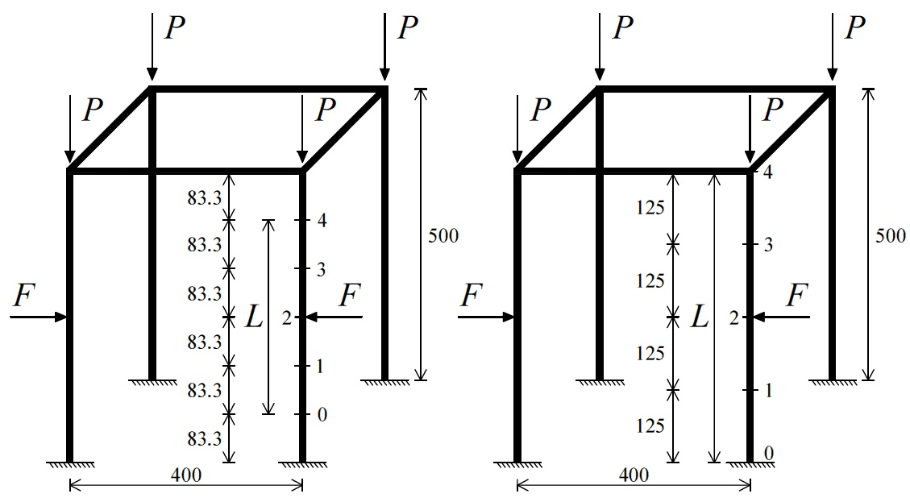
Figure 3.7 - Test 1: Cases I (left) and II (right) - 3D Frame prototype A. Test setup with location of the instrumented sections. Units: mm.
Conversely, Cases III and IV refer when external distributed load q condition assigned:
- Case III: five- measurements considering the distance between the extreme sensors L = 333.3 mm (Fig. 3.8);
- Case IV: five- measurements considering the distance between the extreme sensors equal to the column length L = 500 mm (Fig. 3.8).

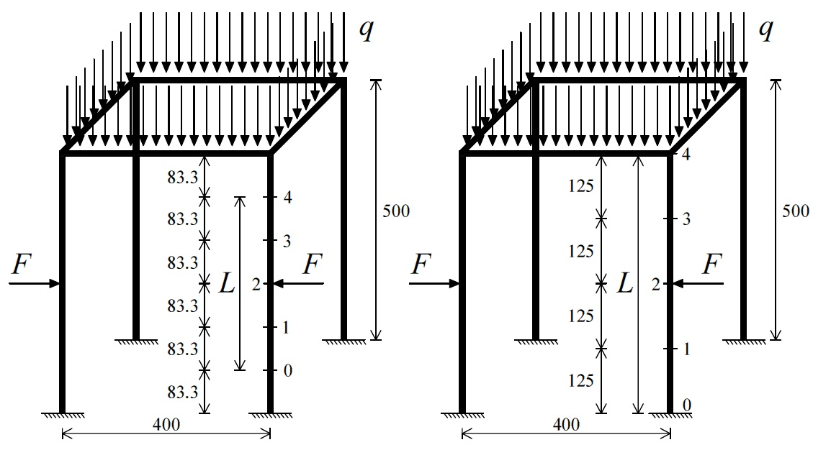
Figure 3.8 - Test 1: Cases III (left) and IV (right) - 3D Frame prototype A. Test setup with location of the instrumented sections. Units: mm.
The cases, cited therein, were performed numerically and experimentally as illustrated in the following sections.

Test 2: lateral loads with outward direction
As described above, test 2 takes into account the lateral loads F+F with outward direction at the mid-height of two columns. The end restraints of the right column under examination are considered unknown.
Cases I and II refer when external point loads P+P+P+P applied at each column:
- Case I: five- measurements considering the distance between the extreme sensors L = 333.3 mm (Fig. 3.9);
- Case II: five- measurements considering the distance between the extreme sensors equal to the column length L = 500 mm (Fig. 3.9).

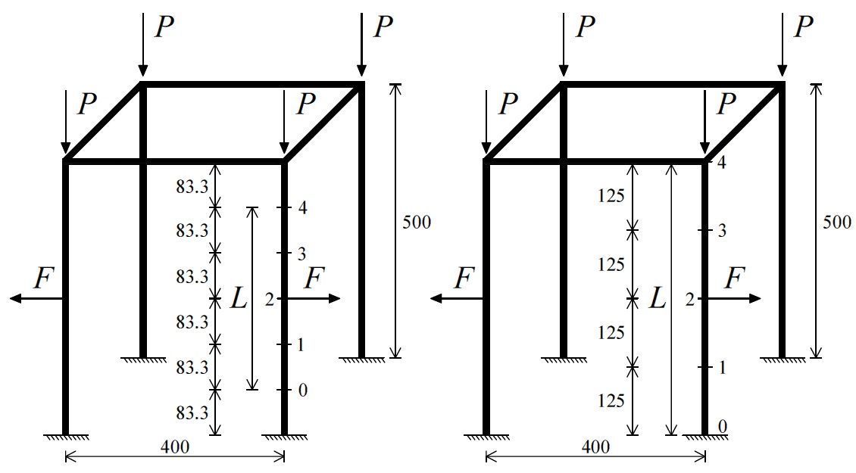
Figure 3.9 - Test 2: Cases I (left) and II (right) - 3D Frame prototype A. Test setup with location of the instrumented sections. Units: mm.
Unlike, Cases III and IV are the configurations when external distributed load q condition assigned:
- Case III: five- measurements considering the distance between the extreme sensors L = 333.3 mm (Fig. 3.10);
- Case IV: five- measurements considering the distance between the extreme sensors equal to the column length L = 500 mm (Fig. 3.10).
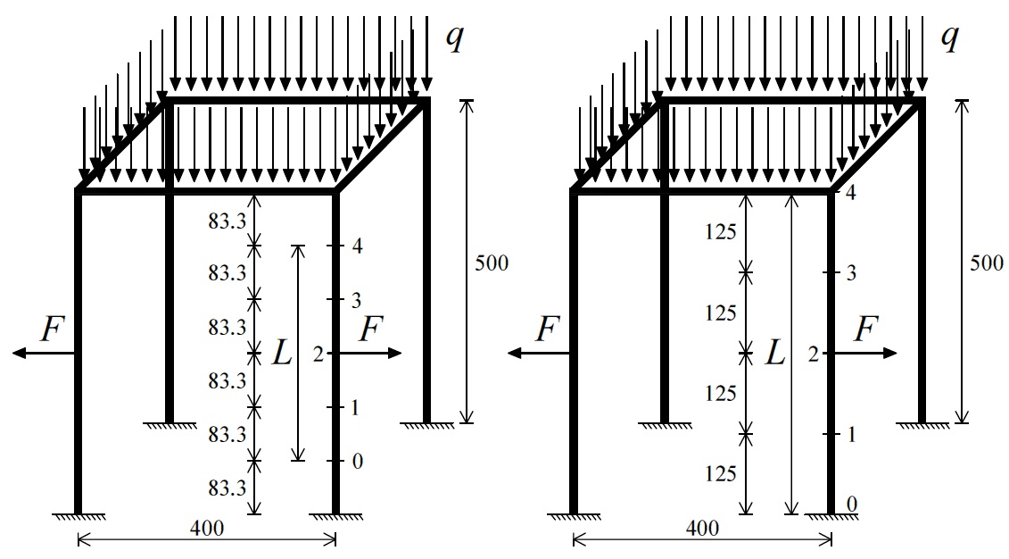
Figure 3.10 - Test 2: Cases III (left) and IV (right) - 3D Frame prototype A. Test setup with location of the instrumented sections. Units: mm.
Cases of Test 2 were developed numerically and experimentally as it will be shown in the following sections.

Results

Exact identifications
Lateral loads F+F applied at the mid-height were 53.9+53.9 N and 58.8+58.8 N when external point loads P+P+P+P assigned at each column, while they were 49+49 N and 53.9+53.9 N when external distributed loads q applied. Elastic modulus E of aluminium was 63.5 GPa. Cases I and III of Tests 1 and 2 were the configurations considered, already depicted in Figs. 3.7, 3.8, 3.9 and 3.10. The external load values are listed in Figs. 3.11, 3.12.
Bending test with five- measurements utilized the procedure of Section 1.2.1. Compressive axial loads N_{a}, present in the right column under investigation, were achieved by the exact parameter values v₀, v₁, v₂, v₃, v₄ and ψ. The length L was assumed to be equal to 333.3 mm in the analytical value N_{a} = n EI/L², since the end restraints of the column were taken into account as unknown.
The displacement parameters v_{i} = v(x_{i}) for i = 0, 1, 2, 3, 4 (Figs. 3.7, 3.8, 3.9 and 3.10), subjected to each loads F+F and each external load, were imposed after obtaining them from non-linear static analysis by “EFEs” model of 3D Frame A, without any geometric imperfection inserted. “EFEs” approach was already described in Section 3.2. The displacements, having tolerance of 0.000001 mm, were extrapolated after applying F+F and considering the typically external load as initial displacement reference condition. This last configuration is perfectly able to simulate the method’s application on a space frame in-situ.
Once the parameters v₀, v₁, v₂, v₃, v₄ achieved, a set of estimated compressive axial loads N_{a} was obtained for each test case of 3D Frame A as follow:
- 8 estimated axial loads N_{a} for Case I of Test 1 (Fig. 3.11);
- 5 estimated axial loads N_{a} for Case III of Test 1 (Fig. 3.11);
- 8 estimated axial loads N_{a} for Case I of Test 2 (Fig. 3.12);
- 5 estimated axial loads N_{a} for Case III of Test 2 (Fig. 3.12).

Figure 3.11 - Test 1: Cases I and III - 3D Frame prototype A. Comparison between estimated (N_{a}) and assumed (N_{x}+∆N_{x}) values of compressive axial forces of the right column.

Figure 3.12 - Test 2: Cases I and III - 3D Frame prototype A. Comparison between estimated (N_{a}) and assumed (N_{x}+∆N_{x}) values of compressive axial forces of the right column
The procedure of the test cases simulated is outlined in Section 1.2.1.
Figs. 3.11 and 3.12 show the comparison between the estimated values N_{a} and the assumed values N_{x}+∆N_{x} of the compressive axial forces. The method is not affected by model errors when applied on regular space frames using the exact parameters v₀, v₁, v₂, v₃, v₄ and ψ with very high accuracy. Moreover, applying the lateral loads F+F allows to identify the N_{x} values without the additional axial force contribution ∆N_{x} given by loads F+F, since ∆N_{x} = 0. The assumed N_{x} and N_{x}+∆N_{x} axial forces, corresponding to the right column, were obtained by means of “EFEs” model of the prototype.

Laboratory tests
Lateral loads F+F applied at the mid-height were 53.9+53.9 N and 58.8+58.8 N when external point loads P+P+P+P assigned at each column, while they were 49+49 N and 53.9+53.9 N when external distributed loads q applied on the upper part of the prototype. Elastic modulus E = 74.13 GPa is evaluated experimentally in Section 3.3.1.1. The laboratory test configurations are the same ones developed numerically in the previous section and depicted in Figs. 3.7, 3.8, 3.9 and 3.10. The external loads applied are listed in Tables 3.10, 3.11, 3.12 and 3.13.
The corresponding displacements v_{i} = v(x_{i}) for i = 0, 1, 2, 3, 4 of the deflected shape of the right column under observation were short-term recorded by centesimal comparators for each test case (Figs. 3.7, 3.8, 3.9 and 3.10). The deflections v_{i} = v(x_{i}) were measured after applying F+F and considering the typically external load (P+P+P+P or q) by cast iron disks as initial displacement reference condition (Figs. 3.13 and 3.14). Two 10 kN load cells, with accuracy of 2.0 mV/V, connected to data loggers were used to impose the loads F+F (Fig. 3.15).

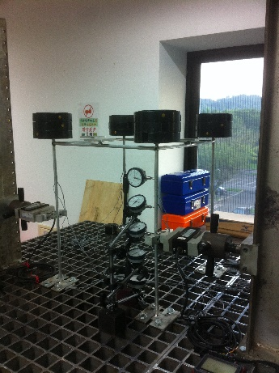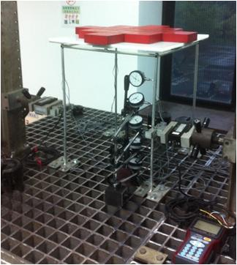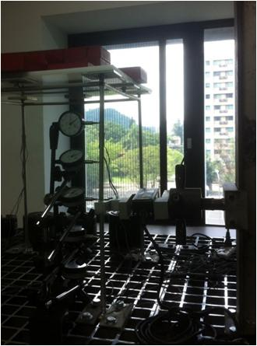
Figure 3.13 - Test 1 - 3D Frame prototype A. Case I (left) and Case III configuration (center) with the deflection of the right column (right).
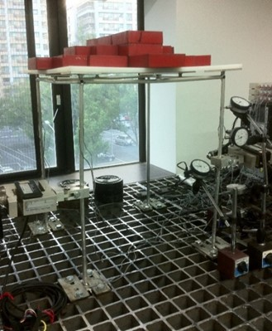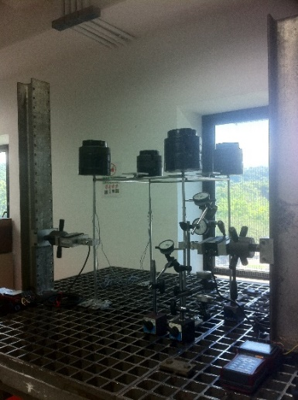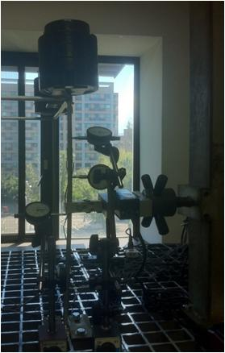
Figure 3.14 - Test 2 - 3D Frame prototype A. Case III (left) and Case I configuration (center) with the arrangement of the centesimal comparators (right).
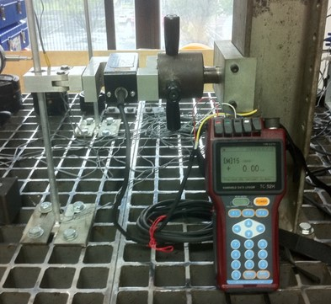
Figure 3.15 - Load cell at the height-span of the right column connected to data logger.
In total, the following experimental combination values v₀, v₁, v₂, v₃, v₄ and ψ were carried out for each test configuration case:
- 10 different combination values for Case I of Test 1 (Tables 3.1, 3.2, 3.3);
- 6 different combination values for Case III of Test 1 (Tables 3.4, 3.5);
- 8 different combination values for Case I of Test 2 (Tables 3.6, 3.7);
- 6 different combination values for Case III of Test 2 (Tables 3.8, 3.9).

Table 3.1 - Experimental combination values for Case I of Test 1.
Table 3.2 - Experimental combination values for Case I of Test 1.

Table 3.3 - Experimental combination values for Case I of Test 1.

Table 3.4 - Experimental combination values for Case III of Test 1.

Table 3.5 - Experimental combination values for Case III of Test 1.

Table 3.6 - Experimental combination values for Case I of Test 2.

Table 3.7 - Experimental combination values for Case I of Test 2.

Table 3.8 - Experimental combination values for Case III of Test 2.

Table 3.9 - Experimental combination values for Case III of Test 2.
3D Frame A was always preserved in the elastic range during experiments. It is worth specifying that every single combination of external load and lateral forces F+F did not reach the yield stress in the prototype, according to the preliminary calculations of the theory of elastic stability.
Compression forces N_{a} of the right column under examination were obtained by the experimental values v₀, v₁, v₂, v₃, v₄ and ψ, following the procedure of Section 1.2.1. The length L was assumed to be equal to 333.3 mm, since the boundary conditions of the column were considered unknown. In specific, a set of axial forces N_{a} was achieved for each configuration case:
- 10 estimated axial loads N_{a} for Case I of Test 1 (Fig. 3.16 and Table 3.10);
- 6 estimated axial loads N_{a} for Case III of Test 1 (Fig. 3.16 and Table 3.11);
- 8 estimated axial loads N_{a} for Case I of Test 2 (Fig. 3.17 and Table 3.12);
- 6 estimated axial loads N_{a} for Case III of Test 2 (Fig. 3.17 and Table 3.13).

Figure 3.16 - Test 1: Cases I and III - 3D Frame prototype A. Comparison between estimated (N_{a}) and measured (N_{x}+∆N_{x}) values of compressive axial forces of the right column.

Table 3.10 - Test 1: Case I - 3D Frame prototype A. Comparison between estimated (N_{a}) and measured (N_{x}+∆N_{x}) values of compressive axial forces of the right column.

Table 3.11 - Test 1: Case III - 3D Frame prototype A. Comparison between estimated (N_{a}) and measured (N_{x}+∆N_{x}) values of compressive axial forces of the right column.

Figure 3.17 - Test 2: Cases I and III - 3D Frame prototype A. Comparison between estimated (N_{a}) and measured (N_{x}+∆N_{x}) values of compressive axial forces of the right column.

Table 3.12 - Test 2: Case I - 3D Frame prototype A. Comparison between estimated (N_{a}) and measured (N_{x}+∆N_{x}) values of compressive axial forces of the right column.

Table 3.13 - Test 2: Case III - 3D Frame prototype A. Comparison between estimated (N_{a}) and measured (N_{x}+∆N_{x}) values of compressive axial forces of the right column.
From the comparison between the estimated N_{a} and the measured values N_{x}+∆N_{x} (Figs. 3.16 and 3.17), experimental results confirm excellent compression force determinations N_{a}, in fact, almost all identification errors were less than 10% in terms of absolute value, as depicted in Tables 3.10, 3.11, 3.12 and 3.13.

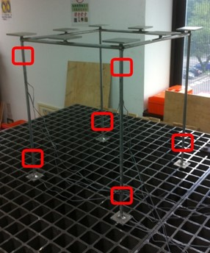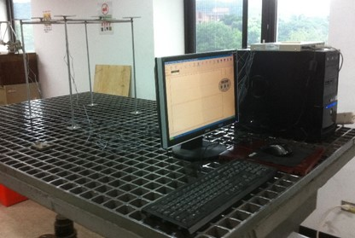
Figure 3.18 - 3D Frame prototype A. Section points of the strain gauges placed at diametrically opposite position (left) and PC for data acquisition (right).
Linear strains in one-direction were measured by 1+1 gauges (with gauge length of 5 mm) placed at diametrically opposite position at 6 section points of the prototype (Fig. 3.18). The corresponding strain values were recorded with 1 Hz frequency for a time period around 1 minute (Fig. 3.18), after applying the loads F+F. The mean strain values, from the 1+1 gauges of the 2 sections on the right column, have then used to evaluate the existing N_{x}+∆N_{x} axial loads using the formulas of elastic theory.

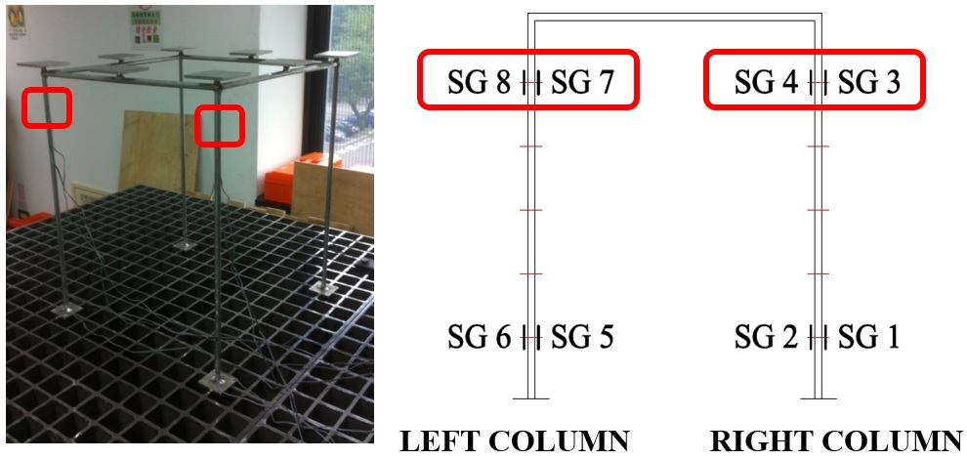
Figure 3.19 - 3D Frame prototype A. Section points of the strain gauges at the upper part of the columns.

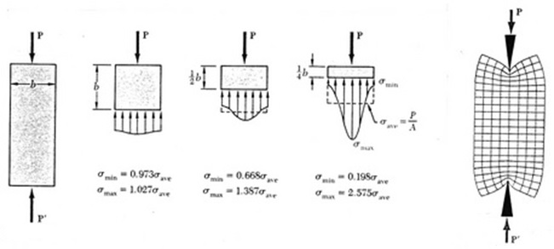
Figure 3.20 - Saint Venant’s principle for slender beam-column under compression force.
The strain gauges at the upper part of the columns (ns. 3 - 4 - 7 - 8) were placed at appropriate distance from the application points of the external loads (Fig. 3.19), according to the Saint Venant’s principle. This elastic theory principle points that stress and strain distributions are not uniform in the immediate vicinity of load application in a slender compression member (Fig. 3.20).
Sensitivity analyses were also performed for Cases I, II, III and IV of both test configurations, for verifying the determinations N_{a} (Tables 3.10, 3.11, 3.12 and 3.13). The maximum magnitudes F+F of tests equal to 58.8+58.8 N and 53.9+53.9 N were considered respectively. The moment of inertia I is the exact value of the tube cross section, while elastic modulus E = 74.13 GPa is determined experimentally in Section 3.3.1.1.
In specific, compressive axial loads N_{a} were obtained from the process of Section 1.2.1 (Eq. 1.19) by the parameters v₀, v₁, v₂, v₃, v₄ and F+F alternatively modified by adding +0.01 and -0.01 for reproducing eventually experimental errors. The deflections v_{i} = v(x_{i}) (Figs. 3.7, 3.8, 3.9 and 3.10), subjected to each loads F+F modified, were already imposed alternatively modified by adding +0.01 and -0.01, after obtaining them from non-linear static analysis by means of “EFEs” model of the prototype (without any geometric imperfection). The displacements, with 0.01 mm tolerance, were extrapolated after applying F+F and considering the typically external load as initial displacement reference condition.
For each test case (I, II, III and IV), the above operation gave rise to:
- 64 different combinations of simulated experimental values for 5 distinct assumed axial forces N_{x}+∆N_{x}.
Then, the combinations achieved gave rise respectively to (Figs. 3.21 and 3.22):
- 64 estimated compressive axial loads N_{a} for 5 distinct N_{x}+∆N_{x} values (using the process of Section 1.2.1).
Figs. 3.21 and 3.22 show the comparison between the worst estimated values N_{a} and the assumed values N_{x}+∆N_{x} for Cases I, II, III and IV of both Tests 1 and 2, in terms of sensitivity analysis functions.

Figure 3.21 - Test 1: 3D Frame prototype A. Sensitivity analysis results of Cases I, II, III, IV and comparison between estimated (N_{a}) and measured (N_{x}+∆N_{x}) values of compressive axial forces of Cases I and III (grey and red data points).

Table 3.14 - Test 1: Cases II and IV - 3D Frame prototype A. Sensitivity analysis results in terms of the determination of estimated values (N_{a}).

Figure 3.22 - Test 2: 3D Frame prototype A. Sensitivity analysis results of Cases I, II, III, IV and comparison between estimated (N_{a}) and measured (N_{x}+∆N_{x}) values of compressive axial forces of Cases I and III (green and blue data points).

Table 3.15 - Test 2: Cases II and IV - 3D Frame prototype A. Sensitivity analysis results in terms of the determination of estimated values (N_{a}).
Tables 3.14 and 3.15 summarize the sensitivity analyses in terms of the determination of values N_{a}, corresponding to the assumed maximum axial loads N_{x}+∆N_{x} by “EFEs” model. The best identifications N_{a} are given when the greatest possible distance between the extreme sensors on the right column L = 500 mm is adopted.
The points N_{a} are completely between the sensitivity analysis functions (Figs. 3.21 and 3.22), even if the maximum range functions are larger than the identification errors of the points. Load cells and centesimal comparators have provided accurate lateral loads F+F and deflection v₀, v₁, v₂, v₃, v₄ measurements, since they are parameters of the non-destructive method.

3D Frame prototype C
The second prototype, called 3D Frame C, was designed with height of 680 mm (L_{C}) and beam spans of 400 mm (L_{B}). It is consisted of slender aluminium beams having tube cross section with external diameter of 10.0 mm and tube thickness of 1.0 mm (Fig. 3.23). Yielding stress f_{yk}, ultimate stress f_{uk} and elastic modulus E were experimentally evaluated as illustrated in Section 3.3.1.1, since the company used the same structural material of 3D Frame A.
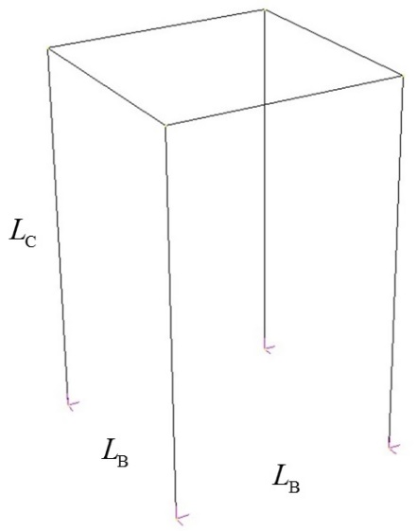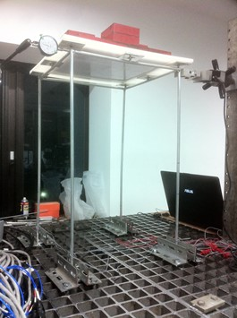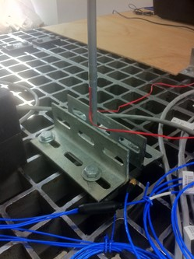
Figure 3.23 - Scheme of 3D Frame prototype C (left). Steel table for the experimental tests (center). External fixed restraints (right).

3D Frame C was externally bounded by fixed restraints on a steel table for laboratory tests, while the internal restraints were created by welding (rigid joints), as depicted in Fig. 3.23. External distributed load values were applied by adding known cast iron disks on the upper part of the prototype. Whereas, the transversal loads F+F were assigned by two 10 kN load cells, with accuracy of 2.0 mV/V, at the mid-height of two columns, as performed for 3D Frame A (Fig. 3.15). The specimen was always obviously preserved in the elastic range during numerical and experimental simulations.
Test configuration with the loads F+F having inward direction was developed analytically and experimentally (Section 3.3.2.1).

Laboratory test results
Considering the sensitivity analysis results of 3D Frame A (Section 3.3.1.4.2), additional tests of the method proposed by Tullini (2013) were executed on 3D Frame C, prototype with higher slenderness of the columns, already described in Section 3.3.2.
Lateral forces F+F applied at the mid-height were 29.4+29.4 N, 58.8+58.8 N and 68.6+68.6 N. Elastic modulus E = 74.13 GPa is evaluated experimentally in Section 3.3.1.1. Tests with three- and five- measurements, depicted in Fig. 3.24, were performed concurrently. Using this configuration, it has been possible to speculate known (K) and unknown (UnK) boundary conditions of the right column respectively, according to the method’s formulation. The applied distributed loads q are listed in Tables 3.16 and 3.17.

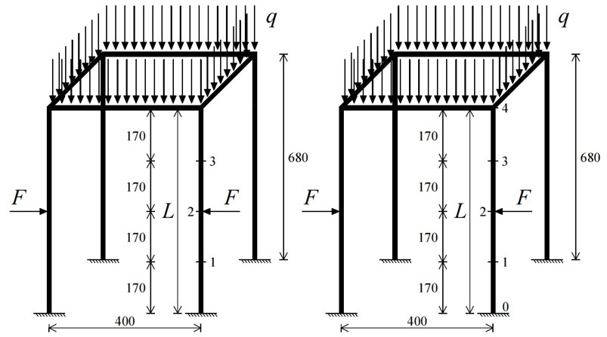
3 POINTS (K) 5 POINTS (UnK)
Figure 3.24 - 3D Frame prototype C. Bending test configurations with three- (left) and five-measurements (right). Tests setup with location of the instrumented sections. Units: mm.
The displacements v_{i} = v(x_{i}) for i = 0, 1, 2, 3, 4 of the deflected shape of the right column under examination were short-term recorded by centesimal comparators for each test configuration (Fig. 3.24). The deflections v_{i} = v(x_{i}) were measured after applying F+F and considering the typically external distributed load q by cast iron disks as initial displacement reference condition (Fig. 3.25).

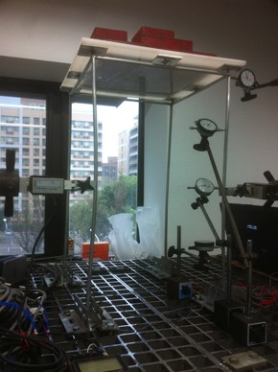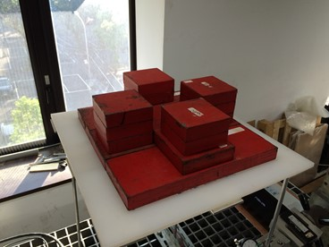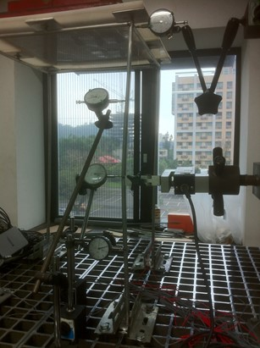
Figure 3.25 - 3D Frame prototype C. Bending tests with three- and five-measurements performed concurrently (left). Symmetrical distributed load q applied (center). Deflection of the right column and arrangement of the centesimal comparators (right).
In short, the experimental combination values v₀, v₁, v₂, v₃, v₄ and ψ were obtained for each configuration, as follow:
- 45 different combinations for bending test with three-measurements;
- 45 different combinations for bending test with five-measurements.
Any combination of distributed load and forces F+F did not reach the yield stress in the specimen.
Bending test with three-measurements makes use of Eq. (1.19), reduces to Eq. (10) in Tullini et al. (2012) since v₀ = v₄ = 0, while bending test with five-measurements utilizes Eq. (1.19) correlated to the process of Section 1.2.1. The constant L was considered equal to the column height in the analytical value N_{a} = n EI/L².
Then, compression forces N_{a} were obtained by the experimental parameters v₀, v₁, v₂, v₃, v₄ and ψ, following the procedures cited therein. In specific, a set of N_{a} values was achieved for every test configuration:
- 45 estimated axial loads N_{a} for bending test with three-measurements (Table 3.16 and Fig. 3.26);
- 45 estimated axial loads N_{a} for bending test with five-measurements (Table 3.17 and Fig. 3.26).

Table 3.16 - 3D Frame prototype C. Bending tests with three-measurements. Comparison between estimated (N_{a}) and measured (N_{x}±∆N_{x}) values of compressive axial forces of the right column.

Table 3.17 - 3D Frame prototype C. Bending tests with five-measurements. Comparison between estimated (N_{a}) and measured (N_{x}±∆N_{x}) values of compressive axial forces of the right column.
Tables 3.16 and 3.17 confirm excellent results since the compression forces N_{a} were identified with errors less than 10% (in absolute value) in almost all combinations with larger forces F+F.
Linear strains were measured through 1+1 gauges fixed at diametrically opposite position at 6 section points of the specimen. The corresponding strains were subsequently recorded with 1 Hz frequency for a time period around 1 minute, as made for 3D Frame A. The mean strain values, from the 1+1 gauges of the 2 sections on the right column, have then used to evaluate the existing compression forces N_{x}±∆N_{x}. Moreover, Saint Venant’s principle was followed (Fig. 3.20) since the gauges at the upper part of the columns were placed at appropriate distance from the application points of the external loads.
Sensitivity analyses were in addition developed for both configurations, considering all magnitudes F+F of the static tests. The moment of inertia I is the exact value of the tube cross section, while elastic modulus E = 74.13 GPa is evaluated experimentally in Section 3.3.1.1.
In detail, compressive axial forces N_{a} were given from the processes of Section 1.2.1 (Eq. 1.19) by the parameters v₀, v₁, v₂, v₃, v₄ and F+F alternatively modified by adding +0.01 and -0.01. The displacements v_{i} = v(x_{i}) (Fig. 3.24), subjected to each loads F+F modified, were already imposed alternatively modified by adding +0.01 and -0.01, after achieved them from non-linear static analysis by “EFEs” model of 3D Frame C (without any geometric imperfection). The deflections v₀, v₁, v₂, v₃, v₄, with tolerance of 0.01 mm, were deduced after applying F+F and considering the typically external load as initial displacement reference condition.
The above operation gave rise to:
- 16 combinations of simulated experimental values for 5 distinct assumed axial forces N_{x}+∆N_{x}, regarding to bending test with three-measurements;
- 64 combinations of simulated experimental values for 5 distinct assumed axial forces N_{x}+∆N_{x}, regarding to bending test with five-measurements.
The combinations then gave rise respectively to (Fig. 3.26):
- 16 estimated compressive axial loads N_{a} for 5 distinct N_{x}+∆N_{x} values, regarding to bending test with three-measurements;
- 64 estimated compressive axial loads N_{a} for 5 distinct N_{x}+∆N_{x} values, regarding to bending test with five-measurements.
Fig. 3.26 shows the comparison between the worst estimated N_{a} and the assumed values N_{x}+∆N_{x} of the right column in terms of sensitivity analysis functions.

Figure 3.26 - 3D Frame prototype C. Sensitivity analysis results of bending tests with three- and five-measurements and comparison between estimated (N_{a}) and measured (N_{x}+∆N_{x}) values of compressive axial forces of both cases (blue and red data points).

Table 3.18 - 3D Frame prototype C. Bending test with three-measurements. Sensitivity analysis results in terms of the determination of estimated values (N_{a}).

Table 3.19 - 3D Frame prototype C. Bending test with five-measurements. Sensitivity analysis results in terms of the determination of estimated values (N_{a}).
Tables 3.18 and 3.19 summarize the sensitivity analysis results in terms of the identification of values N_{a}, corresponding to the assumed maximum axial load N_{x}+∆N_{x}. Excellent approximations of the axial force N_{a} were obtained even when the end restraints were speculated as unknown (UnK), in fact, estimation errors are less than 10% (in absolute value).
The points N_{a} are mostly between the sensitivity analysis functions (Fig. 3.26). The extension of the method on space frames confirms the same test operations when applied on single beams - see the conclusions in Sections 2.2.1.1.2 and 2.2.1.2.2. Space frame systems under investigations, constituted of columns with higher slenderness, provide better identifications for compression forces.

Global buckling load identification by means of the Southwell’s method
This work presents the Southwell’s method (Singer et al. 2000), described in Section 1.3, extended as diagnostic technique for the first time for the global buckling load evaluations of space frames. Experiments were executed on two frame prototypes (3D Frames B and C) at the Teaching Laboratory of the Department of Civil Engineering of National Taiwan University in Taipei, Taiwan.

3D Frame prototype B
3D Frame B is the third prototype presented in this work. The specimen was designed with height (L_{C}) and beam spans of 400 mm (L_{B}). It is composed of aluminium beams having tube cross section with external diameter of 10.0 mm and tube thickness of 1.0 mm (Fig. 3.27). Yielding stress f_{yk}, ultimate stress f_{uk} and elastic modulus E were experimentally evaluated as showed in Section 3.3.1.1, since the company used the same structural material of 3D Frames A and C.

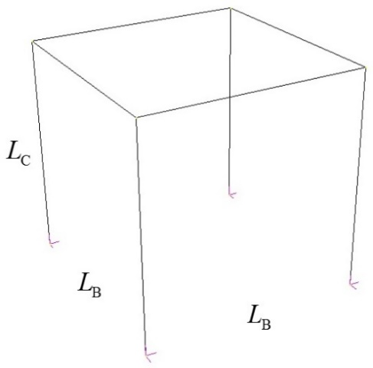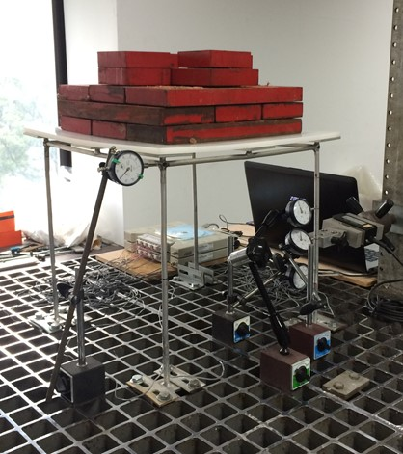
Figure 3.27 - Scheme of 3D Frame prototype B (left). Steel table for the experimental tests (center). External fixed restraints (right).

3D Frame B was externally bounded by fixed restraints on a steel table for laboratory tests. The internal restraints were made by welding (rigid joints), as depicted in Fig. 3.27. The increment of the external distributed load q, test condition of the Southwell’s method, was performed by adding known cast iron disks on the upper part of the structure. A rigid plastic plate was necessary for creating the support for the load q (Fig. 3.30).

Laboratory test results
Symmetrically loaded symmetric space frames, as 3D Frame B taken into account in this study, can buckle symmetrically in the horizontal X- and Z-directions (Fig. 3.28). Global buckling loads q_{crE,expS} respect both X- and Z-directions were determined experimentally.

X-direction
Two “v_{x} versus v_{x}/q” diagrams were considered as “Southwell plots”, according to the principles of the non-destructive technique, already illustrated in Section 1.3. The v_{x} values are the lateral deﬂections in X-direction corresponding to the sections ns. 1 - 3 of the right column v_{1x}, v_{3x} (Fig. 3.28), obtained by increasing the distributed load q.

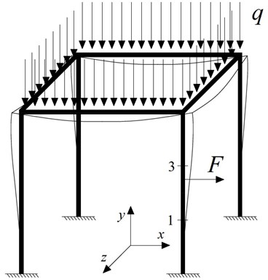
Figure 3.28 - 3D Frame prototype B. Test configuration and setup with location of the instrumented sections.
Therefore, the functions of Southwell’s method take the following form for the point sections ns. 1 - 3, respectively:

(3.10)

(3.11)

where, v_{01x} and v_{03x} are the initial deﬂections in X-direction (imperfections) corresponding to the sections ns. 1 - 3 (Fig. 3.28).

Figure 3.29 - 3D Frame prototype B. Distributed load-displacement v_{1x} curve (left). Distributed load-displacement v_{3x} curve (right).
Static test was developed by applying a constant lateral force F = 24.5 N, close to the mid-height of the column (Fig. 3.28), during the load increment q and until the non-linear behavior of the global structure. Fig. 3.29 represents the distributed load-displacement v_{x} curves until the maximum load q assigned.

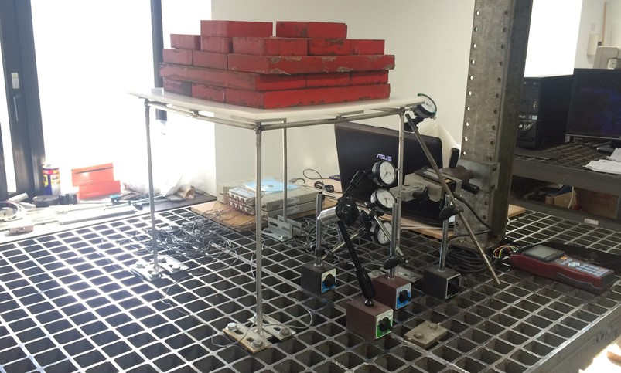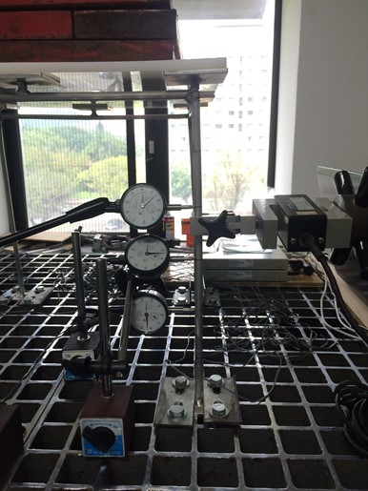
Figure 3.30 - 3D Frame prototype B. View of the experimental test (left). Arrangement of the centesimal comparators and lateral load F applied by 10 kN load cell (right).
The last parts of the two “v_{x} versus v_{x}/q” diagrams may be considered “Southwell plots” (Figs. 3.31 and 3.32) and the corresponding inverse slopes, achieved by least squares method, yield the global buckling loads q_{crEx,expS} of the space structure in X-direction (Eqs. 3.10 and 3.11). The simultaneous data of deflections v_{x} were obviously recorded for each load increments q during test.

Figure 3.31 - 3D Frame prototype B. “v_{1x} vs. v_{1x}/q” diagram (1a). Southwell plot (1b).

Figure 3.32 - 3D Frame prototype B. “v_{3x} vs. v_{3x}/q” diagram (2a). Southwell plot (2b).

The linear buckling analysis of 3D Frame B, by means of “EFEs” model (Fig. 3.33), was utilized as technique for finding the load multiplier λ_{crEx,EFE} of the global buckling load q_{crEx,EFE}, including geometric representation and elastic modulus E = 74.13 GPa identified experimentally.

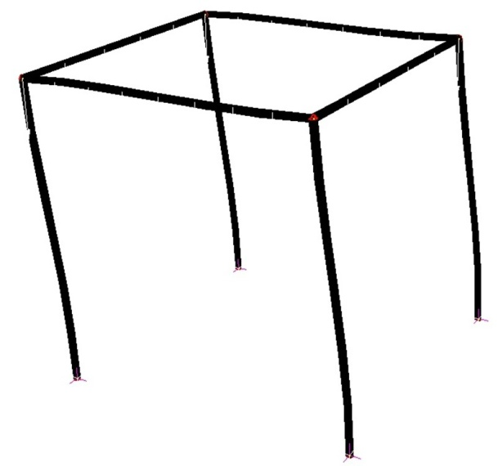
Figure 3.33 - 3D Frame prototype B. Linear buckling analysis by means of “EFEs” model.

The multiplier λ_{crEx,EFE} has reported the value of 2.483 for the corresponding global buckling load q_{crEx,EFE} equal to 2.483 N/mm. With regards to this analytical value, experimental global buckling load q_{crEx,expS}, from Southwell’s method, corresponding to section n. 3 has provided the best approximation with the value of 2.622 N/mm and, therefore, an identification error of 5.6%.

Z-direction
Two “v_{z} versus v_{z}/q” diagrams were developed as “Southwell plots”, as made respect to X-direction. The v_{z} values represent the displacements in Z-direction corresponding to the sections ns. 1 - 3 of the right column v_{1z}, v_{3z} (Fig. 3.34), obtained by increasing the symmetrically distributed load q.

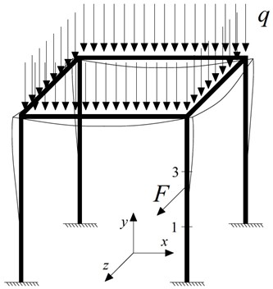
Figure 3.34 - 3D Frame prototype B. Test configuration and setup with location of the instrumented sections.
Thus, the functions of Southwell’s method take the following form for the sections ns. 1 - 3, respectively:

(3.12)

(3.13)

where, v_{01z} and v_{03z} are the initial deﬂections in Z-direction (imperfections) corresponding to the sections ns. 1 - 3 (Fig. 3.34).

Figure 3.35 - 3D Frame prototype B. Distributed load-displacement v_{1z} curve (left). Distributed load-displacement v_{3z} curve (right).
Experiment was performed by applying a constant lateral force F = 24.5 N, close to the mid-height of the column (Fig. 3.34), during the load increment q and until the non-linear behavior of the structure. Fig. 3.35 shows the distributed load-displacement v_{z} curves until the maximum load q applied.
The last parts of the two “v_{z} versus v_{z}/q” graphs are finally considered “Southwell plots” (Figs. 3.36 and 3.37) and the corresponding inverse slopes, obtained by least squares method, yield the global buckling loads q_{crEz,expS} of the prototype in Z-direction (Eqs. 3.12 and 3.13). The simultaneous data of deflections v_{z} were obviously measured for each load increments q.

Figure 3.36 - 3D Frame prototype B. “v_{1z} vs. v_{1z}/q” diagram (1a). Southwell plot (1b).

Figure 3.37 - 3D Frame prototype B. “v_{3z} vs. v_{3z}/q” diagram (2a). Southwell plot (2b).

The linear buckling analysis respect to Z-direction of 3D Frame B, by means of “EFEs” model (Fig. 3.38), was used for finding the load multiplier λ_{crEz,EFE} of the global buckling load q_{crEz,EFE}, including geometric representation and elastic modulus E = 74.13 GPa evaluated experimentally.

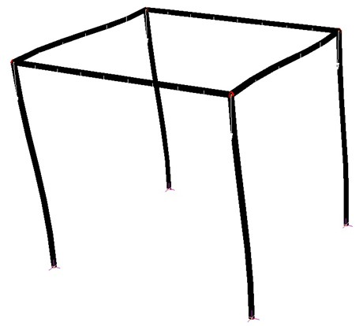
Figure 3.38 - 3D Frame prototype B. Linear buckling analysis by means of “EFEs” model.

The multiplier λ_{crEz,EFE} has reported the value of 2.483 for the corresponding buckling load q_{crEz,EFE} obviously equal to 2.483 N/mm. With regards to this numerical value, experimental global buckling load q_{crEz,expS}, from Southwell’s method, corresponding to section n. 1 has furnished the best approximation with the value of 2.396 N/mm and, hence, an estimation error of -3.5%.

3D Frame prototype C
Southwell’s method (Singer et al. 2000) was moreover performed on 3D Frame C, specimen illustrated in Section 3.3.2. The prototype was externally bounded by fixed restraints on a steel table for experimental tests, while a rigid plastic plate was used for creating the support for the load q (Fig. 3.41).

Laboratory test results
3D Frame C was loaded symmetrically (Fig. 3.39). Global buckling loads q_{crE,expS} respect both X- and Z-directions were identified experimentally.

X-direction
Two “v_{x} versus v_{x}/q” graphs were considered as “Southwell plots”, according to the non-destructive method’s principles. The v_{x} values are the lateral deﬂections in X-direction corresponding to the sections ns. 1 - 3 of the right column v_{1x}, v_{3x} (Fig. 3.39), obtained by incrementing the distributed load q.

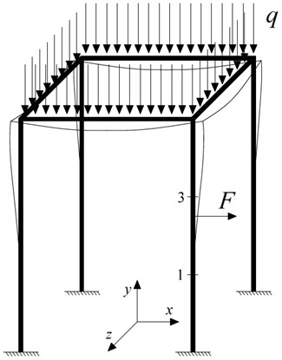
Figure 3.39 - 3D Frame prototype C. Test configuration and setup with location of the instrumented sections.
Thus, the functions of Southwell’s method take the form of expressions (3.10) and (3.11) for the sections ns. 1 - 3, respectively.

Figure 3.40 - 3D Frame prototype C. Distributed load-displacement v_{1x} curve (left). Distributed load-displacement v_{3x} curve (right).
Static test was performed with a constant transversal force F = 14.7 N applied, close to the mid-height of the column (Fig. 3.39), during the load increment q. Fig. 3.40 illustrates the distributed load-displacement v_{x} curves in correspondence of the sections ns. 1 - 3 until the maximum load q applied.

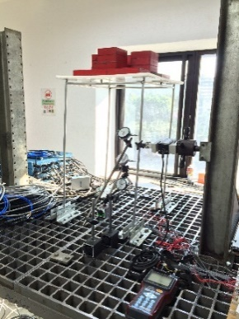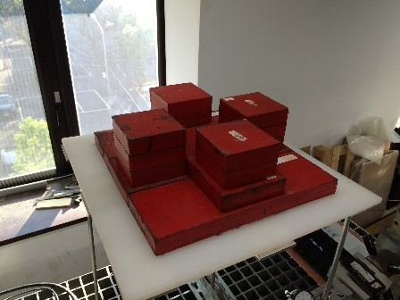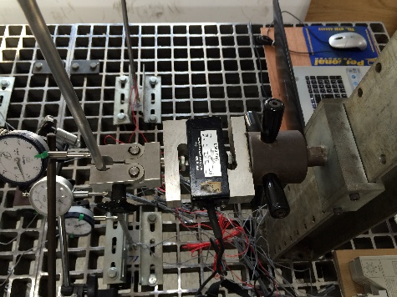
Figure 3.41 - 3D Frame prototype C. View of the experimental test (left). Symmetrical distributed load q applied (center). Lateral load F applied by 10 kN load cell on the right column (right).
The last parts of the two “v_{x} versus v_{x}/q” graphs are finally considered “Southwell plots” (Figs. 3.42 and 3.43) and the corresponding inverse slopes, achieved by least squares method, yield the global buckling loads q_{crEx,expS} of the structure in X-direction (Eqs. 3.10 and 3.11). The simultaneous data of displacements v_{x} were obviously recorded for each load increments q.

Figure 3.42 - 3D Frame prototype C. “v_{1x} vs. v_{1x}/q” diagram (1a). Southwell plot (1b).

Figure 3.43 - 3D Frame prototype C. “v_{3x} vs. v_{3x}/q” diagram (2a). Southwell plot (2b).

The linear buckling analysis of 3D Frame C, by means of “EFEs” model (Fig. 3.44), was used as numerical technique for finding the load multiplier λ_{crEx,EFE} of the global buckling load q_{crEx,EFE}, including geometric representation and elastic modulus E = 74.13 GPa identified experimentally.

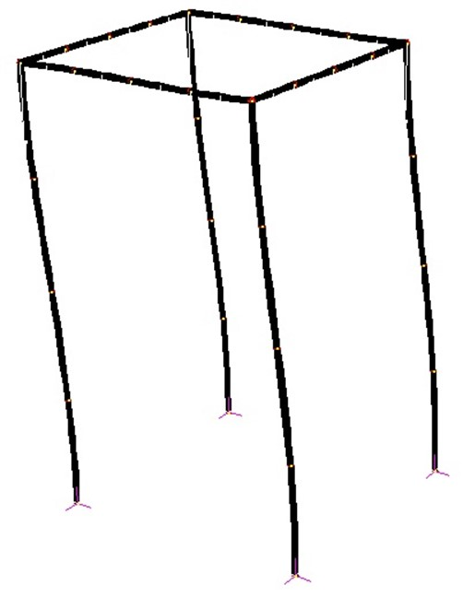
Figure 3.44 - 3D Frame prototype C. Linear buckling analysis by means of “EFEs” model.

The multiplier λ_{crEx,EFE} obtained was equal to 0.963 for the corresponding global buckling load q_{crEx,EFE} of 0.963 N/mm. With regards to this numerical value, experimental global buckling load q_{crEx,expS}, from Southwell’s method, corresponding to section n. 1 has furnished the best approximation with the value of 1.044 N/mm and, therefore, an identification error of 8.4%.

Z-direction
Two “v_{z} versus v_{z}/q” graphs were developed as “Southwell plots”, as made respect to X-direction. The v_{z} values represent the deflections in Z-direction corresponding to the point sections ns. 1 - 3 of the right column v_{1z}, v_{3z} (Fig. 3.45), achieved by increasing the load q.
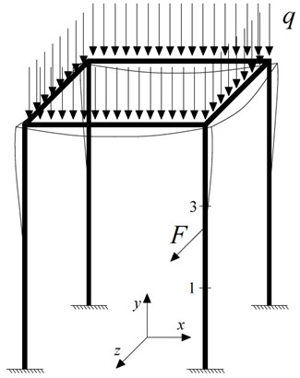
Figure 3.45 - 3D Frame prototype C. Test configuration and setup with location of the instrumented sections.
Thus, the functions of Southwell’s method take the forms (3.12) and (3.13) for the sections ns. 1 - 3, respectively.

Figure 3.46 - 3D Frame prototype C. Distributed load-displacement v_{1z} curve (left). Distributed load-displacement v_{3z} curve (right).
Static test was developed by applying a constant lateral force F = 14.7 N, close to the mid-height of the column (Fig. 3.45), during the load increment q and until the non-linear behavior of the prototype. Fig. 3.46 shows the load-displacement v_{z} curves until the maximum load q value applied.

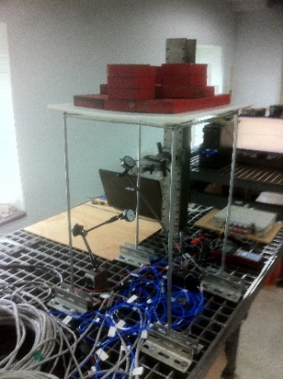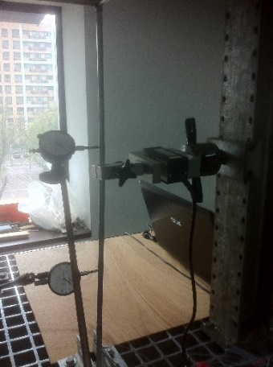
Figure 3.47 - 3D Frame prototype C. View of the static test (left). Symmetrical distributed load q applied (center). Lateral load F applied by 10 kN load cell and arrangement of the centesimal comparators (right).
The last parts of the two “v_{z} versus v_{z}/q” diagrams can be finally considered “Southwell plots” (Figs. 3.48 and 3.49) and the corresponding inverse slopes, obtained by least squares method, provide the global buckling loads q_{crEz,expS} in Z-direction (Eqs. 3.12 and 3.13).

Figure 3.48 - 3D Frame prototype C. “v_{1z} vs. v_{1z}/q” diagram (1a). Southwell plot (1b).

Figure 3.49 - 3D Frame prototype C. “v_{3z} vs. v_{3z}/q” diagram (2a). Southwell plot (2b).

The linear buckling analysis respect to Z-direction of 3D Frame C, by means of “EFEs” model (Fig. 3.50), was utilized for obtaining the load multiplier λ_{crEz,EFE} of the global buckling load q_{crEz,EFE}, including overall geometry and elastic modulus E = 74.13 GPa.

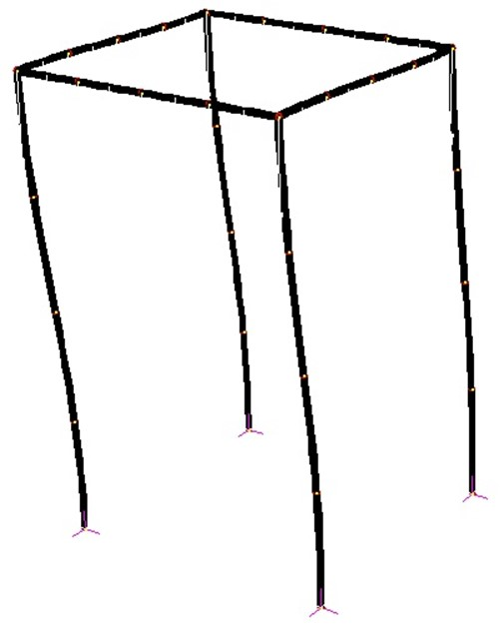
Figure 3.50 - 3D Frame prototype C. Linear buckling analysis by means of “EFEs” model.

The multiplier λ_{crEz,EFE} has reported the value of 0.963 for the buckling load q_{crEz,EFE} obviously equal to 0.963 N/mm. In fact, symmetrically loaded symmetric space frames can buckle symmetrically in the horizontal X- and Z-directions. With regards to the last analytical value, buckling load q_{crEz,expS} from Southwell’s method corresponding to section n. 1 has provided the best approximation with the value of 1.011 N/mm and, hence, an identification error of 5.0%.
The insertion of the global buckling load q_{crE,expS} within the space frame’s finite element model allows to capture the single buckling loads of the beam-columns. Accurate representation of the geometries, knowledge of the boundary conditions and inclusion of material properties are necessary in the model. Local buckling loads of columns belonging to space frames are parameters of the simplified formula of Timoshenko and Gere (1961) and Bazant and Cedolin (1991), and of the simplified formula of Galef (1968).

Identifications by means of the Simplified formula of Timoshenko & Gere (1961) and Bazant & Cedolin (1991)
Section 3.5 presents the compression force determinations using the simplified formula of Timoshenko and Gere (1961) and Bazant and Cedolin (1991), described in Section 1.4, applied for the first time as non-destructive method. The space prototypes under investigation were 3D Frames B and C. All experiments were conducted at the Teaching Laboratory of the Department of Civil Engineering of National Taiwan University (NTU) in Taipei, Taiwan.

3D Frame prototype B
3D Frame B was externally bounded by fixed restraints on a steel table for laboratory tests (Section 3.4.1). Distinctly distributed loads q were assigned by adding known cast iron disks on the upper part of the prototype, whereas the lateral load F was applied through one 10 kN load cell, having 2.0 mV/V accuracy, at the top of the right column under examination. The specimen was always obviously preserved in the elastic range during simulations, taking into account the global buckling load q_{crEx} firstly.
Numerical tests were executed before experiments as follow:
- Test 3: lateral load F at the mid-span (Section 3.5.1.1);
- Test 4: lateral load F at the top (Section 3.5.1.2).

Test 3: lateral load at the mid-span
Test 3 considers the displacements v₁ and v_{tot} recorded at the top of the right column after applying F = 25 N at the mid-span, as depicted in Fig. 3.51. “EFEs” model of 3D Frame B was used for finding the deflections v₁ and v_{tot} by first- and second-order static analysis respectively, without any geometric imperfection inserted. External and internal boundary conditions of the specimen were known, according to the principles of the formula (Eq. 1.28).

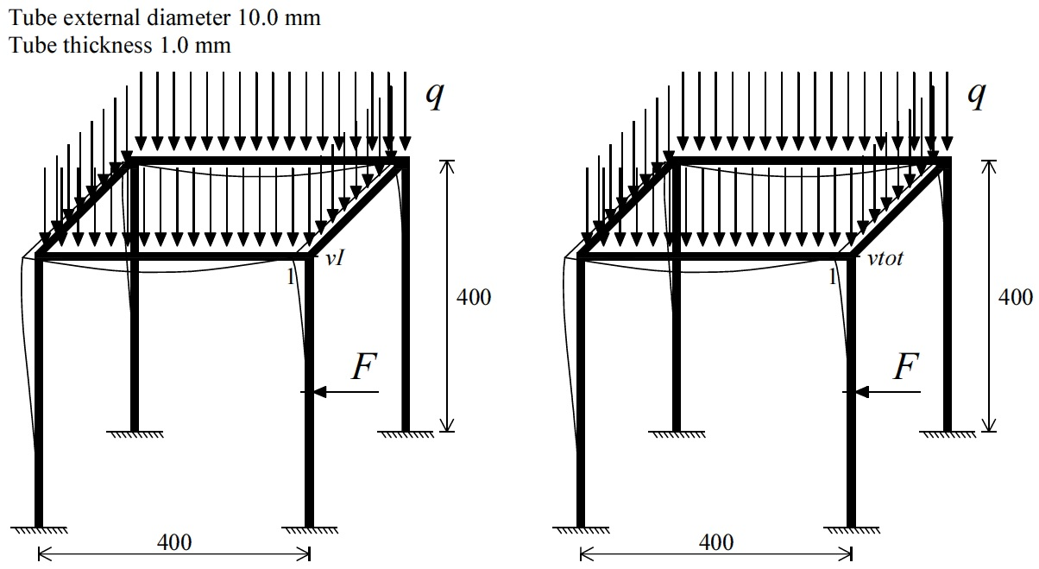
Figure 3.51 - Test 3: 3D Frame prototype B. First- (left) and second-order static analysis (right). Tests setup with location of the instrumented sections. Units: mm.
The moment of inertia I is the exact value of the tube cross section, while elastic modulus E was assumed equal to 63.5 GPa. Buckling load N_{crEx,EFE} = 836 N of the right column was also evaluated analytically by “EFEs” model of the prototype.
Sensitivity analyses were performed. In specific, compression forces N_{a} of the right column were obtained from the procedure of Section 1.4.1 with the parameters F and v_{tot} (Fig. 3.51), alternatively multiplied by 0.99 and 1.01. Unlike, deflection v₁ was not-modified with any manipulation since it is not experimental parameter of the simplified formula.
The above operation gave rise in total to:
- 4 different combinations of simulated experimental values for 5 distinct assumed compression forces N_{x}-∆N_{x}.
Subsequently, the above combinations gave rise respectively to:
- 4 estimated compression forces N_{a} for 5 distinct compression forces N_{x}-∆N_{x} (following the procedure steps in Section 1.4.1).

Table 3.20 - Test 3: 3D Frame prototype B. Table of the sensitivity analysis results for N_{x}-∆N_{x} = 298 N.
Table 3.20 shows the sensitivity analysis results in terms of the determination of values N_{a}, corresponding to the maximum force N_{x}-∆N_{x} obtained by “EFEs” model of the prototype. The axial force contribution ∆N_{x} in the right column, given by applying F with inward direction, is negative (N_{x}-∆N_{x}), where N_{x} is the contribution given by the distributed load q only (if compression forces are assigned positive sign).

Test 4: lateral load at the top
Test 4 considers the displacement measurements v₁, v_{tot} and load F = 20 N application at the top, as shown in Fig. 3.52. The operations of the sensitivity analyses were the same ones of Test 3, as described in the previous Section 3.5.1.1.

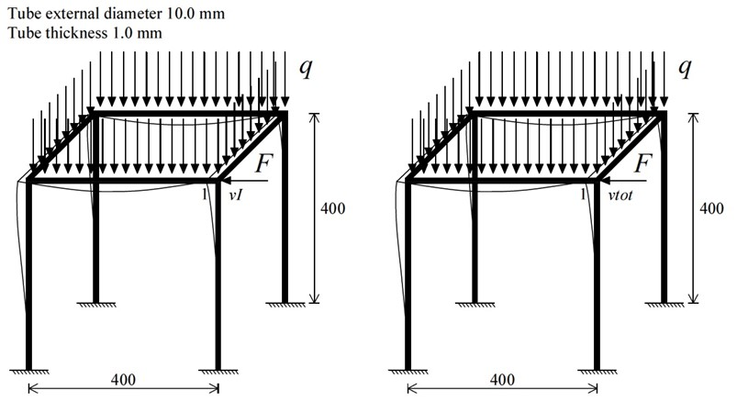
Figure 3.52 - Test 4: 3D Frame prototype B. First- (left) and second-order static analysis (right). Tests setup with location of the instrumented sections. Units: mm.
Table 3.21 summarizes the sensitivity analysis in terms of the determination of values N_{a}, corresponding to the maximum compression force N_{x}-∆N_{x} in the right column under investigation. The axial force contribution ∆N_{x}, given by applying F with inward direction, is negative (N_{x}-∆N_{x}) equally to Test 3.

Table 3.21 - Test 4: 3D Frame prototype B. Table of the sensitivity analysis results for N_{x}-∆N_{x} = 292 N.
Test 4 gave rise to better identifications N_{a} since the maximum error in correspondence of the maximum compression force N_{x}-∆N_{x} is equal to 8.3% (in absolute value).
In both tests, all ratios between displacements v_{tot} and v₁, obtained from the sensitivity analyses, are greater than 1.2 (v_{tot} /v₁ > 1.2).

Laboratory test results
Considering the sensitivity analyses of Sections 3.5.1.1 and 3.5.1.2, experimental simulations of the method were executed assigning the lateral load F at the top only.

X-direction
Lateral load F was 24.5 N, while elastic modulus E = 74.13 GPa is identified experimentally. Firstly, displacement v₁ was recorded according to the applied load F on the unloaded prototype and subsequently, displacements v_{tot} were measured on the loaded prototype (Fig. 3.53). Test configuration in absence of the distributed load q allows the experimental deflections v₁ without considering II-order effects in the column. Force F does not provide any II-order effect since it is assigned transversally. The experimental measurements v₁ may be considered I-order displacements and utilized in the simplified formula (Eq. 1.28), according to the theoretical concepts.
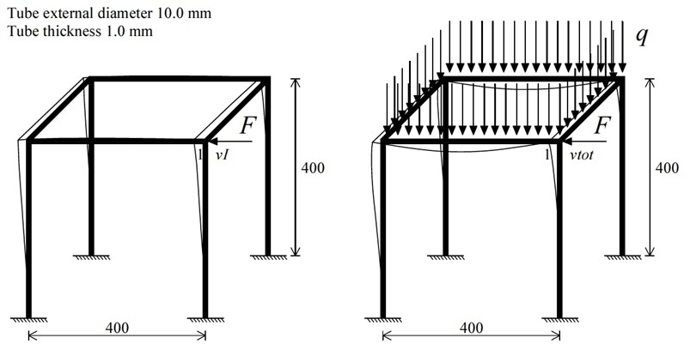
Figure 3.53 - 3D Frame prototype B. Unloaded (left) and loaded prototype (right). Tests setup with location of the instrumented sections. Units: mm.
The displacements v₁ and v_{tot} at the top of the deflected prototype were short-term recorded by centesimal comparator, as shown in Figs. 3.54, 3.55, 3.56 and, moreover, the unloaded specimen was considered as initial displacement reference condition in both configurations (Fig. 3.53). The applied distributed loads q are listed in Tables 3.22 and 3.23.
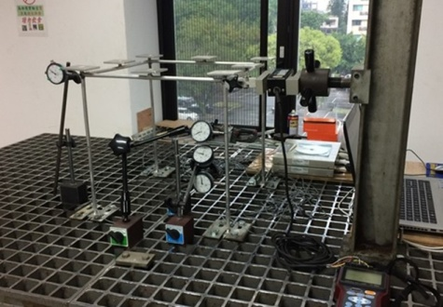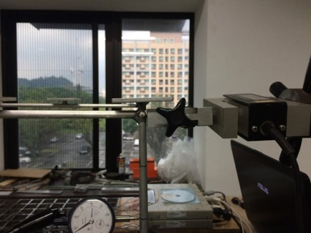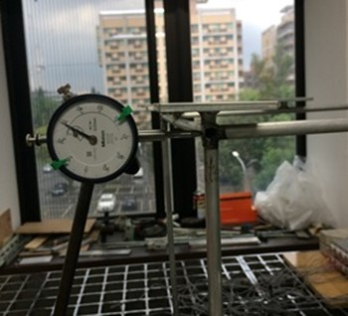
Figure 3.54 - 3D Frame prototype B. Unloaded. View of the experimental test (left). Lateral load F applied by 10 kN load cell (center). Arrangement of the centesimal comparator at the top node (right).
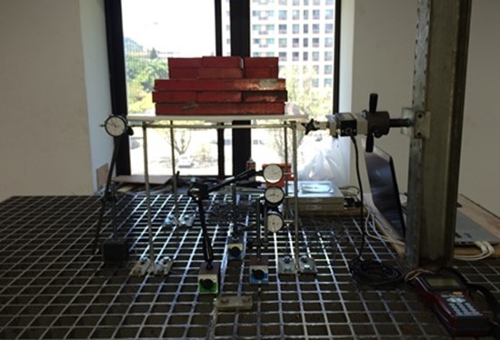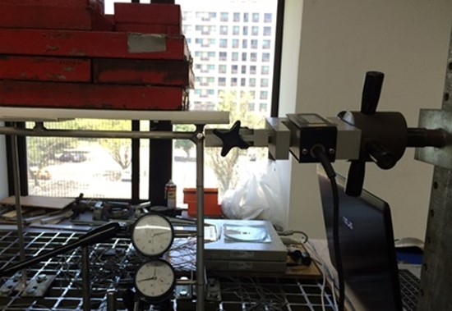
Figure 3.55 - 3D Frame prototype B. Loaded. View of the experimental test (left). Lateral load F applied at the top node by 10 kN load cell (right).
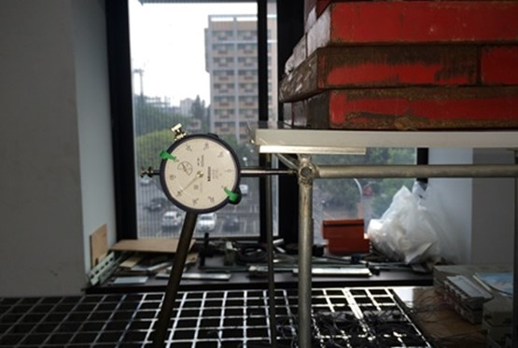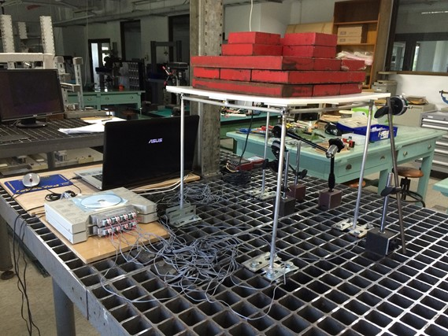
Figure 3.56 - 3D Frame prototype B. Loaded. Arrangement of the centesimal comparator at the top node (left). Strain gauges data acquisition system (right).
In short, deflection v₁ was totally measured five times, while deflections v_{tot} were recorded for each load increment q, giving rise to 60 different experimental combinations of v₁ and v_{tot}.
Compressive axial loads N_{a} were obtained from Eq. (1.29) by the above combinations of v₁ and v_{tot}, following the procedure of Section 1.4.1. Buckling load N_{crEx,expS} = 1049 N of the columns in X-direction was evaluated by inserting the global buckling load q_{crEx,expS}, from Southwell’s method (Section 3.4.1.1.1), within the “EFEs” model of 3D Frame B.
In specific, 60 estimated axial loads N_{a} were in total achieved and then compared with the measured axial loads in the left and right columns, respectively (Tables 3.22 and 3.23). The analytical axial force contribution ∆N_{x} in the left column, given by applying F with inward direction, is positive (N_{x}+∆N_{x}). Conversely, it is negative in the right column (N_{x}-∆N_{x}). N_{x} value is the contribution given by the load q only (compression forces are assigned positive sign).

Table 3.22 - 3D Frame prototype B. Comparison between estimated (N_{a}) and measured (N_{x}+∆N_{x}) values of the compressive axial forces of left column.
Table 3.23 - 3D Frame prototype B. Comparison between estimated (N_{a}) and measured (N_{x}-∆N_{x}) values of the compressive axial forces of right column.
Tables 3.22 and 3.23 show the excellent results since the compression forces N_{a} were identified with errors less than 10% (in absolute value) through almost all experimental combinations of v₁ and v_{tot}. Tests confirm that best estimations N_{a} are obtained when the ratios between the v_{tot} and v_{I} values are much greater than 1.2, that means higher II-order effects in the column under examination.
Linear strains were recorded, with 1 Hz frequency, by 1+1 gauges fixed at diametrically opposite position at 6 sections of the specimen, following the configuration shown in Fig. 3.18. The mean strain values, from the 1+1 gauges of the 2 sections on the left and right column, have then used to measure the compression forces N_{x}+∆N_{x} and N_{x}-∆N_{x}, respectively. Additionally, Saint Venant’s principle was followed (Fig. 3.20) since the gauges at the upper part of the columns were fixed at appropriate distance from the application points of the distributed load q.
Finally, sensitivity analyses were also carried out. The moment of inertia I is the exact value of the tube cross section, while experimental elastic modulus E = 74.13 GPa is assumed. Buckling load N_{crEx,EFE} = 993 N of the columns was evaluated analytically by “EFEs” model. In specific, compression forces N_{a} of the right column were given from the process of Section 1.4.1 by the parameters v₁, v_{tot} and F, alternatively multiplied by 0.99 and 1.01. The displacements v₁, v_{tot}, deduced applying F = 24.5 N modified, were already imposed alternatively multiplied by 0.99 and 1.01 in the simplified formula (Eq. 1.29), after obtaining them from first- and second-order static analyses by “EFEs” model, respectively (Fig. 3.52). The unloaded specimen was considered as initial displacement reference condition in both analyses. Moreover, in this test case, deflection v₁ was modified since it is experimental parameter of the procedure.
The operation, cited therein, gave rise in total to:
- 7 different combinations of simulated experimental values for 5 distinct assumed compression forces N_{x}-∆N_{x}.
Subsequently, the combinations achieved gave rise respectively to:
- 7 estimated compression forces N_{a} for 5 distinct compression forces N_{x}-∆N_{x} (following the steps of Section 1.4.1).
Fig. 3.57 shows the comparison between the estimated N_{a} and the measured values N_{x}-∆N_{x} of the right column and, moreover, the corresponding sensitivity analysis functions from the above operations.

Figure 3.57 - 3D Frame prototype B. Comparison between estimated (N_{a}) and measured (N_{x}-∆N_{x}) values of the compressive axial forces of right column (green data points) and sensitivity analysis functions.

Table 3.24 - 3D Frame prototype B. Table of the sensitivity analysis results of right column for N_{x}-∆N_{x} = 488 N.
Table 3.24 summarizes the sensitivity analysis in terms of the identification of values N_{a}, corresponding to the maximum assumed axial load N_{x}-∆N_{x}. The maximum estimation error is equal to 3.9% (in absolute value).
The measurements at the top in a symmetrically loaded symmetric space frame allow the monitoring of two beam-columns together.

3D Frame prototype C
Experimental simulations of the simplified formula were additionally executed on 3D Frame C, applying the load F at the top. The prototype was externally bounded by fixed restraints on a steel table for tests (Section 3.3.2). It was always obviously preserved in the elastic range, taking into account the global buckling loads q_{crEx,expS} and q_{crEz,expS} from Southwell’s method.
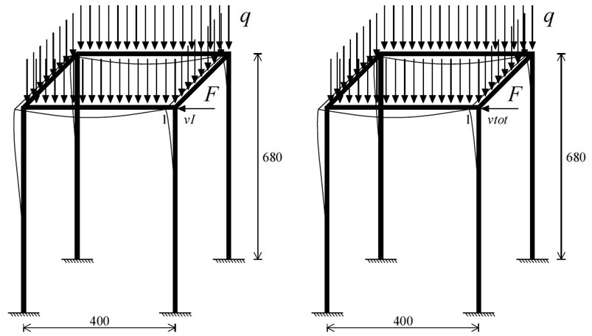
Figure 3.58 - 3D Frame prototype C. First- (left) and second-order static analysis (right). Tests setup with location of the instrumented sections in X-direction. Units: mm.
Figs. 3.58 and 3.59 illustrate the analytical configurations of the simplified formula performed respect to both horizontal X- and Z-directions. The first-order displacement v₁ at the top may be deduced experimentally in absence of distributed load q, that means absence of II-order effects in the vertical columns, as illustrated in the previous Section 3.5.1.3.1.

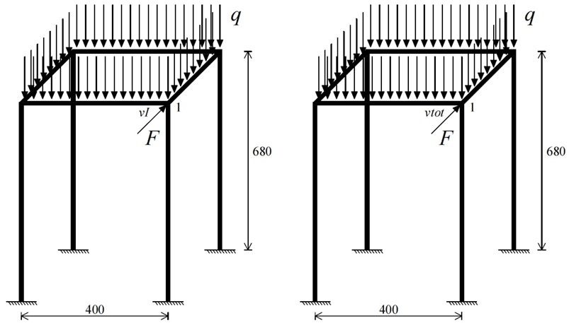
Figure 3.59 - 3D Frame prototype C. First- (left) and second-order static analysis (right). Tests setup with location of the instrumented sections in Z-direction. Units: mm.

Laboratory test results

X-direction
Load F was 14.7 N, while elastic modulus E = 74.13 GPa is determined experimentally. The displacement v₁ was recorded according to the applied force F on the unloaded specimen and subsequently, displacements v_{tot} were measured on the loaded prototype, as depicted in Fig. 3.60.

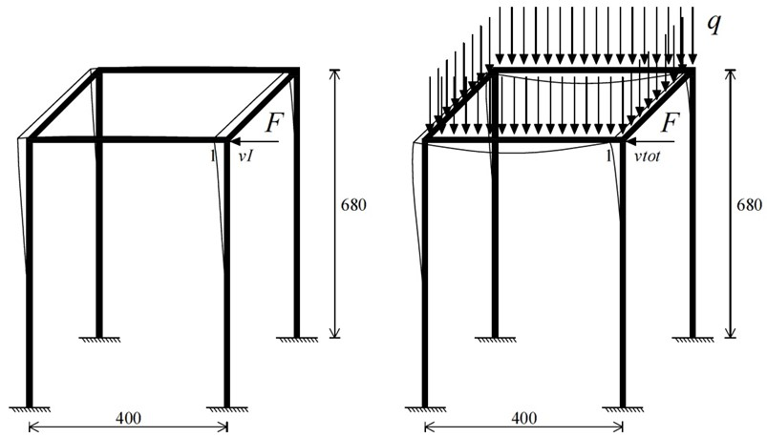
Figure 3.60 - 3D Frame prototype C. Unloaded (left) and loaded prototype (right). Tests setup with location of the instrumented sections in X-direction. Units: mm.
The deflections v₁ and v_{tot} at the top of 3D Frame C were short-term recorded by centesimal comparator (Fig. 3.61). The unloaded specimen was considered as initial displacement reference condition in both configurations (Fig. 3.60), according to the concepts of the simplified formula. The applied distributed loads q are listed in Table 3.25.

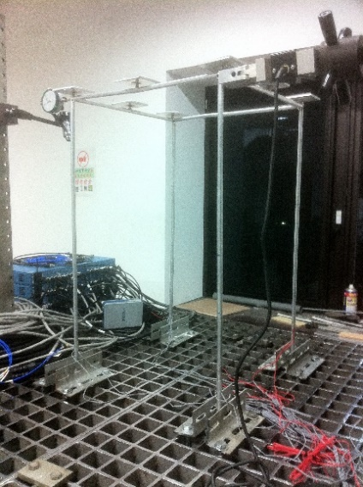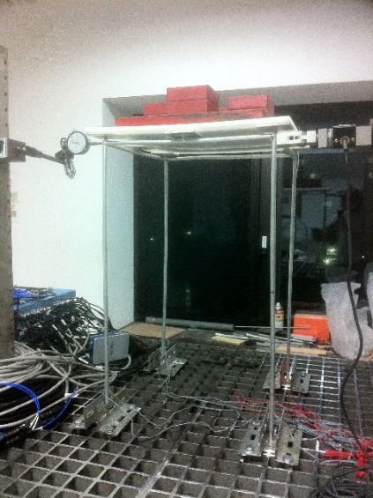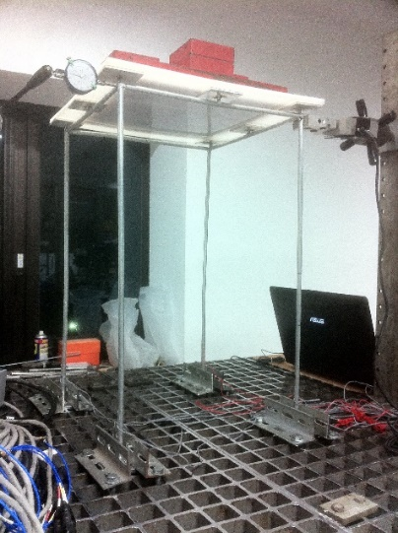
Figure 3.61 - 3D Frame prototype C. View of the test when prototype unloaded (left). Views of the test when prototype loaded (center and right).
In short, deflection v₁ was totally measured three times, while deflections v_{tot} were recorded for each load increment q, giving rise to 15 different experimental combinations of v₁ and v_{tot}.
Buckling load N_{crEx,expS} = 418 N of the columns in X-direction was identified by inserting the global buckling load q_{crEx,expS}, from Southwell’s method (Section 3.4.2.1.1), within “EFEs” model of the prototype.
In specific, 15 estimated compression forces N_{a} were in total achieved from Eq. (1.29) by the above combinations v₁ and v_{tot}, and then compared with the measured axial forces N_{x}-∆N_{x} in the right column (Table 3.25). The analytical axial force contribution ∆N_{x} in the right column, given by applying F with inward direction, is negative (N_{x}-∆N_{x}). N_{x} value is the contribution given by the distributed load q only (compression forces are assigned positive sign).

Table 3.25 - 3D Frame prototype C. Comparison between estimated (N_{a}) and measured (N_{x}-∆N_{x}) values of the compressive axial forces of right column.
Table 3.25 shows the good estimations since more than half of the compression forces N_{a} were identified with errors less than 10% (in absolute value). The mean strain values, from the 1+1 gauges on the 2 point sections of the right column, have used to evaluate the existing compression forces N_{x}-∆N_{x}, as reported in Section 3.3.2.1.
Sensitivity analyses were moreover developed. The moment of inertia I is the exact value of the tube cross section and experimental elastic modulus E = 74.13 GPa is assumed. Buckling load N_{crEx,EFE} = 385 N of the columns was evaluated analytically by “EFEs” model. In detail, compression forces N_{a} of the right column were given from Eq. (1.29) using the parameters v₁, v_{tot} and F, alternatively multiplied by 0.99 and 1.01. The deflections v₁ and v_{tot}, deduced assigning F = 14.7 N modified, were already imposed alternatively multiplied by 0.99 and 1.01 in the simplified formula (Eq. 1.29), after obtaining them from first- and second-order static analyses by “EFEs” model, respectively (Fig. 3.58). In this test case, deflection v₁ was modified since it is experimental parameter of the procedure.
The above operation gave rise in total to:
- 7 different combinations of simulated experimental values for 5 distinct assumed compression forces N_{x}-∆N_{x}.
The combinations achieved then gave rise respectively to:
- 7 estimated compression forces N_{a} for 5 distinct compression forces N_{x}-∆N_{x} (following the process of Section 1.4.1).
Fig. 3.62 depicts the comparison between the estimated N_{a} and the measured values N_{x}-∆N_{x} of the right column and, in addition, the corresponding sensitivity analysis functions from the above operations.

Figure 3.62 - 3D Frame prototype C. Comparison between estimated (N_{a}) and measured (N_{x}-∆N_{x}) values of the compressive axial forces of right column (green data points) and sensitivity analysis functions.

Table 3.26 - 3D Frame prototype C. Table of the sensitivity analysis results of right column for N_{x}-∆N_{x} = 188 N.
Sensitivity analysis in terms of the determination of values N_{a}, corresponding to the maximum compression force N_{x}-∆N_{x}, is summarized in Table 3.26. The maximum identification error is equal to 4.1% (in absolute value).

Z-direction
Test procedure follows the same one respect to X-direction with load F = 14.7 N and elastic modulus E = 74.13 GPa evaluated experimentally. The displacement v₁ was measured according to the applied load F on the unloaded prototype and then, displacements v_{tot} were recorded on the loaded specimen (Fig. 3.63).

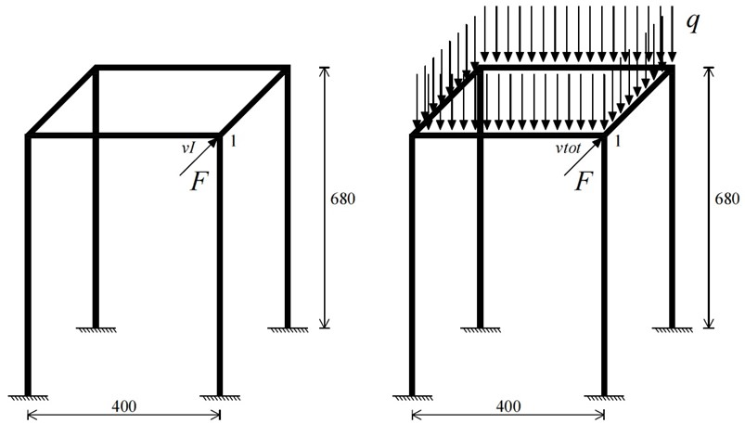
Figure 3.63 - 3D Frame prototype C. Unloaded (left) and loaded prototype (right). Tests setup with location of the instrumented sections in Z-direction. Units: mm.
The displacements v₁ and v_{tot} at the top were short-term recorded by centesimal comparator, as depicted in Fig. 3.64, and moreover, the unloaded prototype was considered as initial displacement reference condition in both configurations (Fig. 3.63). The assigned distributed loads q are listed in Table 3.27.
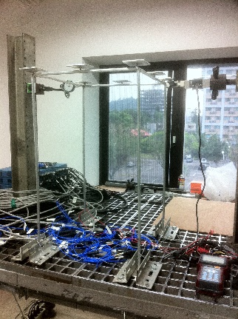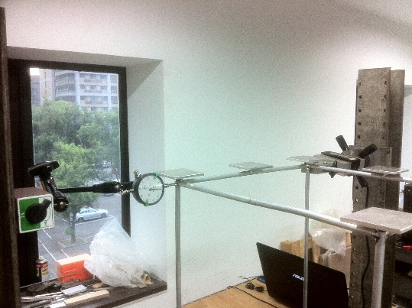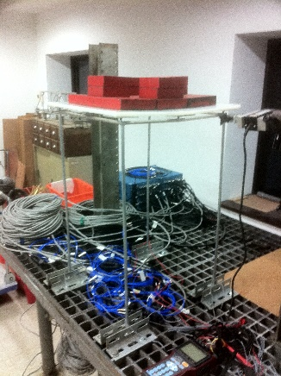
Figure 3.64 - 3D Frame prototype C. View of the test when prototype unloaded (left). Lateral load F applied by load cell and arrangement of the centesimal comparator (center). View of the test when prototype loaded (right).
Buckling load N_{crEz,expS} = 404 N of the columns in Z-direction was identified by inserting the global buckling load q_{crEz,expS}, from Southwell’s method (Section 3.4.2.1.2), within “EFEs” model of the specimen.
In short, 20 distinct experimental combinations of v₁ and v_{tot} were obtained since deflection v₁ was totally measured five times, while displacements v_{tot} were recorded for each load increment q.
In particular, 20 estimated compression forces N_{a} were finally achieved from Eq. (1.29) by the combinations v₁ and v_{tot}, cited therein, and then compared with the measured axial forces N_{x}+∆N_{x} in the left column (Table 3.27). The analytical axial force contribution ∆N_{x} in the left column, given by applying F with inward direction, is positive (N_{x}+∆N_{x}). N_{x} value is the contribution given by the load q only (compression forces are assigned positive sign). From the experimental point of view, N_{x}+∆N_{x} values were evaluated with the mean strains from the 1+1 gauges on the 2 point sections of the left column (Section 3.3.2.1).

Table 3.27 - 3D Frame prototype C. Comparison between estimated (N_{a}) and measured (N_{x}+∆N_{x}) values of the compressive axial forces of left column.
Test configuration respect to Z-direction confirms the good estimations (Table 3.27) since more than half of the compression forces N_{a} were identified with errors less than 10% (in absolute value). Experiments also confirm that best determinations N_{a} are achieved when the ratios between displacements v_{tot} and v_{I} are much greater than 1.2.
The simplified formula’s application on beam-columns of regular space frames results an efficacious non-destructive method.

Discussion and conclusions
The non-destructive methods presented are efficacious techniques for the structural health monitoring of regular space frames in-situ. In the near future, safety inspections will become increasingly important, since the improvement of the material properties has recently allowed to design frames constituted of more slender beam-columns. Laboratory tests on the three small-scale prototypes have given excellent identification results.
The method proposed by Tullini’s (2013), extended on regular space frames, provides the compression force identifications in columns. The estimations become more reliable when the method applied on compression members having higher slenderness and, moreover, when columns subjected to the larger lateral loads. Frames constituted of beam-columns having homogeneous structural material, such as steel or aluminium, may be monitored by higher lateral loads, due to the different mechanical material properties. Furthermore, test configuration applying the double loads F+F allows to identify the compression force N_{x} without the additional axial force contribution ∆N_{x} given by loads F+F.
Southwell’s method (Singer et al. 2000), extended experimentally for the first time as non-destructive technique, has furnished global buckling loads very close to the theoretical predictions for the corresponding perfect frame prototypes. Buckling loads of the single beam-columns can be identified when the global buckling loads from Southwell’s method are inserted within the space frame’s finite element models. Nowadays, with modern data acquisition systems, large amount of simultaneous data of loads and deflections may be recorded in Southwell method’s experiments, since measurements have to be taken at every constant load increment. Additionally, Southwell method’s tests on full-scale frames should be necessary since section point positions of the deflection measurements on the columns are still uncertain.
The extension of the simplified formula of Timoshenko & Gere (1961) and Bazant & Cedolin (1991) has provided excellent identifications. Its application is particularly suitable for validating the design computations of regular space frames, since it requires the knowledge of external and internal boundary conditions. In fact, the comparison between estimated and expected compression forces becomes direct measure of the level of reliability of the design computations and of the entire construction. First-order displacement - parameter of the formula - can be measured experimentally at the top of the frame during the construction process. Different column slendernesses do not affect the estimations, unlike the second-order effects. In fact, the simplified formula requires v_{tot} /v_{I} ratios greater than 1.2. Moreover, the estimations do not depend on the magnitude of the transversal load; this last condition is very positive as applications of elevated loads are generally arduous during static tests in-situ.
All static methods do not require any selection of the experimental data to be used in the procedures and the displacement sensors must to be only placed externally at given sections of the column height respectively.

Axial load identifications in beam-columns of generic space structures

Introduction
Chapter 4 presents the extensions of the method proposed by Tullini (2013), and of the simplified formula of Timoshenko and Gere (1961) and Bazant and Cedolin (1991) for the axial load identifications in beam-columns of generic space structures. The diagnostic procedures were mainly validated experimentally on a small-scale 3D structure (3D Bridge prototype).
Tensile and compression forces in beam-columns may be determined to evaluate the safety assessments of the entire construction. In fact, a significant re-distribution of the internal forces may indicate a structural damage. Efficiently and suitably practical test solutions have been obtained finally to be applied on existing structures, within the Structural Health Monitoring field, such as pipe racks or space truss girders (Fig. 4.1).

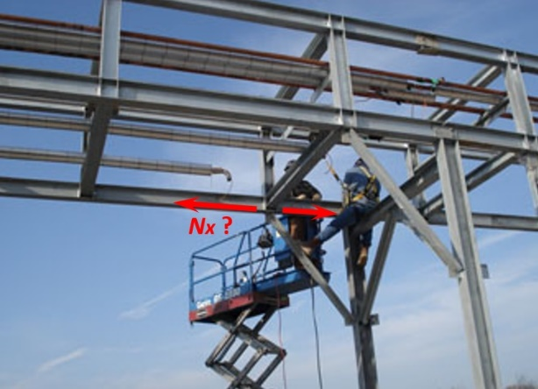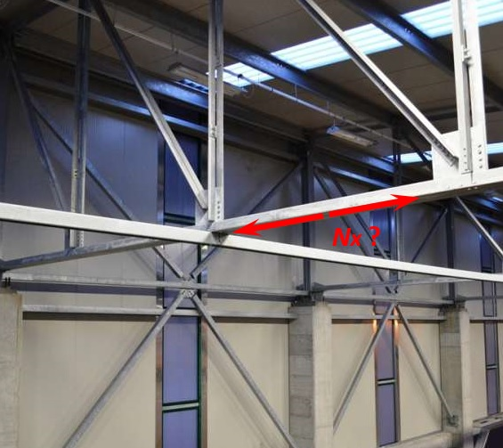
Figure 4.1 - Pipe rack of a thermal power station (left). Space truss roof of an industrial building (right).

Southwell’s method (Singer et al. 2000) is again proposed as non-destructive method for the global buckling load evaluations of space structures. In detail, its effectiveness is confirmed in Section 4.3, since the experiments performed on 3D Bridge prototype have given very good results.

Identifications by means of the method proposed by Tullini (2013)
Section 4.2 treats the tensile and compression force identifications using the method proposed by Tullini (2013) on beam-columns belonging to three prototypes. The static method is able to give either tensile or compressive axial force irrespective to the boundary conditions, as described in Section 1.2. This is the main advantage since slender members with uncertain length and unknown boundary conditions are typical elements of space trusses (Fig. 4.2).

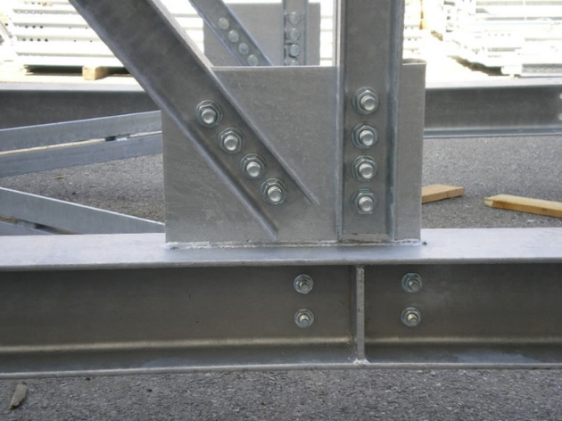
Figure 4.2 - Node connection of a steel pipe rack. Typical unknown boundary condition.

Experimental tests were carried out on 3D Bridge prototype at the Teaching Laboratory of the Department of Civil Engineering of National Taiwan University in Taipei, after verifying the method through numerical simulations on two space prototypes.

Preliminary numerical tests on generic space prototypes
“Regular 3D box truss” and “Irregular pyramids truss” are generic space prototypes, constituted of slender prismatic beams on which preliminary numerical tests were performed. The structures are relevant since they simulate, with space shapes, such as small parts of common truss roofs. Pin-jointed connections at the nodes were selected to reproduce the internal boundary conditions.
The numerical results on beams under tensile and compression forces, assuming their internal boundary conditions as unknown, confirm the robustness of the method. The excellent agreements between estimated N_{a} and assumed axial forces N_{x}+∆N_{x} are shown in the following sections.

Regular 3D box truss
“Regular 3D box truss” was designed by flanking two parallelepiped units with length (l₁) of 2.0 m, height (H) and width (l₂) of 1.4 m. The inclination angles φ and β of the beam members are equal to 35° and 45° respectively (Fig. 4.3). It is totally consisted of 31 steel beam-columns (Fig. 4.4) having tube cross sections with the external diameter of 48.3 mm and the tube thickness of 3.0 mm. Yielding stress f_{yk} = 235 MPa and elastic modulus E = 200 GPa were assumed for the steel.

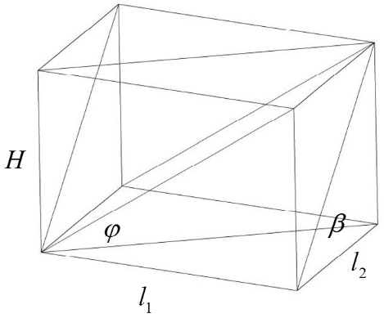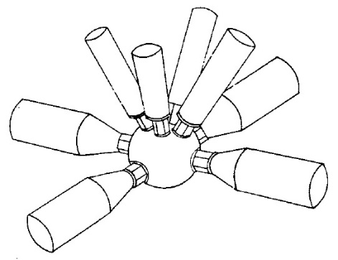
Figure 4.3 - Parallelepiped unit (left). Bowl node (right).

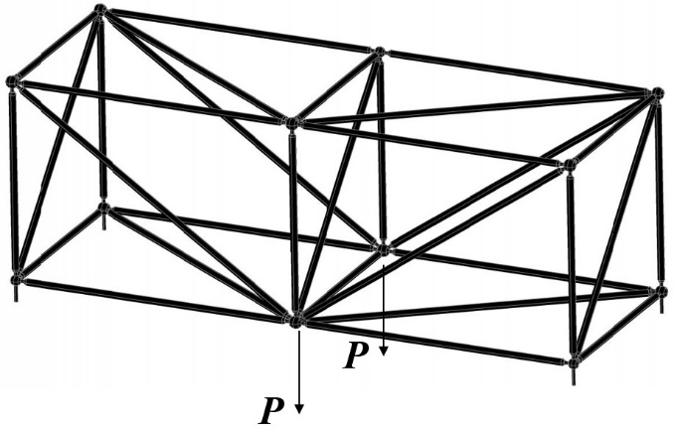
Figure 4.4 - “Regular 3D box truss” prototype.

“EFEs” model (Section 3.2) was utilized to perform the preliminary numerical tests. “Regular 3D box truss” was externally bounded by pinned supports, while the internal restraints were created by pin-joints for simulating the bowl nodes of space truss roofs (Fig. 4.3). In fact, bowl node is a “perfect” hinge. The beam-columns, converging in the hinge, may rotate in the three planes of the space. With this system, all elements are statically only under axial loads with any load condition assigned.

Figure 4.5 - Regular 3D box truss. External point load P -displacement v curve.
Point loads P+P were applied externally at the central nodes (Fig. 4.4). The global buckling load P_{crEv,EFE} = 73.5 kN of the corresponding load configuration was firstly considered for preserving the structure in the elastic range (Fig. 4.5). In specific, numerical tests with lateral load F at the mid-span of beams under investigation were developed, as illustrated in the following Section 4.2.1.1.1.

Test 1: lateral load at the mid-span
The boundary conditions of the beams under observation, belonging to “Regular 3D box truss”, are considered unknown.

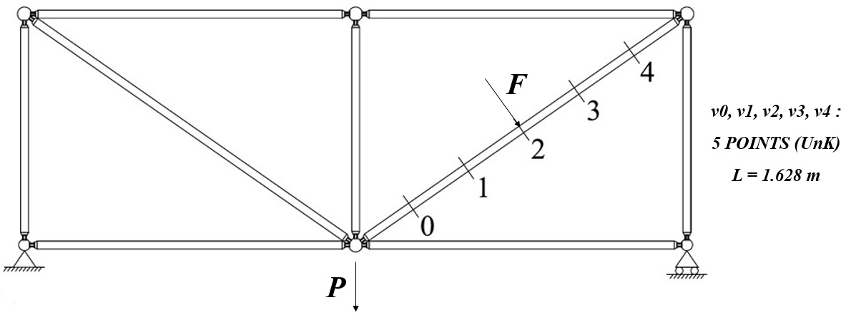
Figure 4.6 - Test 1: Case I - Regular 3D box truss. Bending test with five-measurements.
Cases I and II refer when lateral load F at the mid-span applied and, in detail, as follow:
- Case I: five- measurements on the beam under tensile forces with distance between the extreme sensors L = 1.628 m, depicted in Fig. 4.6;
- Case II: five- measurements on the beam under compression forces with distance between the extreme sensors L = 1.333 m, depicted in Fig. 4.7.

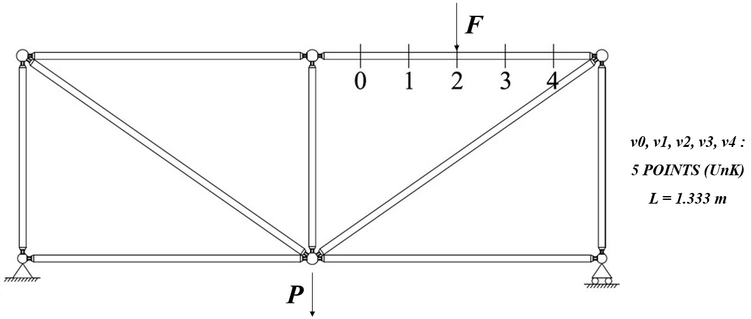
Figure 4.7 - Test 1: Case II - Regular 3D box truss. Bending test with five-measurements.
Test cases, cited therein, were performed numerically as described in the following Section 4.2.1.1.2.

Exact identification results
Transversal load F assigned at the mid-span was 180 N, 220 N and 240 N in both Cases I and II of Test 1 (Figs. 4.6 and 4.7). The moment of inertia I was the exact value of the tube cross sections, while elastic modulus E of steel was 200 GPa. The external point loads P+P are listed in Figs. 4.8 and 4.9.
Bending test with five-measurements utilized the procedure of Section 1.2.1. Tensile and compressive axial loads N_{a}, present in the beams under examination, were achieved by the exact parameter values v₀, v₁, v₂, v₃, v₄ and ψ. The length L was 1.628 m and 1.333 m in the analytical value N_{a} = n EI/L², respectively, since the end restraints of the beams were considered unknown.
The displacement parameters v_{i} = v(x_{i}) for i = 0, 1, 2, 3, 4 (Figs. 4.6 and 4.7), subjected to each force F and external point loads P+P, were imposed after obtaining them from non-linear static analysis by “EFEs” model of “Regular 3D box truss”, without any geometric imperfection. “EFEs” approach was described in Section 3.2. The deflections v_{i} = v(x_{i}), having tolerance of 0.000001 mm, were extrapolated after applying F and considering the typically external point loads P+P as initial displacement reference condition. This last configuration is perfect since it is able to simulate the method’s application on a space structure in-situ.
Once the parameters v₀, v₁, v₂, v₃, v₄ achieved, a set of estimated axial loads N_{a} was obtained for each test case as follow:
- 15 estimated tensile axial loads N_{a} for Case I of Test 1 (Fig. 4.8);
- 15 estimated compressive axial loads N_{a} for Case II of Test 1 (Fig. 4.9).

Figure 4.8 - Test 1: Case I - Regular 3D box truss. Comparison between estimated (N_{a}) and assumed (N_{x}+∆N_{x}) values of tensile axial forces of the beam.

Figure 4.9 - Test 1: Case II - Regular 3D box truss. Comparison between estimated (N_{a}) and assumed (N_{x}+∆N_{x}) values of compressive axial forces of the beam.
The procedure of test cases simulated is outlined in Section 1.2.1.
Figs. 4.8 and 4.9 show the comparison between the estimated N_{a} and the assumed values N_{x}+∆N_{x} of the axial loads. The N_{x}+∆N_{x} values were specifically obtained by means of “EFEs” model of the prototype. The method proposed by Tullini (2013) is not affected by model errors if its algorithm makes use of the parameters v₀, v₁, v₂, v₃, v₄ and ψ having very high accuracy.

Irregular pyramids truss
“Irregular pyramids truss” was designed by flanking two irregular pyramidal units with length (l₁) of 2.0 m, height (H) of 0.686 m and width (l₂) of 1.4 m. The inclination angle φ of the beam members is equal to 29.34° (Fig. 4.10). It is totally consisted of 18 steel beams (Fig. 4.11) having tube cross sections with the external diameter of 48.3 mm and the tube thickness of 3.0 mm. Yielding stress f_{yk} = 235 MPa and elastic modulus E = 200 GPa were assumed for the steel.

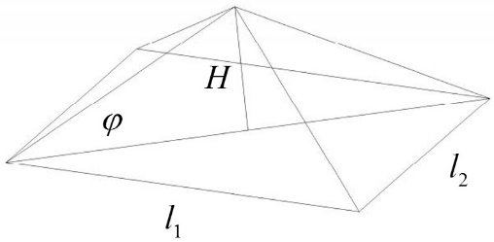
Figure 4.10 - Irregular pyramidal unit (left). Bowl node (right).

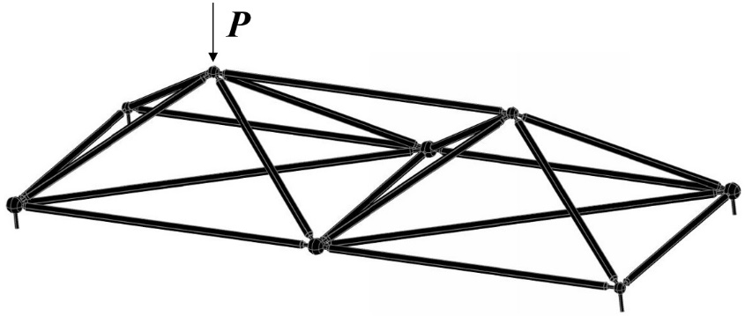
Figure 4.11 - “Irregular pyramids truss” prototype.

“EFEs” model (Section 3.2) was used to carry out the preliminary numerical tests. “Irregular pyramids truss” was externally bounded by pinned supports, while the internal boundary conditions were created by pin-joints for simulating the bowl nodes of space truss roofs (Fig. 4.10), as made for “Regular 3D box truss” prototype.

Figure 4.12 - Irregular pyramids truss. External point load P -displacement v curve.
Point load P was assigned externally at one upper node (Fig. 4.11). The global buckling load P_{crEv,EFE} = 74.0 kN of the corresponding load configuration was firstly taken into account for preserving the prototype in the elastic range (Fig. 4.12). In detail, analytical tests with the transversal load F at the mid-span of the elements under investigation were executed (Section 4.2.1.2.1).

Test 2: lateral load at the mid-span
The boundary conditions of the beams under examination with the method, belonging to “Irregular pyramids truss”, are considered unknown.

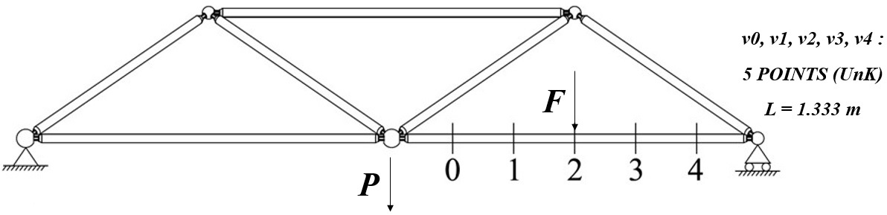
Figure 4.13 - Test 2: Case I - Irregular pyramids truss. Test setup with location of the instrumented sections.
Cases I and II refer when the concentrated load F at the mid-span applied and, in particular, as follow:
- Case I: five- measurements on the beam under tensile forces with distance between the extreme sensors L = 1.333 m, shown in Fig. 4.13;
- Case II: five- measurements on the beam under compression forces with distance between the extreme sensors L = 1.333 m, shown in Fig. 4.14.

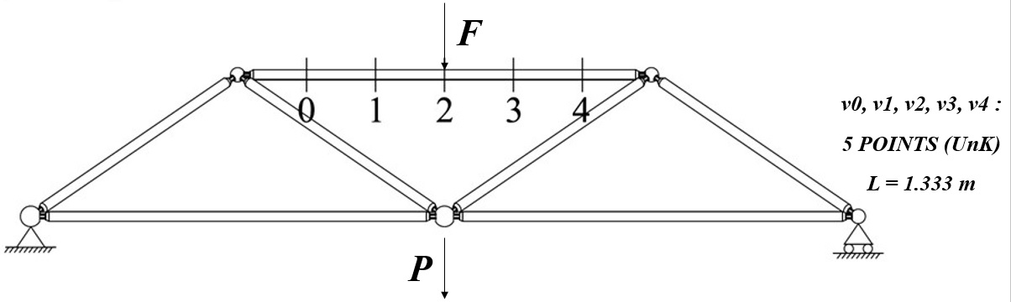
Figure 4.14 - Test 2: Case II - Irregular pyramids truss. Test setup with location of the instrumented sections.
The above test cases were executed analytically as described in the following Section 4.2.1.2.2.

Exact identification results
Lateral load F applied at the mid-span was 180 N, 220 N and 240 N for both Cases I and II of Test 2 (Figs. 4.13 and 4.14). The moment of inertia I was the exact value of the tube cross sections, while elastic modulus E of steel was 200 GPa. The external point load P values are itemized in Figs. 4.15 and 4.16.
Bending test with five-displacement measurements used the procedure of Section 1.2.1. Tensile and compressive axial loads N_{a}, in the beams under examination, were obtained by the exact parameter values v₀, v₁, v₂, v₃, v₄ and ψ. The length L was 1.333 m in the analytical value N_{a} = n EI/L², since the beam ends were assumed unknown.
The deflection parameters v_{i} = v(x_{i}) for i = 0, 1, 2, 3, 4 (Figs. 4.13 and 4.14), subjected to each force F and each point load P, were imposed after obtaining them from non-linear static analysis by “EFEs” model of the prototype, without any geometric imperfection. “EFEs” approach was described in this study in Section 3.2. The displacements v_{i} = v(x_{i}), having tolerance of 0.000001 mm, were determined after applying F and considering the typically external point load P as initial displacement reference condition.
Once the parameters v₀, v₁, v₂, v₃, v₄ achieved, a set of estimated axial loads N_{a} was obtained for each configuration as follow:
- 15 estimated tensile axial loads N_{a} for Case I of Test 2 (Fig. 4.15);
- 15 estimated compressive axial loads N_{a} for Case II of Test 2 (Fig. 4.16).

Figure 4.15 - Test 2: Case I - Irregular pyramids truss. Comparison between estimated (N_{a}) and assumed (N_{x}+∆N_{x}) values of tensile axial forces of the beam.

Figure 4.16 - Test 2: Case II - Irregular pyramids truss. Comparison between estimated (N_{a}) and assumed (N_{x}+∆N_{x}) values of compressive axial forces of the beam.
Figs. 4.15 and 4.16 show finally the comparison between the estimated N_{a} and the assumed values N_{x}+∆N_{x} of the axial forces. The N_{x}+∆N_{x} values were specifically obtained by means of “EFEs” model of the structure for each single beam element. The method is not affected by model errors when applied on generic space structures using the exact parameters v₀, v₁, v₂, v₃, v₄ and ψ with very high accuracy.

3D Bridge prototype
3D Bridge is a symmetric spatial prototype designed for simulating generic space structures in the laboratory. Its total length is 1800 mm, while height and width are respectively equal to 500 mm and 225 mm. It is totally consisted of 80 slender aluminium beam-columns having circular cross-sections of diameter of 5.0 mm. The lengths of the elements are instead equal to 225, 250, 318, 336 and 450 mm (Fig. 4.17). Yielding stress f_{yk}, ultimate stress f_{uk} and elastic modulus E were identified experimentally in Section 3.3.1.1; the company utilized the same structural aluminium of the frame prototypes of Chapter 3.

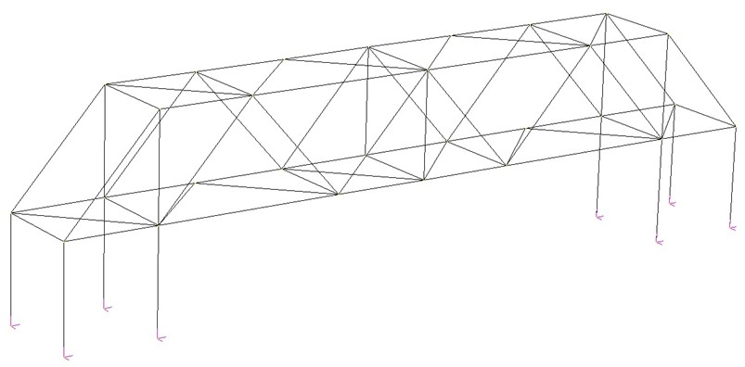
Figure 4.17 - Scheme of 3D Bridge prototype.

3D Bridge was externally bounded by fixed restraints on a steel table for laboratory tests (Fig. 4.18), while the internal restraints were created by welding (rigid joints), as depicted in Fig. 4.19. External point loads were applied by adding known cast iron disks in the central part of the structure and the lateral loads F were likewise assigned by known disks at the mid-span of the beams. 3D Bridge was always preserved in the elastic range during analytical and experimental simulations, considering the global buckling load P_{crEv,EFE} firstly.

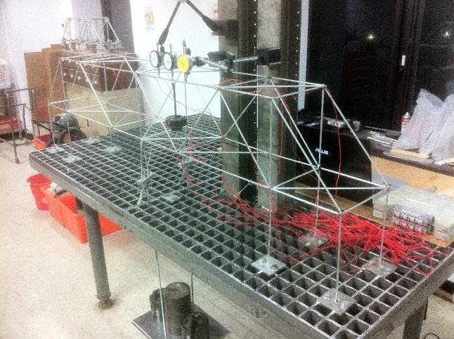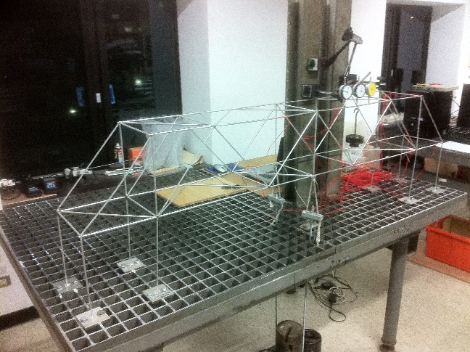
Figure 4.18 - 3D Bridge prototype. Views of the spatial structure bounded on the steel table.

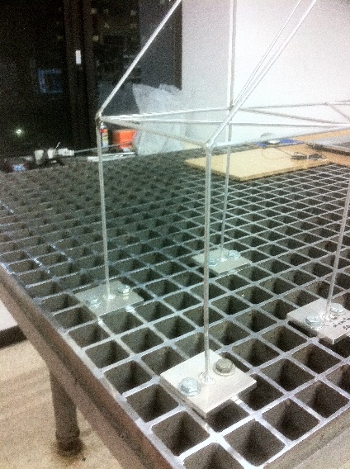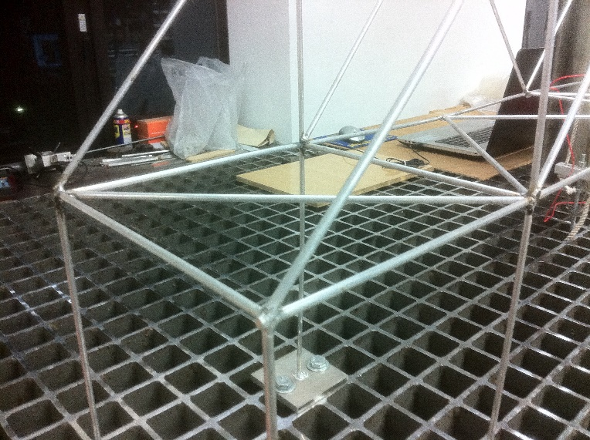
Figure 4.19 - 3D Bridge prototype. External fixed restraints (left). Internal rigid joints (right).

Laboratory tests of the method proposed by Tullini (2013) were in detail divided as follow:
- Test 3: experiments on a generic beam under tensile axial loads (Section 4.2.2.1.1);
- Test 4: experiments on a generic beam under compressive axial loads (Section 4.2.2.1.2).

Laboratory test results

Test 3: generic beam under tensile axial loads
Lateral load F applied at the mid-span was 21.6 N, 26.5 N and 31.4 N, while point loads P+P assigned in the central joints of the prototype were 68.5+68.5 N, 133.5+133.5 N, 198.5+198.5 N and 238.5+238.5 N. The moment of inertia I is the exact value of the circular cross-section, while elastic modulus E = 74.13 GPa is evaluated experimentally in Section 3.3.1.1. The experiments developed were the test configurations with three- (L = 450 mm) and five-measurements (L = 450 mm), depicted in Fig. 4.20.
The corresponding displacements v_{i} = v(x_{i}) for i = 0, 1, 2, 3, 4 of the deflected shape of the beam under observation were short-term measured by centesimal comparators for both configurations performed concurrently (Fig. 4.20). In this way, it has been possible to speculate known (K) and unknown (UnK) boundary conditions respectively, according to the method’s formulation. The deflections v_{i} = v(x_{i}) were recorded after applying F and considering the typically point loads P+P as initial displacement reference condition (Figs. 4.21 and 4.22).

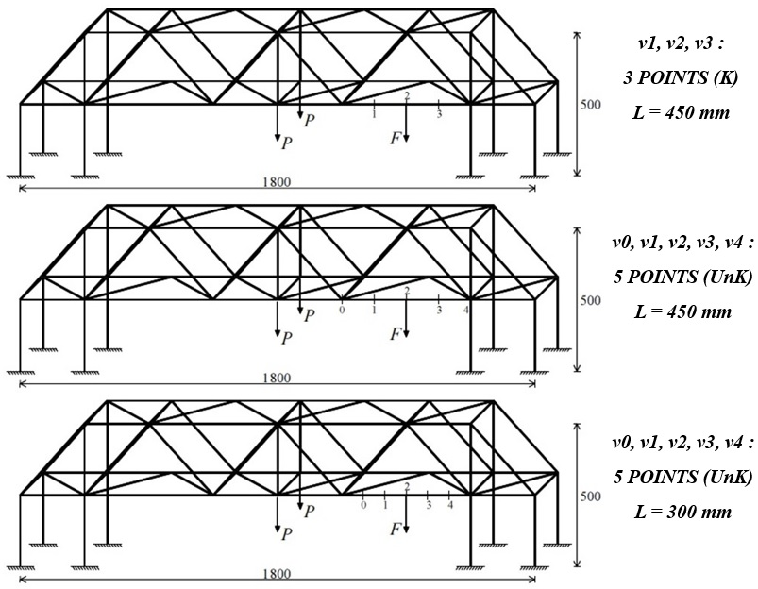
Figure 4.20 - Test 3 - 3D Bridge prototype. Test configurations with three- (L = 450 mm) and five-measurements (L = 450 mm, 300 mm). Tests setup with location of the instrumented sections. Units: mm.
In short, the experimental combination values v₀, v₁, v₂, v₃, v₄ and ψ were obtained in specific as follow:
- 12 different combinations for test configuration with three-measurements (L = 450 mm);
- 12 different combinations for test configuration with five-measurements (L = 450 mm).

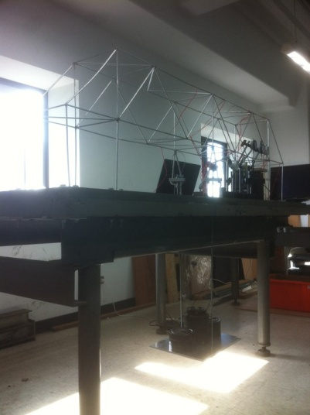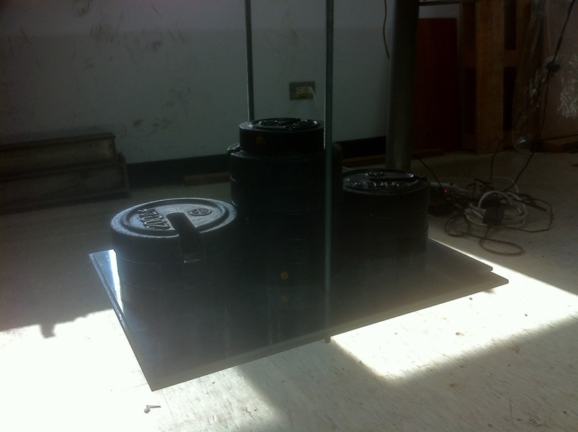
Figure 4.21 - Test 3 - 3D Bridge prototype. View of the static test (left). External point loads P+P applied (right).

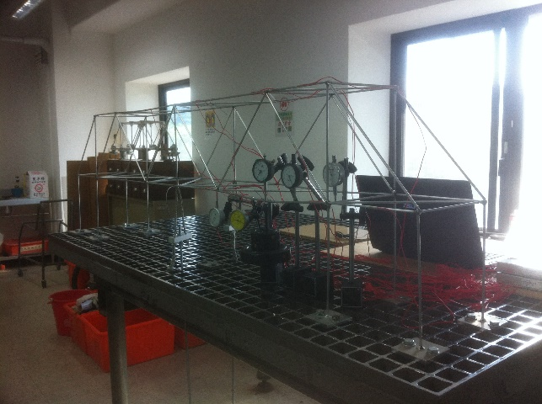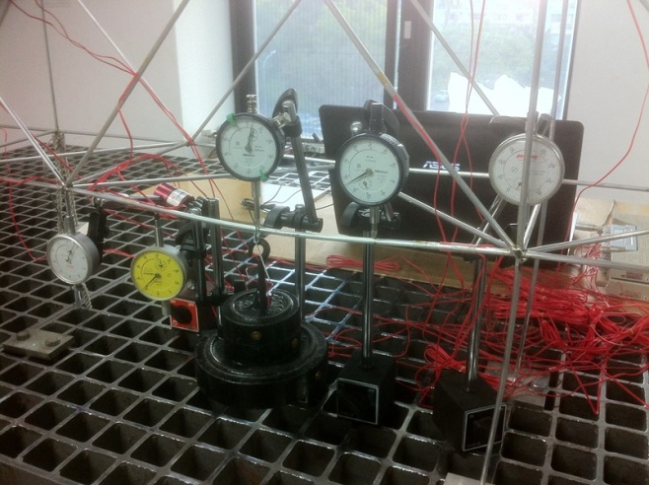
Figure 4.22 - Test 3 - 3D Bridge prototype. View of the static test (left). Deflection of the beam and arrangement of the centesimal comparators and lateral load F (right).
3D Bridge prototype was preserved in the elastic range during tests and obviously every single combination of point loads P+P and transversal force F did not reach the yield stress in the structure, according to the preliminary calculations of the theory of elastic stability.
Bending test with three-measurements makes use of Eq. (1.19), reduces to Eq. (10) in Tullini et al. (2012) since v₀ = v₄ = 0, conversely bending test with five-measurements utilizes Eq. (1.19) correlated to the process of Section 1.2.1. The constant L = 450 mm was assumed in the analytical value N_{a} = n EI/L².
Then, tensile axial loads N_{a} were obtained by the experimental parameters v₀, v₁, v₂, v₃, v₄ and ψ, following the procedures cited therein. In detail, a set of tensile forces N_{a} was achieved for every configuration:
- 12 estimated tensile forces N_{a} for test configuration with three-measurements L = 450 mm (Table 4.1 and Fig. 4.24);
- 12 estimated tensile forces N_{a} for test configuration with five-measurements L = 450 mm (Table 4.2 and Fig. 4.24).

Table 4.1 - Test 3 - 3D Bridge prototype. Test configuration with three-measurements (L = 450 mm). Comparison between estimated (N_{a}) and measured (N_{x}+∆N_{x}) values of tensile axial forces of the beam.

Table 4.2 - Test 3 - 3D Bridge prototype. Test configuration with five-measurements (L = 450 mm). Comparison between estimated (N_{a}) and measured (N_{x}+∆N_{x}) values of tensile axial forces of the beam.
From the comparison between the estimated N_{a} and the measured values N_{x}+∆N_{x} (Fig. 4.24), experiments of the method have given excellent tensile force determinations N_{a}, since almost all errors were less than 10% in terms of absolute value (Tables 4.1 and 4.2).
Linear strains in one-direction were measured by 1+1 gauges (with 5 mm gauge length) placed at diametrically opposite position at 2 section points of the beam under examination. Additional linear strains, respect to the horizontal plane, were moreover recorded with 1 gauge on the adjacent beams (Fig. 4.23). The corresponding strains were measured with 1 Hz frequency for a time period of around 1 minute, after applying the force F. The mean strain values, from the 1+1 gauges of the 2 sections on the beam, have then utilized to determine the existing tensile forces N_{x}+∆N_{x} using the formulas of elastic theory.

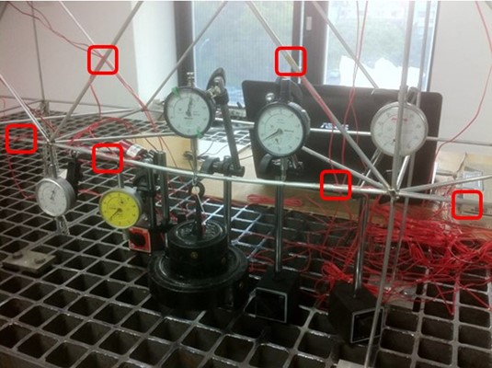
Figure 4.23 - Test 3 - 3D Bridge prototype. Section points of the strain gauges.
Sensitivity analyses were also made for the test configurations depicted in Fig. 4.20. The three magnitudes F of the experiments were again considered. The moment of inertia I is the exact cross-section value, while elastic modulus E = 74.13 GPa was identified experimentally in Section 3.3.1.1. In specific, tensile axial loads N_{a} were obtained from the process of Section 1.2.1 (Eq. 1.19) by the parameters v₀, v₁, v₂, v₃, v₄ and F alternatively modified by adding +0.01 and -0.01 for reproducing experimental errors eventually. The deflections v_{i} = v(x_{i}) (Fig. 4.20), subjected to each force F modified, were already imposed alternatively modified by adding +0.01 and -0.01, after obtaining them from non-linear static analysis by “EFEs” model of the structure (without any geometric imperfection). The displacements, with tolerance of 0.01 mm, were extrapolated after assigned F and considering the typically point loads P+P as initial displacement reference condition, as developed for the laboratory tests.
For each test configuration, the above operation gave rise to:
- 16 combinations of simulated experimental values for 5 distinct assumed tensile forces N_{x}+∆N_{x}, regarding to the test with three-measurements and L = 450 mm;
- 64 combinations of simulated experimental values for 5 distinct assumed tensile forces N_{x}+∆N_{x}, regarding to the test with five-measurements and L = 450 mm;
- 64 combinations of simulated experimental values for 5 distinct assumed tensile forces N_{x}+∆N_{x}, regarding to the test with five-measurements and L = 300 mm.
The combinations achieved then gave rise respectively to (Fig. 4.24):
- 16 estimated tensile forces N_{a} for 5 distinct assumed N_{x}+∆N_{x} values, regarding to the test with three-measurements and L = 450 mm;
- 64 estimated tensile forces N_{a} for 5 distinct assumed N_{x}+∆N_{x} values, regarding to the test with five-measurements and L = 450 mm;
- 64 estimated tensile forces N_{a} for 5 distinct assumed N_{x}+∆N_{x} values, regarding to the test with five-measurements and L = 300 mm.
Fig. 4.24 shows the comparison between the worst estimated N_{a} and the assumed values N_{x}+∆N_{x} for the test configurations cited therein in terms of sensitivity analysis functions.

Figure 4.24 - Test 3 - 3D Bridge prototype. Sensitivity analysis results of tests with three- (L = 450 mm) and five-measurements (L = 450 mm, 300 mm) and comparison between estimated (N_{a}) and measured (N_{x}+∆N_{x}) values of tensile forces (colored data points).

Table 4.3 - Test 3 - 3D Bridge prototype. Test configuration with three-measurements (L = 450 mm). Sensitivity analysis results in terms of the determination of estimated values (N_{a}).
Table 4.4 - Test 3 - 3D Bridge prototype. Test configuration with five-measurements (L = 450 mm). Sensitivity analysis results in terms of the determination of estimated values (N_{a}).

Table 4.5 - Test 3 - 3D Bridge prototype. Test configuration with five-measurements (L = 300 mm). Sensitivity analysis results in terms of the determination of estimated values (N_{a}).
The sensitivity analyses are summarized in Tables 4.3, 4.4 and 4.5 in terms of the identification of values N_{a}, corresponding to the maximum assumed tensile force N_{x}+∆N_{x} by “EFEs” model. The worst estimations N_{a} are given when the greatest possible distance between the extreme sensors L = 500 mm is not adopted (Table 4.5), confirming the validity of the method’s test operations presented in Chapter 3.

Test 4: generic beam under compressive axial loads
Lateral load F assigned at the mid-span was 11.8 N, 16.7 N and 21.6 N, while point loads P+P applied in the central joints were 48.5+48.5 N, 88.5+88.5 N, 128.5+128.5 N and 148.5+148.5 N. The moment of inertia I is the value of the circular cross-section of the elements, while elastic modulus E = 74.13 GPa is evaluated experimentally (Section 3.3.1.1). Test configurations with three- (L = 450 mm) and five-measurements (L = 450 mm) were developed (Fig. 4.25) as for Test 3 correlated to the beam under tensile forces.
The corresponding displacements v_{i} = v(x_{i}) for i = 0, 1, 2, 3, 4 of the deflected shape of the beam were measured by centesimal comparators for both configurations performed concurrently (Fig. 4.25). In this way, the boundary conditions were assumed known (K) and unknown (UnK) respectively, according to the method’s formulation. The deflections v_{i} = v(x_{i}) were recorded after applying F, as already described in the previous Section 4.2.2.1.1 (Figs. 4.26 and 4.27).

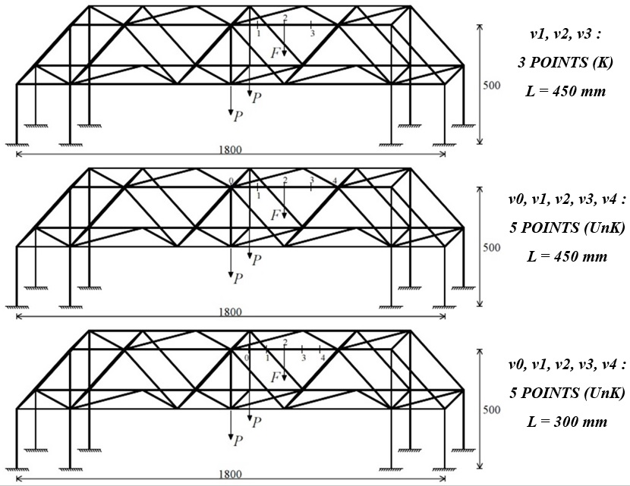
Figure 4.25 - Test 4 - 3D Bridge prototype. Test configurations with three- (L = 450 mm) and five-measurements (L = 450 mm, 300 mm). Tests setup with location of the instrumented sections. Units: mm.
The experimental combination values v₀, v₁, v₂, v₃, v₄ and ψ were in specific obtained as follow:
- 12 different combinations for test configuration with three-measurements (L = 450 mm);
- 12 different combinations for test configuration with five-measurements (L = 450 mm).

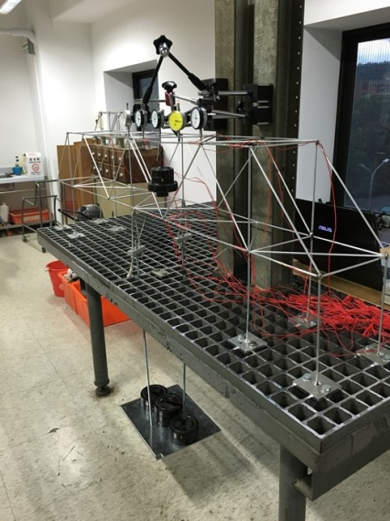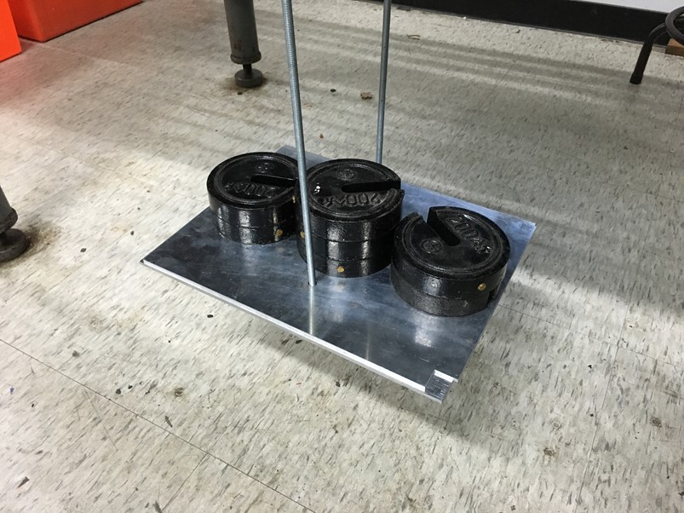
Figure 4.26 - Test 4 - 3D Bridge prototype. View of the static test (left). External point loads P+P applied (right).
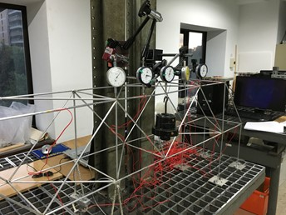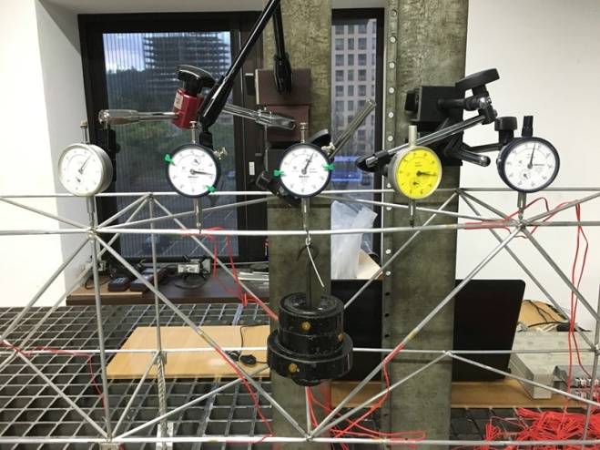
Figure 4.27 - Test 4 - 3D Bridge prototype. Deflection of the beam and arrangement of the centesimal comparators and lateral load F.
Bending test with three-measurements makes use of Eq. (1.19), reduces to Eq. (10) in Tullini et al. (2012) since v₀ = v₄ = 0, unlike bending test with five-measurements uses Eq. (1.19) correlated to the process of Section 1.2.1. The constant L = 450 mm was assumed in the analytical value N_{a} = n EI/L².
Subsequently, compressive axial loads N_{a} were given by the experimental values v₀, v₁, v₂, v₃, v₄ and ψ, following the above procedures. In particular, a set of compression forces N_{a} was obtained for every test configuration:
- 12 estimated compression forces N_{a} for test configuration with three-measurements L = 450 mm (Table 4.6 and Fig. 4.29);
- 12 estimated compression forces N_{a} for test configuration with five-measurements L = 450 mm (Table 4.7 and Fig. 4.29).

Table 4.6 - Test 4 - 3D Bridge prototype. Test configuration with three-measurements (L = 450 mm). Comparison between estimated (N_{a}) and measured (N_{x}+∆N_{x}) values of compression forces of the beam.

Table 4.7 - Test 4 - 3D Bridge prototype. Test configuration with five-measurements (L = 450 mm). Comparison between estimated (N_{a}) and measured (N_{x}+∆N_{x}) values of compression forces of the beam.
The comparison between the estimated N_{a} and the measured values N_{x}+∆N_{x}, shown in Fig. 4.29, has provided almost all errors less than 10% (in absolute value), that means excellent compression force identifications N_{a} (Tables 4.6 and 4.7).
Linear strains in one-direction were measured by 1+1 gauges (with 5 mm gauge length) fixed at diametrically opposite position at 2 sections of the beam under compression forces. Additional linear strains, respect to the horizontal plane, were also recorded by 1 gauge on the adjacent beams (Fig. 4.28). The corresponding strains were measured with 1 Hz frequency for a time period of around 1 minute, after applying the transversal force F. The mean strain values, from the 1+1 gauges of the 2 sections on the beam, have then utilized to obtain the existing compression forces N_{x}+∆N_{x} with the formulas of elastic theory.

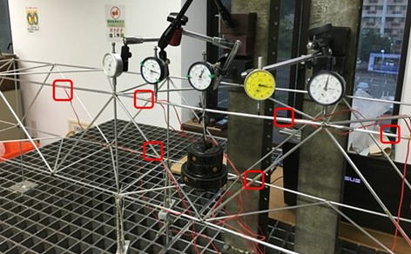
Figure 4.28 - Test 4 - 3D Bridge prototype. Section points of the strain gauges.
The strain gauges at the 2 sections were placed at appropriate distance from the application points (internal end restraints) of the compression forces, according to the Saint Venant’s principle for slender beam-columns (Fig. 3.20).
Sensitivity analyses were furthermore performed for all configurations shown in Fig. 4.25. The three load F values of the experiments were taken into account again. The moment of inertia I is the exact cross-section value, while elastic modulus E = 74.13 GPa was identified experimentally in Section 3.3.1.1. In detail, compression forces N_{a} were achieved from the process of Section 1.2.1 (Eq. 1.19) by the parameters v₀, v₁, v₂, v₃, v₄ and F alternatively modified by adding +0.01 and -0.01 for reproducing eventually experimental errors. The flexural displacements v_{i} = v(x_{i}) (Fig. 4.25), subjected to each load F modified, were already imposed alternatively modified by adding +0.01 and -0.01, after obtaining them from non-linear static analysis by “EFEs” model of the prototype (without any geometric imperfection). The deflections, having 0.01 mm tolerance, were determined after assigned F and considering the typically point loads P+P as initial displacement reference condition (as executed for the laboratory tests).
The operation, cited therein, has furnished for each configuration:
- 16 combinations of simulated experimental values for 5 different assumed compression forces N_{x}+∆N_{x}, regarding to the test with three-measurements and L = 450 mm;
- 64 combinations of simulated experimental values for 5 different assumed compression forces N_{x}+∆N_{x}, regarding to the test with five-measurements and L = 450 mm;
- 64 combinations of simulated experimental values for 5 different assumed compression forces N_{x}+∆N_{x}, regarding to the test with five-measurements and L = 300 mm.
The combinations obtained then gave rise respectively to (Fig. 4.29):
- 16 estimated compression forces N_{a} for 5 different assumed N_{x}+∆N_{x} values, regarding to the test with three-measurements and L = 450 mm;
- 64 estimated compression forces N_{a} for 5 different assumed N_{x}+∆N_{x} values, regarding to the test with five-measurements and L = 450 mm;
- 64 estimated compression forces N_{a} for 5 different assumed N_{x}+∆N_{x} values, regarding to the test with five-measurements and L = 300 mm.
The comparison between the worst estimated N_{a} and the assumed values N_{x}+∆N_{x} in terms of sensitivity analyses for all configurations is shown in Fig. 4.29.

Figure 4.29 - Test 4 - 3D Bridge prototype. Sensitivity analysis results of tests with three- (L = 450 mm) and five-measurements (L = 450 mm, 300 mm) and comparison between estimated (N_{a}) and measured (N_{x}+∆N_{x}) values of compression forces (colored data points).

Table 4.8 - Test 4 - 3D Bridge prototype. Test configuration with three-measurements (L = 450 mm). Sensitivity analysis results in terms of the determination of estimated values (N_{a}).

Table 4.9 - Test 4 - 3D Bridge prototype. Test configuration with five-measurements (L = 450 mm). Sensitivity analysis results in terms of the determination of estimated values (N_{a}).

Table 4.10 - Test 4 - 3D Bridge prototype. Test configuration with five-measurements (L = 300 mm). Sensitivity analysis results in terms of the determination of estimated values (N_{a}).
The sensitivity analyses are summarized in Tables 4.8, 4.9 and 4.10 in terms of the identification of values N_{a}, corresponding to the maximum assumed compression force N_{x}+∆N_{x} by “EFEs” model.
The worst estimations N_{a} are confirmed when the greatest possible distance between the extreme sensors L = 500 mm is not adopted in beam-column either under tensile or compression force (Tables 4.5 and 4.10). Numerical and experimental tests moreover confirm the robustness of the method when applied on beam-columns (either under tensile or compression forces) even in the presence of moderate measurement errors.
The experiment operations presented for single beams must be followed - see the conclusions in Sections 2.2.1.1.2 and 2.2.1.2.2. Generic space structure systems under examinations, constituted of beam-columns with higher slenderness, provide better identifications for tensile and compression forces.

Global buckling load identification by means of the Southwell’s method
Southwell’s method (Singer et al. 2000) was extended for the first time as non-destructive method for the global buckling load evaluations of generic space structures. The experiment was developed on 3D Bridge prototype, illustrated in Section 4.2.2, at the Teaching Laboratory of the Department of Civil Engineering of National Taiwan University in Taipei, Taiwan.

3D Bridge prototype
3D Bridge was externally bounded by fixed restraints on a steel table for laboratory tests. The test configuration of Southwell’s method is the symmetric prototype loaded symmetrically with point loads P+P in the central nodes (Fig. 4.30). The load F = 6.9 N placed constantly is part of the test configuration of the simplified formula of Timoshenko and Gere (1961) and Bazant and Cedolin (1991), since both experiments were performed concurrently. The load increments P+P were created by adding known cast iron disks on a rigid metallic plate (Fig. 4.26). The structure buckles vertically (Fig. 4.34) and the corresponding global buckling load P_{crEy,expS} was at the end identified experimentally.

Laboratory test results
The “v_{y} versus v_{y} /P” diagram was considered as “Southwell plot” according to the principles of the technique, illustrated in Section 1.3. The v_{y} value is the vertical mid-span displacement (in Y-direction) of section n. 2 of the beam under compression forces v_{2y} (Fig. 4.30), obtained by increasing the point loads P+P.

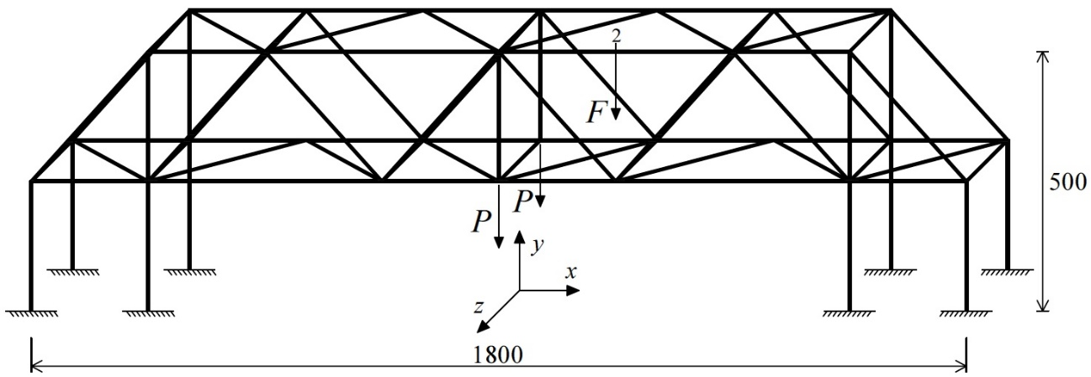
Figure 4.30 - 3D Bridge prototype. Test configuration and setup with location of the instrumented sections.
Hence, the function of Southwell’s method take the following form for point section n. 2:

(4.1)

where, v_{02y} is the initial mid-span deﬂection in Y-direction (imperfection) corresponding to the section n. 2 (Fig. 4.30).

Figure 4.31 - 3D Bridge prototype. External point load P -displacement v_{2y} curve.
Test was developed with a constant force F = 6.9 N at the mid-span of the beam exactly (Fig. 4.30) during the point load increments P+P and until the non-linear behavior of the global prototype. Fig. 4.31 represents the point load P-displacement v_{2y} curve until the maximum load P applied.

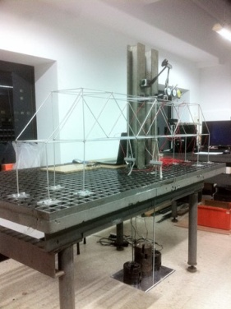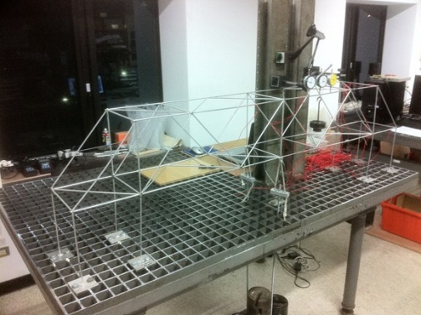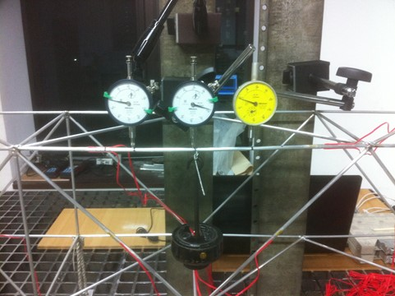
Figure 4.32 - 3D Bridge prototype. Views of the experimental test (left and center). Arrangement of the centesimal comparators and of the constant lateral load F (right).
The last part of “v_{y} versus v_{y} /P” diagram can be considered “Southwell plot” (Fig. 4.33) and the corresponding inverse slope, achieved by least squares method, yield the global buckling load P_{crEy,expS} of 3D Bridge in Y-direction (Eq. 4.1). The simultaneous data of deflections v_{2y} were obviously recorded for each load increments P+P during experiment.

Figure 4.33 - 3D Bridge prototype. “v_{2y} vs. v_{2y} /P” diagram (1a). Southwell plot (1b).

Linear buckling analysis of 3D Bridge, by means of “EFEs” model (Fig. 4.34), was the technique for finding the load multiplier λ_{crEy,EFE} of the global buckling load P_{crEy,EFE}, including geometric representation and elastic modulus E = 74.13 GPa identified experimentally (Section 3.3.1.1).

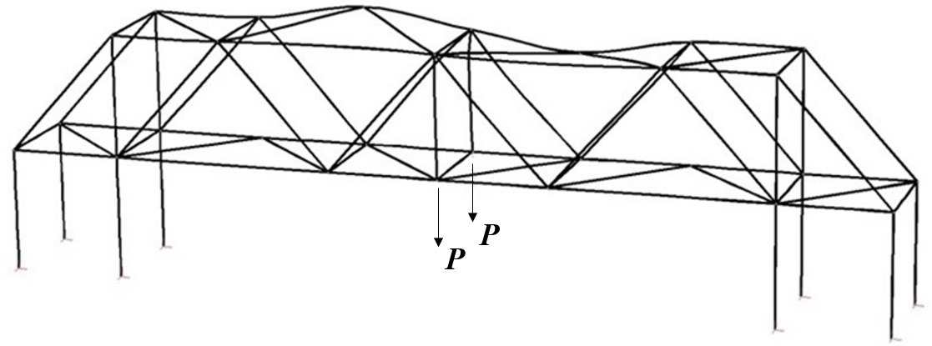
Figure 4.34 - 3D Bridge prototype. Linear buckling analysis by means of “EFEs” model.

The multiplier λ_{crEy,EFE} has reported the value of 610 for the corresponding buckling load P_{crEy,EFE} obviously equal to 610 N. The symmetric space prototype loaded symmetrically buckles vertically in Y-direction (Fig. 4.34). With regards to the analytical value, buckling load P_{crEy,expS} from Southwell’s method corresponding to section n. 2 has furnished the value of 658 N and, hence, an identification error of 7.9%.
The insertion of the global buckling load P_{crEy,expS} within the prototype’s finite element model allows to capture the single buckling loads of the beam elements. Accurate representation of the geometries, knowledge of the boundary conditions and inclusion of material properties are necessary in the model. Local buckling loads of compression members belonging to generic structures are parameters of the simplified formula of Timoshenko and Gere (1961) and Bazant and Cedolin (1991), and of the simplified formula of Galef (1968).

Identifications by means of the Simplified formula of Timoshenko & Gere (1961) and Bazant & Cedolin (1991)
Section 4.4 presents the compression force identifications using the simplified formula of Timoshenko and Gere (1961) and Bazant and Cedolin (1991), described in Section 1.4, on 3D Bridge prototype. The experiment was conducted concurrently with Southwell’s method (Singer et al. 2000).

3D Bridge prototype
Test configuration is illustrated in Section 4.3.1. 3D Bridge prototype was always obviously preserved in the elastic range, taking into account the global buckling load P_{crEy,EFE} firstly.

Laboratory test results
The displacements v₁ at sections ns. 1 - 2 were extrapolated by I-order static analysis through “EFEs” model subjected to loads P+P and F from laboratory test (Fig. 4.35), according to the concepts of the simplified formula (Eq. 1.28). It is experimentally impossible to measure the linear deflections v₁ (I-order) since transverse loads P+P and F cause II-order effects on the slender elements.

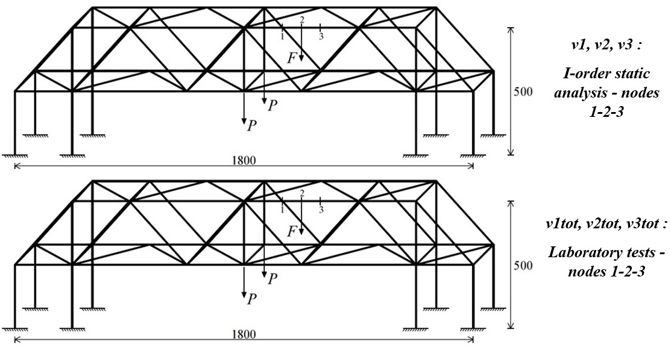
Figure 4.35 - 3D Bridge prototype. First-order static analysis (above) and laboratory test (below). Tests setup with location of the instrumented sections. Units: mm.
Conversely, displacements v_{tot} at sections ns. 1 - 2 were short-term recorded by centesimal comparators, as shown in Fig. 4.32. The assigned loads P+P and F are listed in Table 4.11. In short, deflections v_{tot} were measured for each load increment P+P, giving rise to 21 experimental combinations of v₁ and v_{tot} for each section (ns. 1 - 2).
Compressive axial loads N_{a} were obtained from Eq. (1.29) by the above combinations of v₁ and v_{tot} and followed the procedure of Section 1.4.1. Buckling load N_{crEy,expS} = 436 N of the beam under examination was identified by inserting the global buckling load P_{crEy,expS}, from Southwell’s method, within “EFEs” model of the prototype. In specific, 42 estimated compression forces N_{a} were totally achieved and then compared with the measured compression forces N_{x}+∆N_{x} on the beam (Tables 4.12 and 4.13). The axial load contribution ∆N_{x} in the beam, given by the force F with vertical direction, is positive (N_{x}+∆N_{x}). Moreover, N_{x} value is the contribution given by loads P+P only (compression forces are assigned positive sign).
The strain gauge configurations and the process used to measure the compression forces N_{x}+∆N_{x} were obviously the same ones of Southwell’s method.

Table 4.11 - 3D Bridge prototype. Experimental and measured parameters of the axial load identification process.
Table 4.12 - 3D Bridge prototype. Comparison between estimated (N_{a}) and measured (N_{x}+∆N_{x}) values of compression forces of the beam.
Table 4.13 - 3D Bridge prototype. Comparison between estimated (N_{a}) and measured (N_{x}+∆N_{x}) values of compression forces of the beam.
Tables 4.12 and 4.13 show the excellent results since compression forces N_{a} were identified with errors less than 10% (in absolute value) using the combinations of v₁ and v_{tot} in correspondence of the point loads P+P larger than 350.5+350.5 N. It means that best estimations N_{a} are obtained when the beam-columns under examination are subjected to higher II-order effects (when the ratios v_{tot} /v_{I} are much greater than 1.2).
The simplified formula’s application on generic structures results an efficacious technique for the structural health monitoring of compression members.

Discussion and conclusions
The non-destructive methods presented are efficacious techniques for the structural health monitoring of generic space structures in-situ. Experimental tests on the small-scale space prototype have furnished excellent identifications for tensile and compression forces. Safety inspections will become increasingly important in the near future, especially because of the improvement of the structural material properties that recently allowed to design structures with more slender beam-columns.
The method proposed by Tullini’s (2013) is able to estimate compression and tensile forces in beam-columns belonging to space structures even when the end restraints of the members are unknown, in fact, estimation errors were less than 10%. The identifications become more reliable when the method applied on beam-columns having higher slenderness and, moreover, when elements subjected to the larger lateral loads. Space structures constituted of members having homogeneous structural material, such as steel or aluminium, may be subjected by higher lateral loads, due to the different mechanical material properties. The procedure can be suitable for any slender beam-column of any space structure system.
Southwell’s method (Singer et al. 2000) was extended experimentally for the first time on generic space structures. The global buckling load determined was very close to the theoretical prediction for the corresponding perfect prototype (3D Bridge). Buckling loads of single beam-columns, belonging to a space structure, can be identified by inserting the global buckling load from Southwell’s method within the space structure’s finite elements model. Nowadays, with modern data acquisition systems, large amount of simultaneous data of loads and displacements may be recorded in Southwell method’s experiments, since measurements have to be taken at every load increment.
The extension of the simplified formula of Timoshenko & Gere (1961) and Bazant & Cedolin (1991) has furnished excellent identifications. Its application is mainly suitable for validating the design computations of space structures since it requires the knowledge of external and internal boundary conditions. In fact, the comparison between estimated and expected compression forces becomes direct measure of the level of reliability of the design computations and of the entire construction. First-order displacement - parameter of the formula - must be assumed analytically for space structures only, since transverse loads cause II-order effects on the slender elements. The second-order effects should be in general higher in beam-columns under investigation as the simplified formula requires v_{tot} /v_{I} ratios greater than 1.2. Additionally, compression force estimations do not depend on the magnitude of the transversal load; this condition is very positive from the experimental point of view since applications of elevated loads are arduous during static tests in-situ.
All static methods do not require any selection of the experimental data to be used in the procedures and the displacement sensors must to be only placed externally at given sections of the element span respectively.

Future developments

The further studies will be focused mainly on the continuation of the research activities of Chapter 2 “Identification of the pre-stress force in prismatic beams”. The method proposed by Tullini (2013) and the new static method proposed in this work will be applied on a pre-stressed real-scale concrete bridge beam with total length of 30.0 m. The displacement measurements will be performed by Fiber-Bragg-grating differential settlement measurement sensors (FBG-DSM) at given cross sections of the span respectively.
The numerical simulations of the simplified formula of Galef (1968) on the post-tensioned beam specimens will be moreover developed experimentally, since the pre-stress load identifications have reported reliable results. It is worth specifying that vibration-based measurements respect to the weak axis of bridge beams can be easily executed on bridge decks in-situ.
All future experiments will be conducted in the laboratory of the National Center for Research on Earthquake Engineering (NCREE) in Taipei, Taiwan.


Figure 5.1 - Highland View Bridge, Port St. Joe, Florida, USA.
In the near future, safety inspections will become increasingly important for monitoring the pre-stress losses in-situ. Currently in Italy and Taiwan, as in other countries in the world, plenty of bridges need to be controlled for the monitoring of pre-stress losses. This problem is especially of great importance for concrete bridge beams where many factors, such as relaxation of the tendons, shrinkage and creep of concrete, friction between tendons and tendon ducts, anchorage slip and ambient temperature, can lead to the change of the applied pre-stress forces (established in the design computations). The comparison between the applied and the estimated pre-stress forces becomes direct measure of the level of reliability of the entire bridge. The applications of the non-destructive methods could be suitable for establishing if the bridge will need interventions of renovation, considering that the costs of these interventions are very expensive, such as the insertion of external tendons or other retrofitting methods.

Acknowledgments

Looking back four years since I continued my Ph.D. at University of Ferrara, what an amazing journey it has been for me! Encompassing both good times - which I will remember forever because they were aplenty, and not-so-good times - yet I did not sway from my conscience, this long journey would not have accomplished without fabulous help and support I appreciatively received from many individuals as highlighted below.
First of all, I would like to express my deepest and sincere thanks to my advisors, Prof. Tullini Nerio and Prof. Chang Kuo-Chun, for their advice, guidance, inspiration, suggestions, criticism and financial support during my Ph.D. studies. I am greatly honored and feel very fortunate to have completed my Ph.D. program in their research groups at University of Ferrara and at National Taiwan University (NTU), respectively.
I sincerely appreciate my committee members, Prof. Olivito Renato Sante, Prof. Secchi Simone, Prof. Mancini Giuseppe, Dr. Moramarco Tommaso and Prof. Bitelli Gabriele for their comments and suggestions. Their professional perspectives and viewpoints have enriched my dissertation.
The “Tender for Young Researchers Abroad Grant” year 2014 sponsored by the University of Ferrara, Italy, for Ph.D. researches and the “Summer Program in Taiwan Grant” years 2014/2015 sponsored by the Ministry of Science and Technology of the Republic of China (Taiwan) for European Ph.D. candidates gratefully acknowledged.
Through these programs, I had the opportunity to work at the Department of Civil Engineering of National Taiwan University (NTU) and at the National Center for Research on Earthquake Engineering (NCREE) in Taipei. I would like to give my immense gratitude to Dr. Chen Chun-Chung and Dr. Lee Zheng-Kuan of NCREE for their advices, guidance and suggestions during all experiments of my Ph.D. studies for totally one-year visiting study in Taiwan. I also appreciate the help of the student Fan-Peng that I followed for the development of his Master degree’s thesis in Civil Engineering at NTU.
This dissertation was moreover partially supported by scholarship from the Department of Civil Engineering of NTU: Granting for Research Assistant (2015) for which I appreciate very much.
Most importantly, I would like to thank my family for their support and being with me through the most difficult times of this long journey when I was pursuing my Ph.D. degree.

References

Abraham M. A., Park S., Stubbs N. (1995). Loss of pre-stress prediction based on non-destructive damage location algorithms. Smart Structures and Materials, vol. 2446 of Proceedings of SPIE, 60-67.
Amabili M., Carra S., Collini L. Garziera R., Panno A. (2010). Estimation of tensile force in tie-rods using a frequency-based identification method. Journal of Sound and Vibration, 329 2057-2067.
Bahra A. S., Greening P. D. (2006). Particularities of Newton’s method in space frame force determination utilising eigenpair functions. Journal of Sound and Vibration, 291 (1-2) 462-490.
Bahra A. S., Greening P. D. (2009). Identifying axial load patterns using space frame FEMs and measured vibration data. Mechanical Systems and Signal Processing, 23 1282-1297.
Bahra A. S, Greening P. D. (2011). Identifying multiple axial load patterns using measured vibration data. Journal of Sound and Vibration, 330 (15) 3591-3605.
Baruch M. (1973). Integral equations for nondestructive determination of buckling loads for elastic bars and plates. Israel Journal of Technology, 11 (1-2) 1-8.
Bazant Z. P., Cedolin L. (1991). Stability of Structures. Elastic, Inelastic, Fracture, and Damage Theory. Oxford University Press, Oxford.
Beconcini M. L. (1996). Un metodo pratico per la determinazione del tiro nelle catene. Costruire in laterizio, 54/96 299-301.
Blasi C., Sorace S. (1994). Determining the axial force in metallic rods. Structural Engineering International, 4 (4) 241-246.
Bonopera M., Tullini N., Chen C. C., Lin T. K., Chang K. C. (2015). Identification of the pre-stress force in bridge beams using their first natural frequency. 1st Association of Computational Mechanics Taiwan (ACMT) Conference, Taipei, Taiwan, October 22-23.
Briccoli Bati S., Puccetti P., Tonietti U. (1992). Experimental methods for testing the pull tension in chains. Hallay C., Kulcsar P. (Eds.), Proceedings of the 13th World Conference on Non-Destructive Testing, Amsterdam, Elsevier, 1259-1263.
Briccoli Bati S., Tonietti U. (2001). Experimental methods for estimating in situ tensile force in tie-rods. Journal of Engineering Mechanics, 1275-1283.
Bruschi G., Nardoni G., Lanza L., Laudiero F., Tullini N., Mezzadri G., Tralli S. (2004). Experimental stress analysis of historical forged tie beams of archeological museum of Spina in Ferrara, Italy. Modena C., Lourenço P. B., Roca P. (Eds.), Proceedings of the Structural Analysis of Historical Construction, vol.1, Taylor & Francis, London, 489-497.
Bu J. Q., Wang H. Y. (2011). Effective pre-stress identification for a simply supported PRC beam bridge by BP neural network method. Journal of Vibration and Shock, 30 (12) 155-159.
Caironi M., Gambarova P., Tattoni S. (1999). Teoria e tecnica delle costruzioni. Introduzione alla Analisi Strutturale, Ed. Paravia/Scriptorium.
Candela M., Lanza L., Tullini N., Mezzadri G. (2004). Identificazione dello stato di tensione nelle catene storiche a supporto di due interventi di consolidamento di edifici monumentali. Dalla conoscenza e dalla caratterizzazione dei materiali e degli elementi dell’edilizia storica in muratura ai provvedimenti compatibili di consolidamento. Workshop at DIS, Politecnico di Milano.
Ceballos M. A., Prato C. A. (2008). Determination of the axial force on stay cables accounting for their bending stiffness and rotational end restraints by free vibration tests. Journal of Sound and Vibration, 317 127-141.
Chen S. E., Petro S. (2005). Nondestructive bridge cable tension assessment using laser vibrometry. Experimental Techinques, March/April, 29-32.
Eurocode 2. Design of concrete structures - Part 1-1: General rules and rules for buildings. UNI EN 1992-1-1:2005.
Fraternali F., Angelillo M., Fortunato A. (2002). A lumped stress method for plane elastic problems and the discrete-continuum approximation. International Journal of Solids and Structures, 39 (25) 6211-6240.
Fraternali F. (2010). A thrust network approach to the equilibrium problem of unreinforced masonry vaults via polyhedral stress functions. Mechanics Research Communications, 37 (2) 198-204.
Fraternali F. (2011). A mixed lumped stress-displacement approach to the elastic problem of masonry walls. Mechanics Research Communications, 38 (3) 176-180.
Galef A.E. (1968). Bending frequencies of compressed beams. Journal of the Acoustical Society of America, 44 (8) 643.
Geier R., De Roeck G., Flesch R. (2006). Accurate cable force determination using ambient vibration measurements. Structure and Infrastructure Engineering, 2 (1) 43-52.
Gentile C. (2010). Deflection measurement on vibrating stay cables by non-contact microwave interferometer. NDT&E International, 43 231-240.
Giuriani E., Marini A., Porteri C., Preti M. (2009). Seismic vulnerability for churches in association with transverse arch rocking. International Journal of Architectural Heritage, 3 (3) 212-234.
Go C. G., Lin Y. S., Khor E. H. (1997). Experimental determination of the buckling load of a straight structural member by using dynamic parameters. Journal of Sound and Vibration, 205 (3) 257-264.
Greening P. D., Lieven N. A. J. (2003). Identification and updating of loading in framework using dynamic measurement. Journal of Sound and Vibration, 260 (1) 101-115.
Hamed E., Frostig Y. (2006). Natural frequencies of bonded and unbonded pre-stressed beams pre-stress force effects. Journal of Sound and Vibration, 295 (1-2) 28-39.
Jacobson M. J., Wenner M. L. (1968). Predicting buckling loads from vibrational data. Experimental Mechanics, 8 (10) 35-38.
Kim B. H., Park T. (2007). Estimation of cable tension force using frequency-based system identification method. Journal of Sound and Vibration, 304 660-676.
Kim J. T., Ryu Y. S., Yun C. B. (2003). Vibration based method to detect pre-stress loss in beam type bridges. Smart Systems and Non-destructive Evaluation for Civil Infrastructures, vol. 5057 of Proceedings of SPIE, 559-568.
Klein B. (1957). Determination of effective end ﬁxity of columns with unequal rotational end restraints by means of vibration test data. Journal of the Royal Aeronautical Society, 61 131-132.
Lagomarsino S., Calderini C. (2005). The dynamical identification of the tensile force in ancient tie-rods. Engineering structures, 27 (6) 846-856.
Law S. S., Lu Z. R. (2005). Time domain responses of a pre-stressed beam and pre-stress identification. Journal of Sound and Vibration, 288 (4-5) 1011-1025.
Law S. S., Wu S. Q., Shi Z. Y. (2008). Moving load and pre-stress identification using wavelet based method. Journal of Applied Mechanics, Transactions ASME, vol. 75, no. 2, art. ID 021014.
Lee Z. K. (2013). Dazhi bridge safety monitoring demonstration project. 5th International Conference on Advances in Experimental Structural Engineering, Taipei, Taiwan, November 8-9.
Lee Z. K., Chen C. C., Hung H. H., Sung Y. C., Lee L. S. (2014). Loading tests and long-term monitoring on Wugu-Yangmei viaduct of Taiwan National Highway. The 5th Asia Conference on Earthquake Engineering, Taipei, Taiwan, October 16-18.
Li H., Lv Z., Liu J. (2013). Assessment of pre-stress force in bridges using structural dynamic responses under moving vehicles. Mathematical Problems in Engineering, art. ID 435939.
Li S., Reynders E., Maes K., De Roeck G. (2013). Vibration-based estimation of axial force for a beam member with uncertain boundary conditions. Journal of Sound and Vibration, 332 (4) 795-806.
Livingston T., Béliveau J. G., Huston D. R. (1995). Estimation of axial load in prismatic members using ﬂexural vibrations. Journal of Sound and Vibration, 179 (5) 899-908.
Lu Z. R., Law S. S. (2006). Identification of pre-stress force from measured structural responses. Mechanical Systems and Signal Processing, 20 (8) 2186-2199.
Lurie H. (1952). Lateral vibrations as related to structural stability. Journal of Applied Mechanics, 19 (2) 195-203.
Maes K., Peeters J., Reynders E., Lombaert G., De Roeck G. (2013). Identification of axial forces in beam members by local vibration measurements. Journal of Sound and Vibration, 332 (21) 5417-5432.
Milani G., Tralli A. (2012). A simple meso-macro model based on SQP for the nonlinear analysis of masonry double curvature structures. International Journal of Solids and Structures, 49 (5) 808-834.
Miyamoto A., Tei K., Nakamura H., Bull J. W. (2000). Behavior of pre-stressed beam strengthened with external tendons. Journal of Structural Engineering, 126 (9) 1033-1044.
Park S., Choi S., Oh S. T., Stubbs N., Song H. C. (2006). Identiﬁcation of the tensile force in high-tension bars using modal sensitivities. International Journal of Solids and Structures, 43 (10) 3185-3196.
Plaut R. H., Virgin L. N. (1990). Use of frequency data to predict buckling. Journal of Engineering Mechanics, 116 2330-2335.
Rebecchi G. (2011). Beam axial load identification using one vibration mode shape. PhD Thesis, University of Ferrara, http://eprints.unife.it/tesi/389.
Rebecchi G., Tullini N., Laudiero F. (2013). Estimate of the axial force in slender beams with unknown boundary conditions using one flexural mode shape. Journal of Sound and Vibration, 332 (18) 4122-4135.
Ren W. X., Liu H. L., Chen G. (2008). Determination of cable tensions based on frequency differences. Engineering Computation: International Journal for Computer-Aided Engineering and Software, 25 (2) 172-189.
Saiidi M., Douglas B., Feng S. (1994). Pre-stress force effect on vibration frequency of concrete bridges. Journal of Structural Engineering, 120 (7) 2233-2241.
Saiidi M., Douglas B., Feng S. (1996). Pre-stress force effect on vibration frequency of concrete bridges. Journal of Structural Engineering, 122 (4) 460.
Segall A., Baruch M. (1980). A non-destructive dynamic method for determination of the critical load of elastic column. Experimental Mechanics, 20 285-288.
Shaker F. J. (1975). Effect of axial load on mode shapes and frequencies of beams. NASA Technical Note, NASA TN D-8109.
Shi L., He H., Yan W. (2014). Pre-stress force identification for externally pre-stressed concrete beam based on frequency equation and measured frequencies. Hindawi Publishing Corporation, Mathematical Problems in Engineering, art. 840937.
Singer J., Arbocz J., Weller T. (2000). Buckling experiments: experimental methods in buckling of thin-walled structures: basic concepts, columns, beams and plates. Vol. 1, John Wiley & Sons, New York.
Sorace S. (1996). Parameter models for estimating in-situ tensile force in tie-rods. Journal of Engineering Mechanics, 122 (9) 818-825.
Southwell R. V. (1932). On the analysis of experimental observations in problems of elastic stability. Proc. Royal Society, London, series A, 135, 601 616.
Sweet A. L., Genin J., Mlakar P. F. (1976). Vibratory identiﬁcation of beam boundary conditions. Journal of Dynamic Systems, Measurement and Control, 98 387-394.
Timoshenko S. P., Gere J. M. (1961). Theory of Elastic Stability. McGraw-Hill, New York.
Tullini N., Laudiero F. (2008). Dynamic identification of beam using one flexural mode shape. Journal of sound and vibration, 318 131-147.
Tullini N., Rebecchi G., Laudiero F. (2012). Bending tests to estimate the axial force in tie-rods. Mechanics Research Communications, 44 57-64.
Tullini N. (2013). Bending tests to estimate the axial force in slender beams with unknown boundary conditions. Mechanics Research Communications, 53 15-23.
Virgin L. N., Plaut R. H. (1993). Effect of axial load on forced vibrations of beams. Journal of Sound and Vibration, 168 (3) 395-405.
Xu J., Sun Z. (2011). Pre-stress force identification for eccentrically pre-stressed concrete beam from beam vibration response. Tech Science Press, SL, 5 (2) 107-115.
Xuan F. Z., Tang H., Tu S. T. (2009). In situ monitoring on pre-stress losses in the reinforced structure with fiber optic sensors. Measurement: Journal of the International Measurement Confederation, 42 (1) 107-111.

